How to Build a Hanging Bed
Posted by: Craig Allen



This DIY Hanging Bed project is perfect for a back porch or summer home. Here are the step-by-step instructions. We have printable instructions that you can download, too.
Skill Level: Intermediate
Time: 8 hours
Cost: $350
Tools and Materials
- 4 3/8-inch x 6-inch eye bolts
- 8-foot long 4 x 4 posts
- 8 double shear hangers
- 4-pack 3/8-inch fender washers
- 4 8-foot long 2 x 4 posts
- 4 corner brackets
- 4 joist hangers
- 1 box 10d joist hanger nails
- 2 9 oz. tubes adhesive
- 4 x 8 x ¼-inch sanded pine plywood
- 3 8-foot long 1 x 6 pine posts
- 1 pack 1 ½-inch finishing nails
- 1 pack 1 ½-inch common nails
- Tack cloths
- 1 quart Behr Exterior Latex Primer
- 1 quart Behr Exterior Gloss White Paint
- 4 3/8 x 5-inch eye bolts
- 8 pack 3/8-inch bolt washers
- 4 2-pack 2-inch S-hooks
- 2 15-foot packs #135 chain
- 75 x 39-inch bunk bed mattress
- 6-foot step ladder
- Measuring tape
- Carpenter’s pencil
- 3/8-inch VSR drill
- 3/8-inch drill bit Screwdriver
- 15-inch hand saw
- Caulk gun
- Claw Hammer
- Chalk line
- 9/16-inch combination wrench
- 2/32-inch nail setter
- Paint brush tray kit
- Framing square
- Work gloves
- Safety glasses
Shop the items for this project at The Home Depot.
This project is intended for open joist or open rafter ceilings. Access to these structural members is needed to construct braces suitable for supporting the weight of a bed and its occupants. Finished ceilings will need to be opened up and later repaired.
The bed uses a standard twin size bunk bed mattress, which is 75 inches x 38 inches. You will be constructing a supporting frame of this size using 2-inch x 4-inch lumber, and wrapping the frame sides with 1-inch x 6-inch pine boards, which will keep the mattress in place. Because this bed hangs, it can swing somewhat, so avoid placing it near walls or other furniture.

Disclaimer: Local law in your area may contain specific codes or ordinances that may affect or place restrictions on your project. You are advised to consult with your local authorities before starting this project.

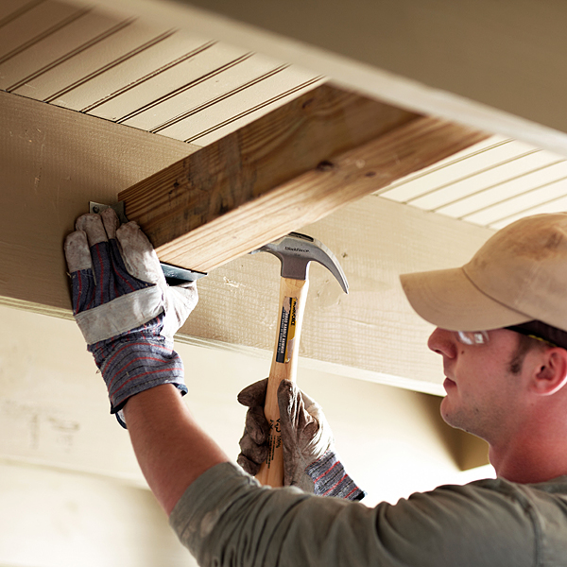
STEP 1
Measure the joist spacing where the bed will hang — either 14 ½ inches or 16 inches on center joists, or 22 ½ inches or 24 inches on center joists. Cut four pieces of 4 x 4 post lumber to that length.
Using the double shear hangers and joist hanger nails, secure the 4 x 4 braces you have cut to the ceiling joists. Each pair of braces should be spaced 75 inches apart so that you are able to drill vertical holes in each brace with a spacing between 28 inches and 34 inches. If you have open rafters, you can mount these braces higher up into the space for an improved appearance. If you plan on refinishing the ceiling, these mounts will need to be flush with the bottom of the joists.

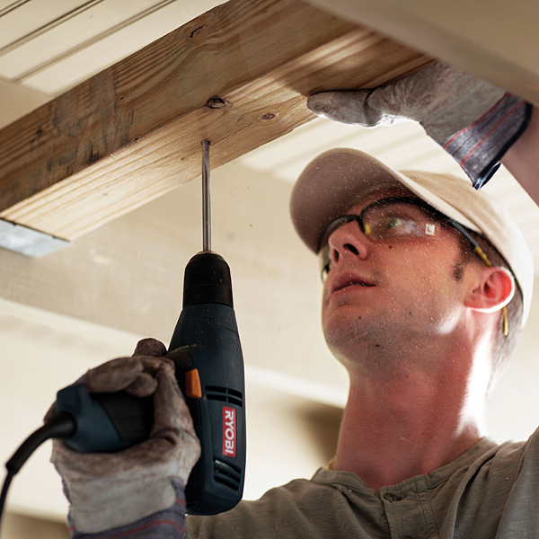

STEP 2
Using a 3/8-inch drill bit, drill one vertical hole in each 4 x 4 brace. This is where the hanging eye bolts will go. These holes should be centered in the width of the brace, but can be drilled anywhere along its length so that the eye bolts will be located in a rectangle sized about 76 inches x 30 inches. As noted above, the width can vary as needed more than the length.
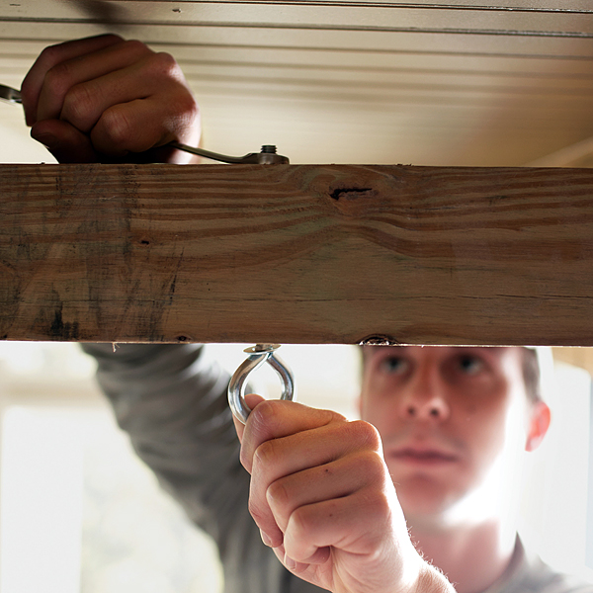

STEP 3
Push each 3/8 x 6-inch eye bolt through its hole. Place a 3/8-inch fender washer on the threaded end, and then thread on its nut. Tighten the nut with a 9/16-inch wrench, using a screwdriver placed through the eye to keep it from turning. The eyes should be parallel with the length of the bed frame location.

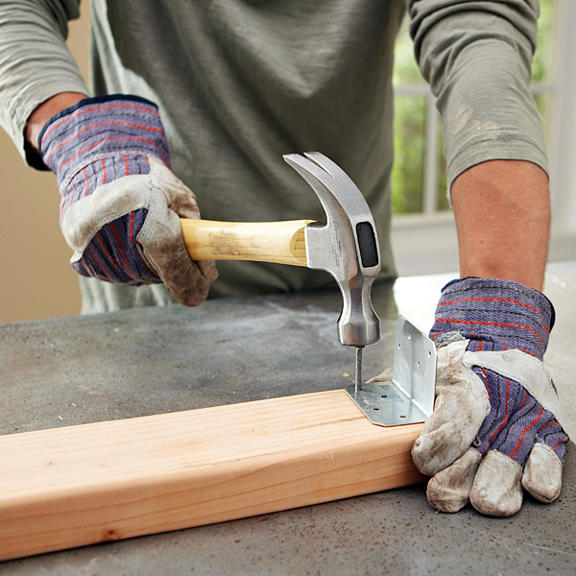

STEP 4
To begin frame construction, cut your 2 x 4 lumber into two 75-inch pieces and four 35-inch pieces. Two of the 35-inch boards will be on the ends of the bed, while the other two will be inside support members.
Using joist hanger nails, attach the four corner brackets to the two 35-inch end pieces. These are located on the inside of each board at each end, placed flush with the very end of each board.



STEP 5
Using joist hanger nails, attach the four joist hangers to the 75-inch boards. These are located on the inside of each board 25 inches away from each end, forming the mounts for the inside frame support boards.

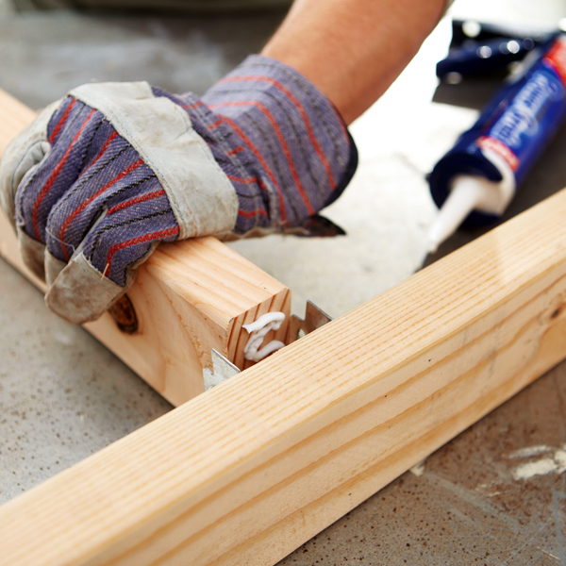

STEP 6
Apply adhesive to the end of one of the 35-inch support boards, place it in the hanger, and nail it in. Repeat this with the second support board.
Apply adhesive to the other ends of these support boards, and place them into the hangers on the opposite 75-inch rail. Nail these in.

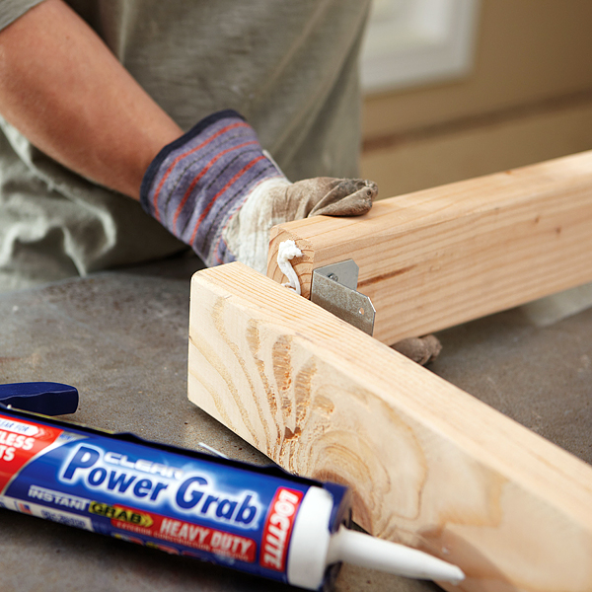

STEP 7
Apply a bead of adhesive to both ends of one 35-inch end support, and set it in place at one end of the frame. You can now nail in the corner braces to the long frame rails. Repeat with the second end.

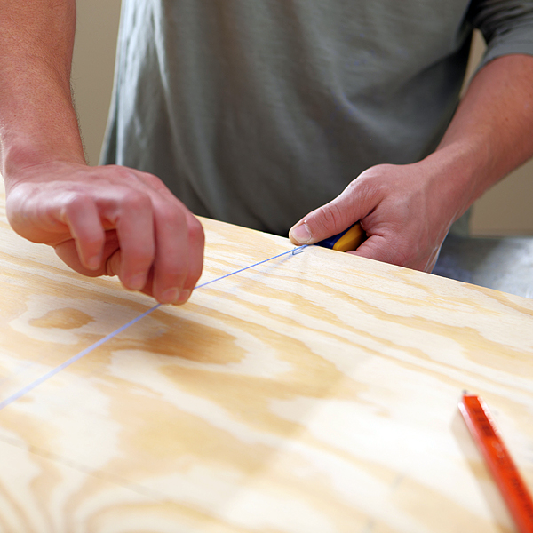

STEP 8
Cut the ¼-inch plywood down to mattress size: 75 inches x 38 inches. Mark the plywood 25 inches from each long end, and use the chalk line to make two lines. These will correspond to the inside support board locations.

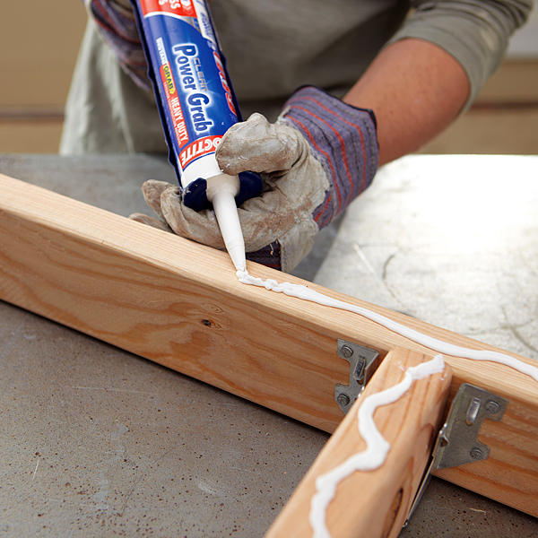

STEP 9
Apply a bead of adhesive along the top of the 2 x 4 subframe, including the end and support boards.



STEP 10
Place the plywood on top of the frame, and use the 1 1/2-inch common nails to secure it to the boards. Space the nails about a foot apart and include three nails for each inside support along the chalk lines you drew.
You now have a finished supporting subframe, which should be the same size as your mattress.

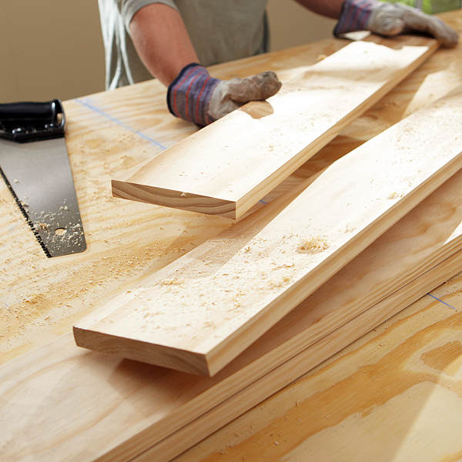

STEP 11
Cut your pine 1 x 6 boards into two 75-inch pieces and two 39 ½-inch pieces. These will provide a finished look to your bed, as well as hold the mattress in place.

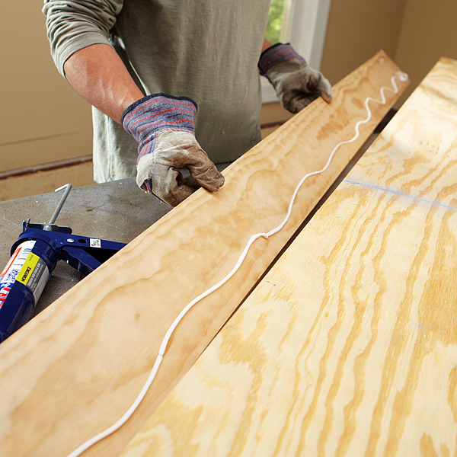

STEP 12
Apply a bead of adhesive to one long side of your subframe, and attach a 75-inch pine board to it using six to eight finishing nails. Use your nail set to punch the finishing nails flush with the pine board. Repeat this process with the other side, and then with each end.

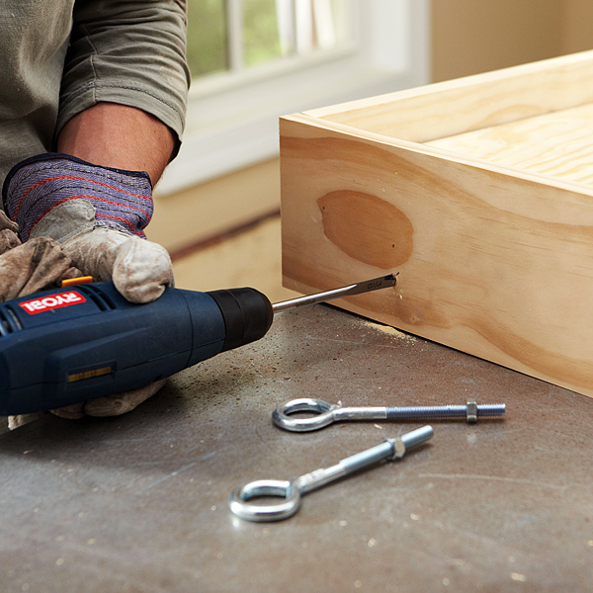

STEP 13
Measure and mark hole locations for the bed eye bolts. There are two of these on each end of the bed, 5 inches in from the corner and 1 inch up from the bottom edge.
Using your 3/8-inch bit, drill these four holes through the pine boards and the 2 x 4 frame boards.

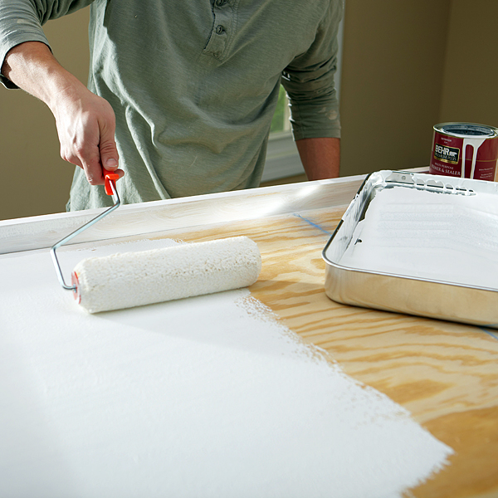

STEP 14
Use your tack cloth to remove dirt and dust residue from the sides and plywood top to prepare for painting.
Prime the bed frame and plywood with Behr Exterior Latex Primer. This primer needs a minimum of one hour drying time before painting over it. If you have the time, four hours is better.
Paint the bed frame and plywood with Behr Exterior Gloss Paint. We chose white, but you can have any color you desire mixed for you. Allow at least one hour drying time.

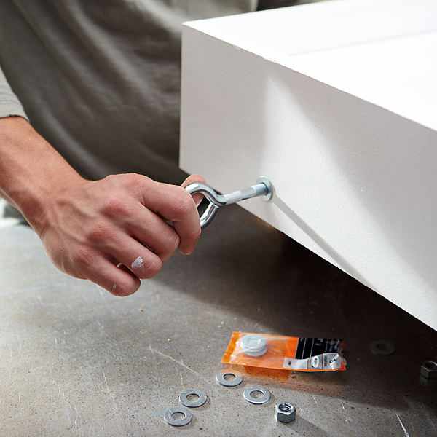

STEP 15
Attach the bed frame eye bolts through the holes you drilled before painting. Use the regular 3/8-inch washers and the supplied nuts, and tighten the same way you attached the ceiling eyes. The eye bolts should be oriented vertically.

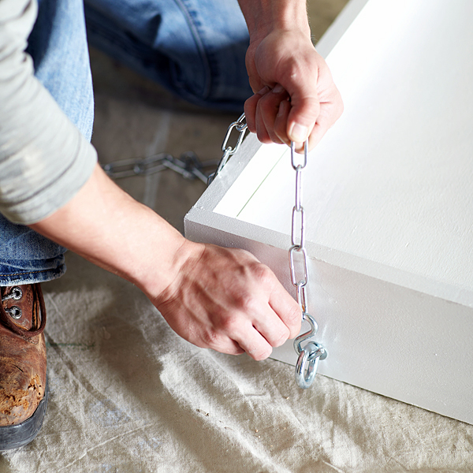

STEP 16
Use the S-hooks to attach each eye bolt on the bed to the end of each chain. One at a time, lift the bed and hook the chain to a ceiling support. The bed height you choose is a matter of personal preference, but keep in mind who will be using the bed. It should be hung level regardless of height.
Surplus chain links should be at the ceiling end rather than hanging off the bed. The chain lengths were chosen for ceiling heights between 8 and 9 feet. If you have a higher or sloped ceiling, you may have to adjust the chain lengths that you purchase. This chain can be purchased in any length you desire at Home Depot stores.

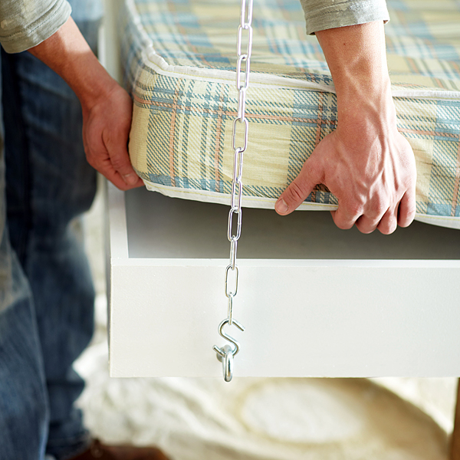

STEP 17
Place the mattress inside the frame.
And now you have a Hanging Bed you made yourself. Congratulations!

