How To Protect Your Car Against Disasters
by Alec Deacon
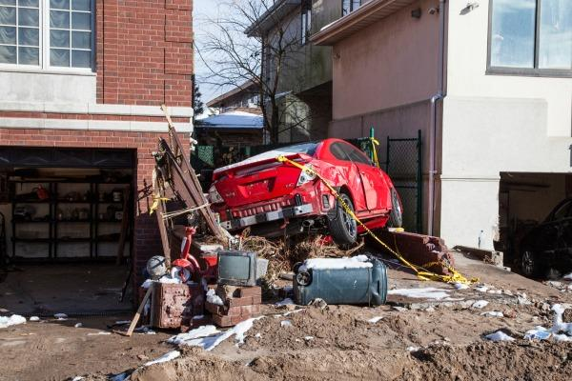Before Hurricane Sandy hit, car owners rushed to lock their vehicles in the garage, to make sure the damage stays as close to a minimum as possible. But here`s the thing: when it comes to disasters like floods, earthquakes and superstorms… there is no such thing as “minimum” damage.
If you can`t accept that your car is going to turn into an aquarium or a pinata overnight, then you`re in for a big surprise.
Many of those who carefully parked their car in a safe garage did not take into consideration the fact that their car will be soaked in dirty water and other debris. When the water rises to a point where you can see cars swimming down the street like it`s the Olympics… you`d better expect your “perfectly safe” car to be drowning, as well.
The question is… what can you do to fix the damage a disaster leaves behind? Get yourself an insurance that covers natural disasters. Now, that may seem like a dumb answer… anyone could tell you that, right? But the truth is… insurers can be very tricky and you need to learn to spot their shenanigans before you end up paying through your nose.
So let`s take it step by step:
#1. How do you know if your insurance covers natural disasters?
First, you need to check your car insurance and see if it`s got Comprehensive coverage. This is the category under which natural disasters fall.
#2: Does your insurance cover all natural disasters?
You may not know this, but comprehensive coverage does not always include all natural disasters.
For example, if you live in an area where earthquakes are a common threat, your insurance might not cover earthquake related damage. This is often the case with floods. Since many areas in the U.S. have spent a lot of time underwater in the past few years, insurers have placed floods under “exclusions”, which means they will not pay a dime if your car gets sunk during the next Sandy.
In 2011 alone, four of the seven emergencies declared by FEMA have been related to flooding, so just imagine how much insurance companies would have to pay if all those affected by floods asked them for money… it`s much easier to just exclude the most common disasters and generously offer to pay for earthquake damages in Texas, right?
So read your policy documents carefully and see what`s listed under “exclusions”, to see what your insurer refuses to pay for.
#3. How to protect your car against all natural disasters
If you live in an area that`s prone to floods, for example, but this disaster is listed under “exclusions”, you can buy an additional insurance to cover it. It`s actually an amendment to your existing insurance, but you`ll have to pay an extra fee.
Make sure you assess benefits and expenses before you get any additional insurances. If the monthly fee for these amendments would cost just as much as replacing your car in case of disaster, don`t get the extra papers. It`s a waste of time and money.
#4: Watch out for moratoriums
If you decide to get a comprehensive car insurance coverage after a disaster warning has been publicly issued… good luck with that! Insurers usually find out these things before you do and they immediately put moratoriums on the endangered areas.
“Moratorium” is just a fancy word for “we know you`re gonna get hit and we won`t pay for last minute preparations”. Honestly, I`d do the same. Just picture this: you`re running an insurance company and, one day, you`re flooded with people who ask for the cheapest insurance you`ve got. Next week, you get hundreds of claims from people asking more money than they paid you in the first place. You`d have to close business and pay from your own pocket, as well.
So my advice is to get this type of insurance before a disaster knock on your door.
#5. If your car is damaged, take photos
I know it`s hard to think about your car when you`ve just been hit by a disaster. But if you and you family are safe and healthy and you`re ready to start assessing damages… start with your car. Take photos of your car exactly the way you`ve found it, from all angles possible. This way, your insurance company will see the full extent of the damage.
#6. File a claim FAST!
As soon as you`ve got the time, rush to your insurer and file a claim. These companies usually take these claims one by one, in chronological order, so to say… And if you`re among the first to file a claim, you`ve got better chances to get your money fast.
#7. How to replace your car
“A car is typically declared a total loss if the anticipated costs of repairing it exceed approximately 70 percent of its estimated replacement value.(edmund.com
If replacing your car would be easier than fixing the damage, be careful to get the right amount of money from your insurance company. Usually, it`s surprisingly easy to reach a settlement wih them, but sometimes, they might try to scam you.
It`s important to keep a record of all your conversations you`ve had with your insurer. Write down the date, the time and the person you`ve talked to. Record the conversations if you can. If they try to push you towards an uncomfortable settlement, file a complaint and use these conversations to your advantage.
According to Edmund.com, if that doesn`t work, “you can file a complaint with the insurance commissioner’s office in your home state. Most offices have online forms you can use to file the complaint along with your supporting documentation. Keep in mind, though, that resolution via this path usually takes longer than working directly with your insurer. The paperwork involved with settling complaints made to commissioners’ offices is burdensome to insurers, so simply threatening to file one may by itself motivate your insurer to act in your favor.”
I hope this helps you protect your car in the most efficient and least expensive manner. Don`t forget time is of the essence, so don`t wait until the very last minute. Play smart and prepare before everyone else.

