How To Prepare For Sinkholes

Understanding Sinkholes
Every year thousands of sinkholes cause damage to buildings and homes in the United States, and according to the USGS, our aging infrastructure will likely cause the number to rise.
Thankfully, however, death-by-sinkhole is exceedingly rare.
Nevertheless, it can and does occur.
For example, in 2013, a sixty-foot sinkhole opened up under Jeffery Bush and swallowed him up while he slept.
Based on more than 20 years of research, Anthony Randazzo, who lectures on sinkholes at Oxford University, said,
“Usually, you have some time…these catastrophic sinkholes give you some warning over the course of hours. This was an extremely rare case.”
Hillsborough County released this video footage of the sinkhole. https://youtu.be/oYbPXYc13-c

What Causes A Sinkhole?
This video from the USGS explains it well. https://youtu.be/wubMuKDGBuk

How To Determine Risk
Unfortunately, according to the USGS, there isn’t a good way to know if there is a sinkhole under your property, however, there are some things to look for.
First, examine the maps provided by the USGS and determine if you are in a high-risk area.
Second, watch for small holes in the ground and any cracks formed in the foundation of your home or others buildings.
Third, check with local county offices, geological surveys, and the USGS to see if you have soluble rock under your property.
According to the USGS, “Karst terrain,” underlies 20% percent of the country. The most common places include Florida, Texas, Alabama, Missouri, Kentucky, Tennessee, and Pennsylvania.
The map below provides more detail on the potential for sinkhole development in your area.
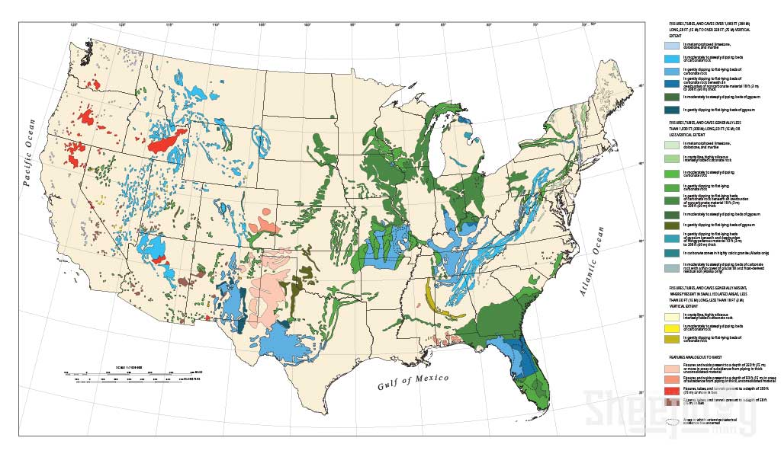
USGS map showing areas of the contiguous United States that are underlain by relatively soluble rocks with potential for cave and natural sinkhole formation. Note that the delineated areas are generalized; actual potential for sinkhole development varies locally within each region. Download PDF

How To Prepare For Sinkholes
First, be ready to evacuate your home at a moment’s notice if necessary. Most likely you will have to leave immediately until it can be determined that you can safely return.
Second, have a bug-out-bag ready.
Third, create a family plan for where you will go, and a meeting place in case you are separated.
Third, prepare a bug-out binder that contains copies of important documents especially insurance policies. See our bug-out binder list here.
And lastly, if you are in an area of sinkhole danger, contact your insurance company and ask about coverage in the event of a sinkhole.

How To Survive a Sinkhole
In the extremely unlikely case that you do find yourself suddenly swallowed in the dark abyss of a sinkhole, here are some things that can increase your chance of survival.
Cover your head with your arms as best you can. This will help to protect your head and give you some breathing room.
Practice a PLF (Parachute Landing Fall) to protect your bones. Squeeze your arms and legs together, tuck your knees, and upon impact fall to your side so that the force of the impact is evenly distributed along your joints and spine. Roll backward. Try not to land straight up and stiffened.
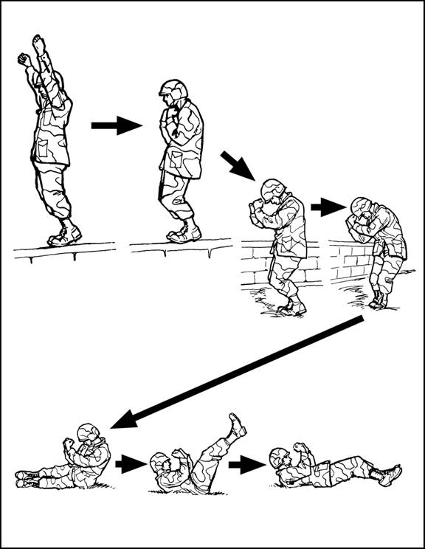
Carry a whistle as part of your EDC. A whistle can help search and rescue locate you when you are buried under a pile of rubble. It is certainly better than yelling which can also deplete your available oxygen.
Carry a mobile phone to call for help.

Additional Resources

Websites
USGS Sinkholes
Videos
Sinkholes the Ground-Breaking Truth (YouTube Video). https://youtu.be/TLUgEXI9RYI

