How To Make an Ear Candle
by admin
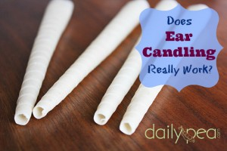

Daily Pea website shares a personal account of ear candling and how it can relieve excess ear wax through ear candling.

I, personally, enjoy ear candling as a way to relieve ear pressure and pain. Ear candling is a two person operation for safety sake.

The first video below takes you through the ear candling process. The second video shows you how to make homemade ear candles.

Click here to read the article:

http://www.youtube.com/watch?feature=player_embedded&v=nDCe8vpe8Oc

http://www.youtube.com/watch?v=aqf6zyp28ec&feature=player_embedded

