How To Make Your Own Bar Soap
By Stephanie Dayle
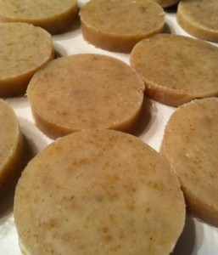
Soap making is a great "self-reliance" skill that enables a person provide something for themselves that they would otherwise have to depend on a store to get.
Homemade Soap and Emergency Preparedness
Making soap is one of those old skills that used to be really common and now is nearly unheard of. If soap makers are ever again needed, learning it would give you a valuable skill that could help your family and community.
However, for prepping purposes I prefer keeping a stock of 'pre-made' ready-to-use soap or even store bought soap rather than prepping 'soap making supplies' (click here for Five Great Soaps to Prep). While I always have a good supply on hand, soap making fats and oils do not store well, so it is difficult to keep them for longer than a few years.
The only exception I make to this is lye, I stock plenty of lye as it consumes time and fuel to make. I am not aware of a shelf-life on lye, and have personally used lye that was nearly 20 years old. The store bought version is inexpensive, and has many uses - this makes it very easy for me to prep.
Soap Making Facts
Soap is actually a salt (source). It's the result of a chemical reaction between fat (an acid) and lye (sodium hydroxide (NaOH) or potassium hydroxide (KOH) a base. Lye is also commercially sold as a plumbing solvent for clogged drains and is also used to preserve food like in the Norwegian dish lutefisk. Lye is not a scary man-made chemical, it occurs in nature and with a little knowledge can be handled very safely.
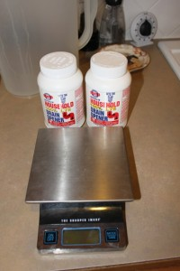
Soap cannot be made without lye. It is possible to create a cleansing substance without lye, but it will not be soap. Sodium hydroxide is often used to make solid soap while potassium hydroxide is usually used to make softer soaps and liquid soap. For this article we will be using sodium hydroxide (NaOH) for a harder bar of soap.
The amount of lye needed to react with the fats and oils will vary depending on the chemical makeup of the fats and oils you are using. This is why it is important to use either established soap recipes or a lye calculator, when you make soap. A cup of olive oil may not need as much lye as the same amount of a different type of oil, so if you swap oils on the recipe you may end up with too much or too little lye. Too much lye means the soap will be caustic (capable of burning, corroding, or destroying living tissue) too little lye means the soap will contain too much fat, which will go rancid in time.
Cold Processed Soap vs Hot Processed Soap
Cold-processed soap still requires some heat but not much. This soap making process requires exact measurements of lye and fat amounts and computing their ratio, using saponification charts or a lye calculator. With cold processed soap, the bulk of the saponification happens after the combined oil and lye solution is poured into molds, usually over a period of two to six weeks. Because of this, cold processed soap still contains glycerine which is generally considered good for human skin.
Hot-processed soaps are created by encouraging the saponification reaction by adding heat to speed up the reaction. Unlike cold-processed soap, in hot-processed soap, the oils are completely saponified by the end of the handling period. Therefore hot processed soap is ready to use right away. In the "fully boiled hot-process" technique the glycerine and most of the impurities in the fat, lye, and water (which gives cold pressed soap its color) are completely cooked out of the soap and drained off as a liquid to be repurposed, leaving a pure hard white bar.
For the purposes of this article I will go over cold processed soap. But you can click here to learn more about each process.
Equipment List
- 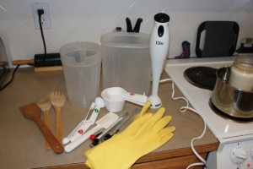
- Scale that weighs in pounds and ounces (digital is preferred in soap making for precision but a manual scale will also work)
- One large stainless steel or enamel pot (do not use aluminum for soap making, aluminum is reactive)
- One large stainless steel or enamel bowl (use this if you are splitting a batch for different scents or colors)
- Hand stick blender (you can stir by hand if you want, it just takes more time)
- Plastic measuring cup (for weighing out your oils and anything else)
- 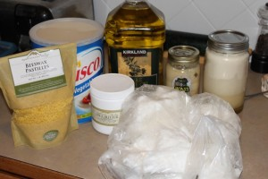Two cooking thermometers that must read over 100 degrees
- Two wooden or plastic spoons (if using wood or plastic, here on after, use this equipment ONLY for soap making)
- Rubber gloves
- Safety goggles
- Clear half gallon plastic container - like a juice pitcher
- A Soap mold (a couple of cardboard boxes lined with freezer paper, chunks of PCV pipe, or a clean kitty litter box will also work as a mold)
- Old bath towel
- Rubber spatula (for scraping the pot and/or bowl after pouring)
There are many different types of soap; like goats milk soap, pine tar soap, castile soap, and coffee soap, but I will cover those in future articles. Once the equipment is obtained and the process is learned these new types of soaps will be fun and easy. For this article I will include two simple recipes (below) the instructions are universal and can be applied to most cold pressed soap recipes.
Simple Cold Processed Soap
This recipe will make 25-30 nice bars of soap that will be kind to your skin, that you could gift to friends and family. The lye is discounted at 7% (this means there is more fat in the recipe than the lye can convert to soap, the extra fat is good for your skin). You can make it as fancy or as simple as you want and it stores really well. I recommend that people learn how to make soap with this recipe then move on to other recipes that may peak their interests.
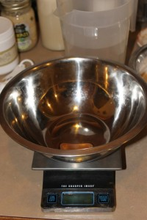
First gather your equipment and pre-measured ingredients. Wear a long sleeved shirt, rubber gloves, eye protection, keep your hair pulled back and wear shoes. Keep some vinegar nearby, so that if you get some lye on you (it will start to itch before it burns) you can treat it. Wash with plenty of soap and running water *first* and then rinse with vinegar. Same with surfaces, wash and rinse in case of spills then spray with vinegar and then repeat when you are finished making soap. If you get some on your clothes, immediately throw them in the washer.
- 32oz Cold Water
- 12oz Powdered Lye
Add 32oz of water to the plastic container. In a well ventilated area slowly add the lye into the water, stir gently trying not to splash. Never the other way around - you will get a violent volcano reaction. Always add lye to water. Set aside with one of the thermometers to cool to around 100° F - this could take several hours, to speed the process along set pitcher in an ice water bath or on a cold cement floor. If the lye has cooled too much vigorously stir the mixture, this will heat it back up.
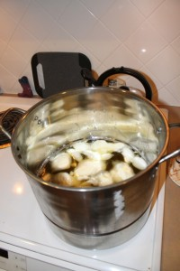
In the large stainless steel or enamel stock pot add following solids, then place over medium-low heat on the stove until all are liquified:
- 24 oz Coconut Oil (coconut oil gives soap its bubbles and gives hardness to the bar, this is why most soap makers will tell you that bubbles to do not necessarily equal cleaning power).
- 28 oz White Shortening (Crisco will work)
- 10 oz Rendered Bacon Grease, or Rendered Tallow (click here to see How to Make Your Own Tallow) unsalted butter will also work. I don't do vegetarian soap, I live on a farmstead so I use animal fat in all my soaps.
Remove melted solids from heat (from here on out you are done with the stove, turn it off). Check your lye water temperature.
- Add 24 oz of Olive Oil or vegetable oil
This will start lowering the fat temperature, you want it at 100° F as well (you can combine lye water and the oils anywhere between 125°F -100°F as long as they are the same temp or within 4 degrees of each other). Use the other cooking thermometer to check the temp. Once the temperature of the lye water and oils are the same, slowly stir the lye water into the melted fats and oils. Watch as the mixture begins to change color, get cloudy and thicken as the chemical reaction starts. You just made soap!
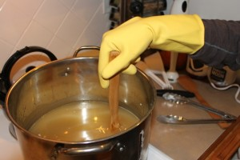
Stir the soap for 10 minutes, then let it rest for 15 minutes, set a timer if you need reminding. Some people say to stir continuously, I have found this has no effect on how fast the soap finishes, so you might as well do something else for 15-20 minutes. Continue on this way until a thin layer of oil remains and the surface thickens to the point where you can see a trail where you just stirred (see picture below). This is called "trace," and it indicates that the soap is ready to be finished.
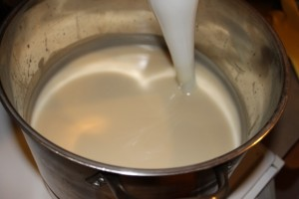
Hand stirred soap can take several hours to achieve "trace," to speed things along use a stick blender. Be sure to run the blender for a few minutes and then let it rest. Their cheap little motors will burn up if they are run continuously. Don't lift the bender above the liquid level, doing so will mix in a bunch of air into your soap. Trace can be achieved in as little as 5-10 minutes using a stick blender, but it can take longer.
- Add 3 oz of any desired essential oils, or any colorants and desired botanicals (like corn meal or oats for scrubbing power) an mix well at this point.

Finishing the Soap
Stir thoroughly, then pour into molds. If the mold does not have a lid, place a piece of butcher paper over top of the soap. This will help prevent soda ash from forming on the soap. Wrap with the towel, and place in an undisturbed dark area for 24 hours. Do not check on it. Leave it alone. After 24 hours remove the towel and let it sit for *another* 12 hours.
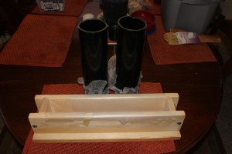
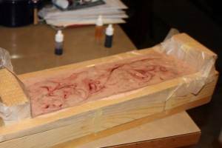
Cutting the Soap
After that point it should be a nice block of soap that you can pop out of the mold. Continue to wear gloves, at this point the soap is still caustic. Once out of the mold you may want to let it firm up for another day before cutting. A mitre box can be used to cut straight bars. It's important to do this fairly early in the game, because if the soap firms up too much it will cut poorly and flake.
Collect the soap trimmings after cutting soap bars and press them together with your hands to make soap balls.
Set the bars some where dark to cure and harden uncovered for 2-6 weeks. Like wine, the longer cold pressed soap sits the better it will be. If you jump the gun and use your soap too soon it may burn you or it may just be too harsh, so its important to let it sit.
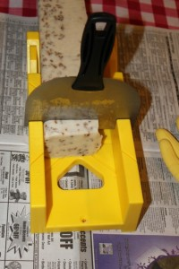
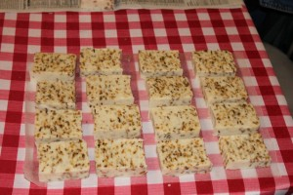
Long Term Emergency Basic Soap Recipe
(recipe credit - Millersoap.com)
This recipe makes about 9 pounds of pure, hard, smooth no-nonsense soap suitable for hand washing, cleaning, laundry or soap flakes, follow this simple recipe:
- 13 oz of lye
- 5 cups cold water
- 6 pounds clean fat (tallow or lard or some combination of both)
Follow the above procedures of making lye water, melting the fats, combining the two, stirring until trace, then adding to a mold. If you are in a cool area and it looks like the fat is starting to set up before the lye can convert it to soap (this is known as a false trace), apply some gentle heat to the bottom of the pot. A false trace may present itself as a really grainy texture. Stirring continuously and briskly for this recipe is better, when it starts to trace for real it will start to stick to the side of your pot.
There is nothing fancy about this recipe, the soap it produces will not lather real well, and may dry your skin - but it will get things clean. You may want to give this a try some day, and/or print the recipe out and keep it on hand just in case.

