How To Make Pitch Glue
Or Mountain Cedar Sap
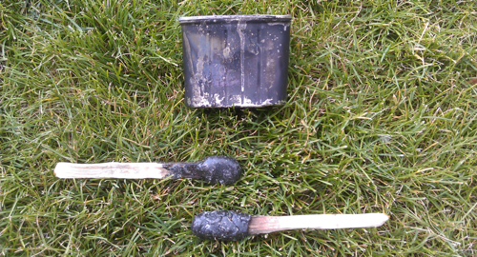

Pine pitch glue is a cool and a pretty effective primitive glue that you could use for a lot of different things in a survival situation. Making pine pitch glue is pretty easy as well. The first thing you will need to do is find a few pine trees with pine pitch oozing out of them. Then get an old metal container and gather up a few ounces of the pine pitch. Then get a good fire going and burn some good fuel sized wood and get a piece of throughly burned charcoal. You want the charcoal to be about 1/3 of the amount of the pine pitch. Crush the charcoal into a fine powder (The charcoal acts as a bonding and hardening agent). Then melt the pine pitch in the metal container (I used an old spam can) over the hot coals. I learned the hard way that trying to do this over open flames isn’t the best because the pine pitch keeps wanting to catch on fire. So good hot coals work best. Let the pine pitch melt down to a good consistent liquid. Remove the metal container from the fire and stir in the charcoal and mix completely. Then allow to cool slightly. Now take 2 sticks about the size of a popsicle stick and stir in the pine pitch glue. Then take the stick out if the pine pitch glue and allow it to cool. Then put it back in and get more glue on the stick and repeat. Eventually you will have a nice lollipop sized glob of pine pitch glue on the end of the stick. Allow that to cool completely and your done!
The pine pitch glue stick will harden nicely and won’t be sticky. When your ready to use it just heat the glob up until it liquifies and slap it on whatever your trying to glue. For best results the item should be dry and clean and be sure to apply the pine pitch glue to both sides. The glue sets hard and isn’t flexible. Pine pitch glue is probably similar in strength to school glue if I had to guess. It is also good and waterproof. You may remember that Noah used pitch to waterproof and construct the Ark in Genesis 6:14. The funny thing is, is that pine pitch glue is still flammable and could still be used as an accelerant in fire starting. Take a look at the short video below to see me go through the whole process.

Jerry Samouce has a recipe that calls for adding some beeswax and gum arabic. He says that adding more beeswax will keep the glue from hardening too much. He added that in ancient times the Israelites would take the sticky pine pitch glue and cover throw sticks with it and throw them at birds. The glue then stuck to the feathers of the bird and kept them from flying off or pulled them out of the sky. Pretty cool trick! He also points out that pine pitch glue is also good for holding leather or cord wrapped handles on spears or walking sticks and can also be used to add strength to whipping on spear points or primitive knives, etc.

How To Find Pine Pitch
Before you can begin making pine pitch glue, you will need to gather up some globular pine pitch. Take a look at the video below to see how I collected some in my backyard.
Click here to watch this video on YouTube if you don’t have Flash: http://www.youtube.com/watch?v=ljF9PMJMjYk

How to Make Pine Pitch Glue
Click here is you don’t have Flash to watch this video on YouTube: http://www.youtube.com/watch?v=GOX86D8aszs

