How To Be Prepared For The Worst Case Scenarios
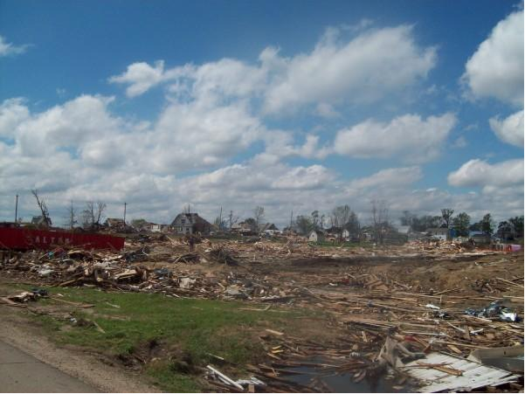
In case of a natural disaster or some other type of earth-shattering event, it is crucial that you have a disaster plan in place for yourself and your family. This includes not only stockpiling food and water and other emergency supplies, but making sure that your important documents are all in a safe spot. You should have an emergency plan to keep everyone as safe as possible and to stick together, no matter what.
Your Emergency Stash
You may be wondering just what type of items you should store in the event of an emergency situation. It is best if you make up a go-bag for each person, as well as for your pets. Items that should be in the go-bag include: emergency cash in small denominations, as well as change; batteries; a flashlight; warm hat, change of clothes, and sturdy shoes; whistle; pocket knife; water and food; first aid supplies and prescription medications; lists of emergency phone numbers and any allergies; and a toothbrush and toothpaste, among other things. For your pet, include items such as: plastic bags, litter box and litter; muzzles for dogs; food and water for one week; medicine; recent photo of each pet, in case you are separated; baby gate or portable fencing; contact information for animal hospitals/veterinary shelters/etc.; and manual can opener and plastic lids, as well as non-spill bowls and several other items.
First Aid Items
When it comes to first aid items, you may want to have a separate kit for easy use. Place your regular prescription medications and medical supplies in it, as well as any over-the-counter medications that would be beneficial. To wash out and treat cuts, you should include some type of cleansing agent and antibiotic towelettes, antibiotic ointment, sterile dressings, and adhesive bandages. Also, burn ointment, scissors, and eye wash solution is important to have.
Food Supply
You will need to have food supplies at hand, along with water. Be sure to store food that is familiar, taking into consideration any dietary restrictions on members of your family. Choose items that are shelf-stable, such as peanut butter, other nut butters, canned goods, dried fruit, cereals, nonfat dry milk and juice. Do not forget to store baby food and formula, as well. Make sure that you label items without expiration dates, with rotation dates. Place loose food items in airtight containers, and store them in a cool, dark place.
Make sure that you gather your disaster supplies, and practice your emergency plan with your family to test it out for any problems. This not only will save you from a major headache, but it could save your lives. Keep the above tips in mind, and you will be well prepared.

