How Scoring Works

How do the Preppers Get Their Survival Score Anyway?
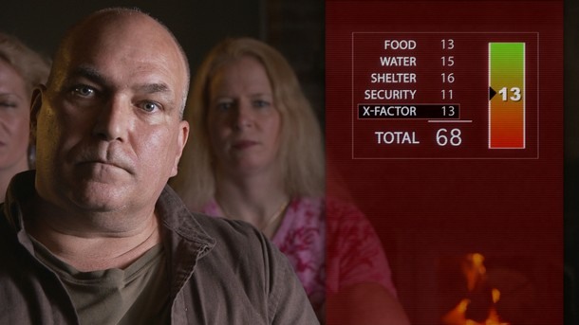
Prepper Report Card (View larger version)
Published Oct. 10, 2012

How Scoring Works Supplemental Information


The Practical Preppers

Meet the experts behind the prepper evaluations.
Ask Practical Preppers consultant David Kobler about the report card that he and colleague Scott Hunt issue to preppers on the program, and he’ll explain that he just rolls a pair of dice to come up with their score. He’s kidding, of course. That might work in Monopoly, but surviving a breakdown of civilization is, well, a little more challenging than most board games. In reality, Kobler reveals, the consultants have developed a fairly elaborate set of criteria for evaluating how well prepared a client is for the worst that could happen. The resulting scoring system takes into account the relative value of each particular item—from a solar-powered well pump to military or medical training—in a dire situation. In addition, it takes into account whether a prepper has adequate backup systems, and other factors—such as the distance of a property from major cities where unrest might break out—that might affect a prepper’s safety and access to necessities.
Here are some of the considerations that go into scores for the major categories of survival preparedness—water, food, shelter, and security—and what Kobler and Hunt call the “X-Factor” category, which includes other atypical attributes that may increase a prepper’s abilty to survive.
Water (maximum of 20 points): To get the optimum 10 points for stored water—the single most critical survival resource—Kobler says a prepper community should have enough water to last for 90 days, if a gallon of water is allotted to each resident per day. (That’s the bare minimum for survival.) Additionally, preppers get a point or two for each resupply source that they have, such as a creek, pond or well, up to five points. “If it’s close to their house, they get the full credit,” Kobler says. “Two miles away, not so much credit.” If a prepper has a well, Kobler will generally give it an additional point if it’s equipped with a method for moving the water—such as a hand pump or a solar-powered pump—that’s not dependent upon the electrical grid. Finally, preppers can earn up to five points for water purification systems. The capacity for boiling water, or good supply of chlorine bleach will earn a single point, while a good-quality ceramic filter may earn three points.
Food (maximum 20 points): Again, the most important preparation is having a lot of stored food on hand. To earn the optimum 10 points, a prepper community needs a year’s supply of food for each resident, based upon a minimum energy allotment of 2,200 calories per day. Additionally, preppers can earn up to five points for having a good resupply plan; each source, such as a large garden or a henhouse full of chickens, will earn a point, with redundancy earning the most points. They also can earn up to five points for having the means to preserve food. A smokehouse, the ability and supplies needed for canning, or even a freezer powered by solar power can earn them points. Again, it takes redundancy to earn the maximum score.
Shelter (maximum 20 points): This category is split into more items, with fewer points awarded for each. Having a remote location far away from city, where unrest is most likely to break out, can earn a prepper up to four points. “30 miles outside a city isn’t going to do you that much good,” Kobler says. “Being in rural Montana would be better.” Living in a small town with a strong sense of community, though, can make up for not being completely isolated. The physical shelter that preppers have can earn them up to four points as well. Having a full-fledged underground bunker or hardened “safe room” will get the optimum score, but at least having a basement is worth two points. Power generation capability can earn a prepper up to four points. Again, redundancy is rewarded; to get all four points, a prepper would need to have some combination of solar power, fuel-powered generators, wind, or hydro-power—or else plenty of stored fuel and a couple of generators, in case one breaks down. It’s much easier to earn the maximum of three points each for heating and cooking, simply by owning a wood cook stove with an oven, and also some sort of backup heat and cooking source available as well. Finally, preppers can earn three points by having a bug-out location where they can flee in the event of an attack or a disaster that destroys their main shelter. Simply having a piece of land merits a point, but to get the max, a shelter with backup supplies of food, water, fuel and medical supplies would be required.
Security (Maximum 20 points): Preppers can earn up to five points for having some sort of relevant experience or training, such as a stint in the military or a survival shooting course. The quality of the experience or training matters, though; a U.S. Army veteran with infantry experience is going to get more points than one who held a desk job. Another five points can be earned for having firearms; a pistol or a shotgun is worth a point or two, but to get the maximum score, a prepper needs serious weaponry, such as a military-style semiautomatic rifle and an ample supply of ammunition. Various types of security enhancements, ranging from fortifications to night-vision equipment, can earn preppers up to five points. Having a security network—such as a group of fellow preppers and a plan for meeting at a rally location in the event of a catastrophe—can earn a prepper up to five points.
X-Factor (Up to 20 points): Some of these items are ones that simply don’t fit into the other categories. Medical preparation is one example; a basic first aid kit earns a point, while having more elaborate emergency equipment can earn up to four points. For communications, a prepper could earn the maximum four points by having ham radio equipment and being skilled in its use, plus a few hand-held radios for local communication and security. Having a bug-out vehicle—ideally, a large truck or utility vehicle with off-road capabilities and plenty of storage space—can earn up to five points. Possessing items that can used for barter with neighbors—ranging from hens that can produce surplus eggs, to extra matches or soap, to commodities such as gold or silver—can earn preppers a maximum of four points. Finally, there’s the “miscellaneous” subcategory, which includes any sort of equipment, training or experience that gives a particular prepper a survival edge. A prepper with extensive wilderness experience or military Special Forces training would earn some points here.
At the end, Practical Preppers assigns a cumulative score, which includes an estimate of how long the subject might be able to survive in the event of a disaster. As Kobler explains, that estimate is more illustrative than a hard number. Even a prepper who gets a relatively low score of 50-60, which indicates a survival time of four to eight months, might hold out for a lot longer, if he or she is experienced at living out in the country and has an ample stored supply of food. And even the prepper with the lowest score is probably far better prepared than the typical person.

