Homestead Shopping Guide
A productive home requires tools and equipment:
Wouldn’t it be nice to know what’s totally worth the purchase and what’s a waste of money?
This guide is a review of all the products we’ve acquired at Tenth Acre Farm throughout our half-decade of homesteading and permaculturing and gardening and cooking from scratch and preserving food.
Click on a category below to browse the product reviews.
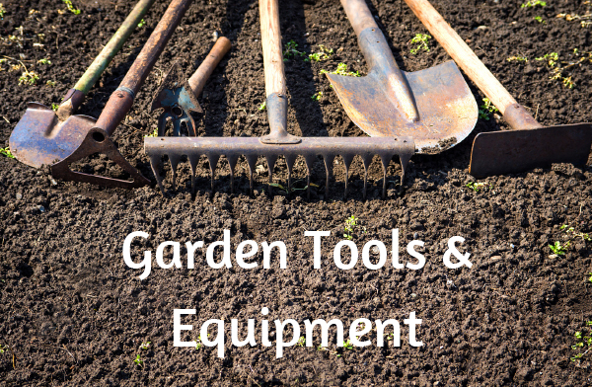

Garden Tools & Equipment
Garden tools and implements have been hit-or-miss for us. Lots of products didn’t do what was advertised, and many items didn’t last the test of time or weathering.
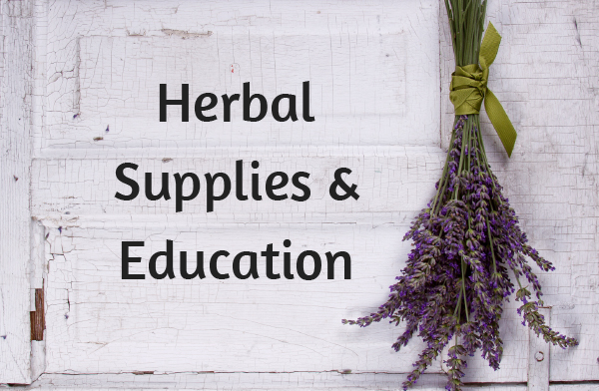

Herbal Supplies & Education
I turn to Mountain Rose Herbs, which is my long-time, most trusted source for high-quality herbs and supplies.
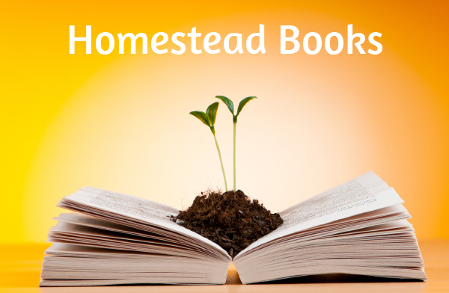

Homestead Books
Here are my 15 most favorite books about community, gardening, homesteading & permaculture.


Kitchen Appliances & Gadgets
As homesteaders, we spend a lot of time in the kitchen processing the garden harvest, cooking real food from scratch, and preserving the excess.
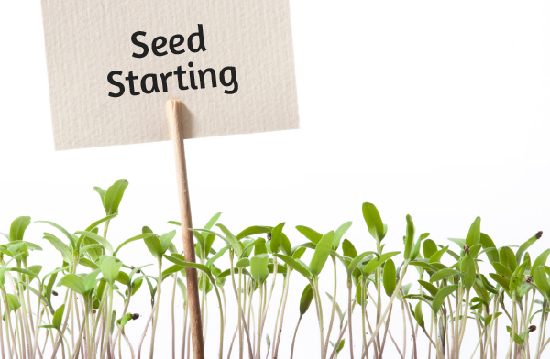

Seed Starting
Indoor seed starting can be an intimidating activity because of all of the materials needed. I hope I’ve demystified seed starting by sharing this list of necessary items.

