Homemade Laundry Soap
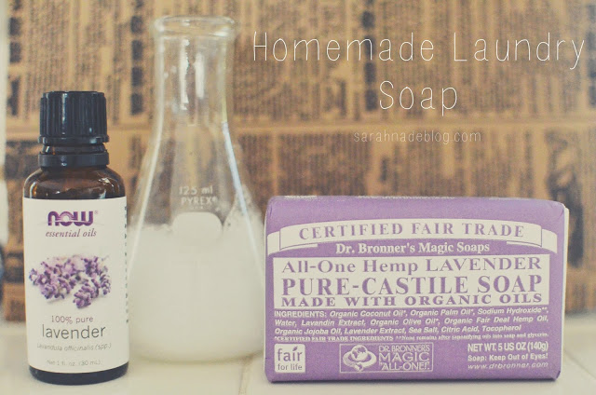
A lot of friends have asked me to post my recipe for homemade detergent here. I am happy to comply, but I want to preface this post by saying that there are one million recipes on the internet and most are variations of the same ingredients. I use the one I use because I have tweaked it to where I like it, the process satisfies me, and it meets the needs of my family. There were many reasons why we started using homemade detergent and a lot of it started when I was cloth diapering my babies and really noticing what was in detergent and how it adversely affected my dipes and my babies bums. There's nothing like having babies to make you start looking at what comes into your home under a microscope. I have read a lot about chemicals used in everyday items and it is staggering. Our government is not strict on regulations in this area so it is up to us to do our homework. That being said, I fully acknowledge the fact that we can't do it all. I am constantly being called out for being fanatical, over crunchy, and even DIRTY (because cloth diapers are gross and natural cleaners can't possibly get things clean) when I fully realize that I can't build a bubble around my family and I can't get rid of every bad thing in the world. However, I'm a nurse and a mom and I do believe it is my job and my calling to promote health and safety. I'm also a Christian and I believe this is our job to care for and respect the earth we have been given. You wouldn't spray paint over a Picasso, right? The thing is, every little bit helps. I don't expect everyone in the world to run out and get cloth diapers and make their own everything and buy a farm (confession: my kids eat mcdonald's on road trips) but I will be really happy if people start paying attention, figuring out what they CAN do, and doing it. Whether it's using reusable shopping bags, switching to cloth napkins, joining a CSA, or just reading and researching chemicals in every day household items and making simple changes, there's at least one thing we all can do. And if each of us does one thing...well, you get the idea.
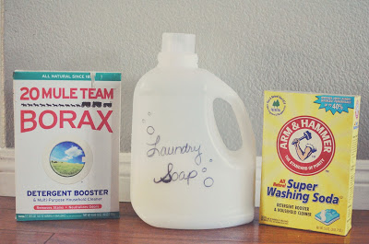

The soap I make has just 4 ingredients (plus water) and takes me about a half hour to make and sits overnight for use the next day and beyond. A lot of the diy detergent recipes out there make 5 gallons of soap, which is awesome except that I live in a teeny house with 5 people and have to use my storage for dog and guinea pig food, not detergent. I use a jug from the last detergent I bought and it works great and lasts a long time. It ends up being about 6 1/2 quarts. I prefer a liquid detergent over powder just because I have a thing about clumps of powder in my wash. It comes from my days as a new wife with a 30 year old washing machine.
Since I am always learning, it has come to my attention that Borax, while not harmful to the environment, may have toxic effect to the human reproductive system. I use it in my recipe, but have more research to do on the subject. It has long been praised as a green cleaner and does work wonderfully for a lot of cleaning jobs but, as always, I want to know more about what that means for the health of my kids.
As for scent, I like lavender. The detergent will have a scent, but won't leave that scent heavily on your clothes. The only time I smell it is when the laundry is running and it smells clean and then I might put a couple of drops of essential oil on a cloth and throw it in the dryer with the load. However, I am with Martha Stewart on the subject. I like to smell like me, not like detergent. As long as my clothes smell fresh and clean and not like little boys' socks, I'm good to go. I use Dr. Bronner's castile soap because it has so few ingredients and is reliable and has a lot of great scents. (Have you watched the documentary about him on Netflix? It's called Dr. Bronner's Magic Soapbox. He was a VERY eccentric guy, but sometimes, the wackiest people do greatest things.) I also add 10-20 drops of whatever essential oil complements the scent of the soap I'm using. I have used peppermint too which is one of my favorite smells for cleanliness. The essential oil is purely optional, but I am currently having a "where have you been all my life" love affair with essential oils.
And then there's the washing soda. It's made by Arm and Hammer and you can get it pretty much anywhere. All of these ingredients are widely available and accessible. If you can't find any of them, there's always Amazon.
Note: a lot of recipes use white vinegar in the wash which is fine, just read this article first. It should be used only in the rinse cycle or it will cancel out the cleaning effects of your castile soap.
OK, so here's what I do.
1 bar Dr. Bronners
10-20 drops of essential oil in whatever scent you like
1/2 cup borax
1/2 cup washing soda
water
Grate the bar of soap. (people complain about this step. I don't get it. It takes a minute, really. You could use Dr. Bronner's liquid soap if grating agitates you, though I haven't tried it). Combine it with 6 cups of water in a saucepan and cook until the soap is melted. Turn to low heat and add the borax and washing soda stirring until the powders are dissolved.
Fill your jug half way with water and then pour in the soap mixture. Slowly fill the jug almost to the top with more water. I say slowly because there will be bubbles if you go too crazy. Put the lid on the jug and give it a good shake or 5 then let it sit over night.
It will be ready to use the next day. I use 1/4 to 1/2 cups in my top loader washing machine depending on what I'm washing. Not so dirty things are fine with 1/4 cup. My boys' laundry gets 1/2 cups and sometimes an extra shake of borax if it's been that kind of week.
Things to note:
The consistency will be like a thin egg drop soup. Some lumps are normal.
You may have to give it a shake sometimes. No biggie.

