Have a Whistle While You Work
As a society, we spend a LOT of time at work. More than half of your waking hours are often spent at work or traveling between work and home. Think about that for a minute. Well, as sad as that is, if you're living that way now, it probably won't change. It's hard to change what you will do with your time, but it's easier to change how you do whatever it is you do. Of course there are sorts of higher philosophical endeavors that we can try to accomplish with our time at work, home, or wherever else...but while we're figuring those out, we've got other things we can do. For example, if you are at work on National Talk Like a Pirate Day, then don't let it go to waste.
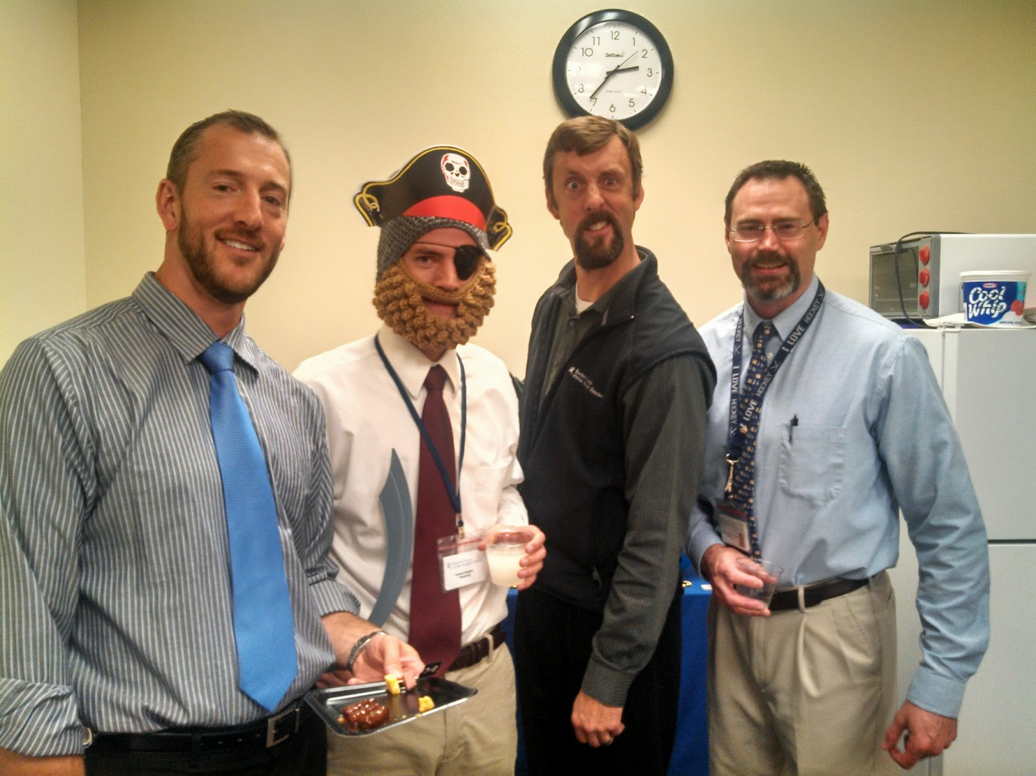
...I'll let you guess which one is me.
I work with a good group, and this really was a Talk Like A Pirate Day party. We even had some citrus-y drinks and some orange slices to fight scurvy, which reminds me to tell you that you need to keep foods that hold the nutritional value you will need in an emergency, especially if you are expending more energy than you normally would.
Last week, we hadan activity that was more preparedness oriented. We participated in the ShakeOut earthquake drill, the largest ever earthquake drill involving over 18.8 million participants worldwide. One of the ladies at work, who ran the drill for us, used the PA system in the building to let us know we were having a fake earthquake. She had some information to read and we all dropped, found cover, and held on, like we were supposed to. All the while, the maintenance guy was flipping the breakers to the lights, so we would have some bursts of light, then darkness. I thought it was a nice touch, even if it was my idea. We learned a lot during this drill. One guy learned how dirty it was under his desk and immediately located a vacuum after the drill. Another realized that he didn't have enough room under his desk to allow him to take cover.
While under a desk, you can do a lot of things. You can change your shoes, take a nap, or put on your earthquake response gear.
One of the things you can think about under your desk is what you would do if there were a real earthquake. I remember doing earthquake drills in elementary school. As I slipped under my desk I would grab a ruler from my desk so I could use it to poke rubble away from my desk. Alright, I was 9, so I didn't have the best plans in the world, but I tried. I also wondered who would come to rescue us and if there really was going to be an earthquake. Now I wonder about some of the same things. Will there really be an earthquake? Will there be a disaster of any sort? Who will come to rescue us if there is? The truth is, there may or may not be a disaster. You will have some upsets in life, so it's good to be prepared, even though you may never face the "big one." It's the little ones that are so annoying. Another truth is that there may not always be someone coming to help, at least not right away. As we grow up, some of us learn that the world doesn't actually revolve around us and that other people live here, too. It's a sad thought, but it's important. What it means is that we have to be ready to take care of ourselves and we should be willing to help others.
While I was at work, I thought about what I would want to have with me at while I am there; things that would be handy in any sort of disaster, or any time. The first things I thought of were the things I always keep with me, then I thought that I should keep an extra set of everything at work, just in case. Most of us have an extra drawer, cabinet, or shelf that we can use to store a box or bag of a few emergency supplies.What are some of the things we could store?
A Whistle- I only put this first because the title of this post revolves around it. A whistle is a great signalling device. One of the many tools that can come in handy.
Water- With all the time you spend at the water cooler, you may think there is a never-ending supply of the stuff, but as vital as water is, it is wise to keep a few bottles packed up.
Food- Other than the fact that the mid-afternoon drag is often remedied by a snack, it's a good idea to keep some food on hand in case of an emergency.

Flashlight- Have a good flashlight and extra batteries. You could also think about glowsticks, since they don't use batteries...but they aren't as bright and they don't last as long. A wind-up flashlight is also a good idea if you don't want to worry about batteries.
First Aid Kit- You can keep a little first aid kit, or something a bit more comprehensive, like the tackle box first aid kit. You could also pack a few things that are meant for more serious injuries.
Tools- Something like a Gerber or Leatherman multi-tool will always be your best friend. Duct tape would also be good.
Phone charger- This is important if you need to contact home. If there is no electricity, consider a charger that you can hand-crank, or even one you can plug into a 12v outlet in your car. If you have a fully charged laptop computer, consider using the USB connection to charge your phone.
Protective Gear- These are things like gloves, face masks, goggles or safety glasses, boots, a hardhat, a coat, or anything else you might want.
Knowledge- Know and understand your office emergency operations plan, including how to safely evacuate the building. Know where you can find a fire extinguisher, first aid kit, AED, ...vending machine, bathroom; you know, the important things.

Always remember to have personal needs met, like prescription medicine, glasses, or whatever else. If you have a medical condition, let others know about it and what to do to help you if you can't help yourself. If you work with someone with a medical condition, learn what you can do to help them.
If you ever find yourself stuck under your desk, make sure you're prepared. Most people are more vulnerable to disasters at work than they are at home, so try to keep ahead of the game. The work kit is usually a lot smaller than a kit you would have at home, like a 72-hour kit, and it will likely have fewer items. Just get a few things you think you could use. Take a minute and sit under your desk to think about it. It only takes a little bit of time, but could save you a lot of trouble down the road. You don't want to get scurvy or anything like that.

