The Survival Husband, Shelly, has been waiting for a sunny day so that he can set up the Harbor Freight solar system that arrived a couple of weeks ago. We did get everything laid out but for now, it looks like we will have to wait a few more weeks before climbing up to the garage roof and hooking up the gear.
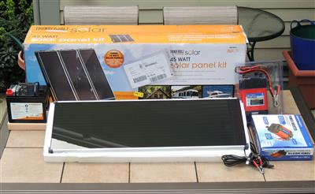
For those of your that are interested, here is a link to the basic solar panel kit.

