Guide To Rendering Fat

Written by Jenny Lamb
Animal fats have many health benefits. Rendering fat is a very simple process that separates animal fat from the meat and other tissue fibers. Once you render the fat, you can use for cooking (lots of health benefits), making soap, as a leather preservative for boots and other leather good, in candles, simple oil lamps and more.
Most folks these days do not render fat because they either don’t know how, or can’t imagine why anyone would want to. As mentioned above, there are many uses for rendered fat, but today, it’s mainly used in cooking and in homemade soap .
Just about any animal fat can be rendered, although some are definitely more desirable than others. Rendered beef or mutton fats is called tallow, which makes excellent, very hard, long-lasting bars of soap. Once pig fat has been cooked down, or rendered, it’s called lard. Chicken fat is soft. Although it can be rendered and used in making soap, the bars will be soft, if it even firms enough to cut bars. Moose fat cooks down similar to tallow, and bear fat resembles lard. All are superior to most commercial vegetable shortenings in cooking, especially if you use the fat from wild game such as moose, or at least from high quality, organic beef.
Before we get to the guide to render fat, let’s look at some of the primary health reasons for wanting to render it. Yes, there are many health benefits to animal fats, but I’ll only list a few here. A book that I would encourage anyone to read is Nourishing Traditions by Sally Fallon. Here are some excerpts from that book:
“Saturated fats play a vital role in the health of our bones. For calcium to be effectively incorporated into the skeletal structure, at least 50 percent of the dietary fats should be saturated.
They lower Lp(a), a substance in the blood that indicates proneness to heart disease.
They protect the liver from alcohol and other toxins, such as Tylenol.
They enhance the immune system.
They are needed for the proper utilization of essential fatty acids. Elongated omega-3 fatty acids are better retained in the tissues when the diet is rich in saturated fats.
The scientific evidence, honestly evaluated, does not support the assertion that “artery-clogging” saturated fats cause heart disease. Actually, evaluation of the fat in artery clogs reveals that only about 26 percent is saturated. The rest is unsaturated, of which more than half is polyunsaturated.
Cholesterol acts as a precursor to vital corticosteroids, hormones that help us deal with stress and protect the body against heart disease and cancer; and to the hormones like androgen, testosterone, estrogen and progesterone.
Cholesterol is a precursor to vitamin D, a vital fat-soluble vitamin needed for healthy bones and nervous system, proper growth, mineral metabolism, muscle tone, insulin production, reproduction, and immune system function.”
Rendering Fat
The guide to rendering fat (below) is part of “Making Lye Soap, by the late John “Pipedreams” Booth’. We’ll publish the remainder of the guide in the January/February issue of Frontier Freedom Online Magazine. We’d like to thank his friends, “Old Judge Creek ”, “Orion ” and Mahachippy for giving us permission to use it here.
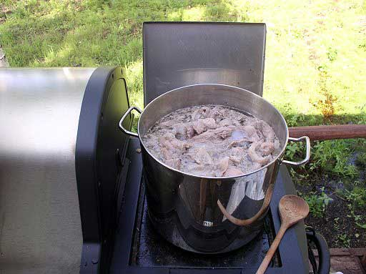
I get beef trimmings from the butcher, chop them into smaller pieces and cook them for a few hours until the fat breaks down. This is not really something you want to do in the house . . . too much stinky stuff and grease in the air.
Removing the solids from the rendered fat . . . 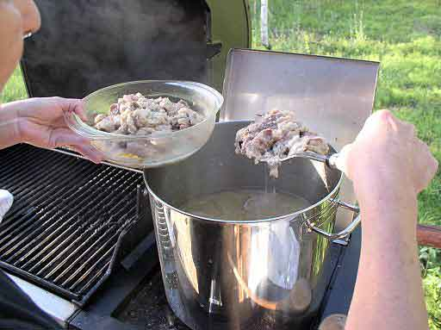
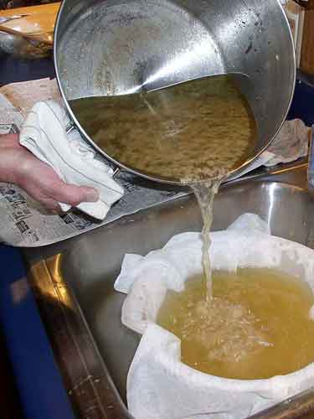
Straining the rendered fat through layers of cheesecloth to remove all debris . . . into a bowl that can be place in the refrigerator.
Straining through cheesecloth. The bowl of rendered fat still has some water in it . . . so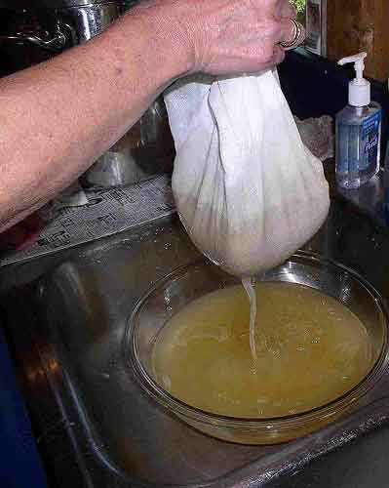 it has to be chilled. I put it in the freezer for a couple of hours before turning it out to separate the fat from the "jelly". The rendered fat should be white at that time.
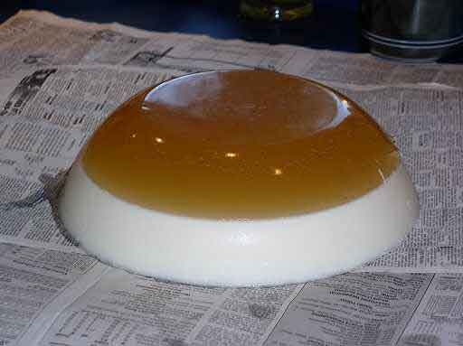
The "jellied" part is just scraped into the trash can. Then I wash off the tallow and cut it up in chunks to put in the freezer for later use if I am not going to make soap right away.
(Editor’s note: That “jellied part” is actually delicious and healthy aspic. It’s great for your bones and cartilage. Use it to make gravy, in soups, stews, chili, spaghetti sauce or in a pot of beans. It will melt as it warms.)

