Getting Started in Beekeeping

by Sarah
This is my 3rd year as a hobby beekeeper, I seriously love being a beekeeper and look forward to heading out to the apiary (technical name for where the beehives are) to see the girls buzzing in and out of their hives. If you look closely at each bee when it returns to the hive you can usually see mounds of pollen clumped to their back legs…sometimes its bright orange or yellow and sometimes its pale almost white. I chose to start beekeeping mostly to help my garden with pollination. I have many fruit trees and a large area planted and loved the idea of greater pollination rates but also “free” honey!
My first step to getting started in beekeeping was to read…I read every book, article and website I could get my hands on. Some of my favorites are Beekeeping for Dummies, www.Beesource.com , The Hive and The Honeybee, and ABC & XYZ of Bee-Culture. These sources will help you understand the basic terminology involved in beekeeping and the cycle of the colony.
The first item that you need is a hive. The most common hive is the Langstroth hive, developed in 1851 by Reverend Lorenzo Lorraine Langstroth.
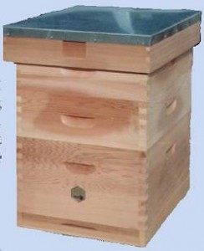
Picture courtesy of E H Thorne (Beehives) Ltd.
The Langstroth hive consists of hive bodies, frames and honey supers, bottom board and cover. The hive body is a deep hive box that placed on the bottom of the stack of boxes. In each of these deeps are 10 frames.
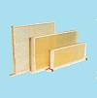
Picture courtesy of E H Thorne (Beehives) Ltd.
Usually a wood or plastic rectangle with wax coated plastic foundation or an all wax foundation held in by wires. This is where the brood will be. The Queen bee will normally stay in these 2 or 3 boxes, laying egg after egg in each of the cells on the frames.
On top of the deeps are the honey “supers”, usually with a depth of 6 5/8”. This is where the worker bees create honey. These boxes get added or removed throughout the year in conjunction with the honey flow. For example, in the spring you add supers and switch them out with empty ones as the bees fill them up. In each of these supers are also frames, same as in the deeps.
Another type of hive used is called a Top Bar Hive. Top Bar Hives consist of a long wooden body with sloped sides and wooden bars along the top. These bars are what the bees attach their comb too, drawing the wax down in the trapezoid shape of the box.
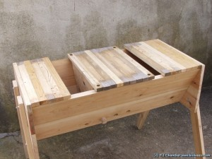
Picture courtesy of BBE-Tech [via http://www.biobees.com
Kenyan Top Bar Hives are usually kept by people interested in more natural beekeeping methods. You can find great info on Top Bar Hives and other natural beekeeping methods at Bush Farms website or at the Bio Bees website.
Other equipment you may need is a jacket/veil combo or bee suit, a smoker, a hive tool, a bee brush and gloves. These items are highly recommended, but not necessary in order to keep bees…they just make it easier. Extra equipment you may also consider is a frame lifting tool, a honey extractor, or a hive carrier. All of these tools are very useful in certain settings and become extremely useful the more hives you have.
Finally, of course, you are going to need bees! There are a couple of different sources you can utilize to stock your hive. Probably the easiest way to get bees is to buy a package.
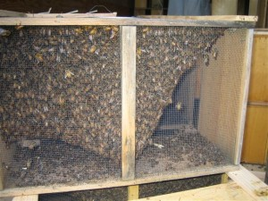
Picture courtesy Tarboo Valley Bees
Packages of bees can be purchased from bee supply companies; they usually run $75-160 and will ship direct to you in the spring. Bee packages sell out quickly so you have to place your order very early, usually late in the previous year. Your package of bees will arrive, with your queen suspended in a cage of her own inside the package. You hang your queen cage in your hive and then dump your package of bees into the hive. The bees will chew through the plug in the queen cage and eventually release her.
Another source for bees is to catch a swarm. When a colony of bees grows too large for its hive it will grow a new queen and the old queen with about half of the colony will head out to look for a new home, this is how bees propagate. These swarms are usually very docile and are eager to find a new home. Give your name and number to local law enforcement and pest control companies and you will most likely get calls for swarms in no time. Catching the swarm is usually pretty easy, as they usually clump on a tree branch. All that’s needed is a cardboard box and some garden clippers. You then hold your cardboard box under the swarm, either clip the branch so it falls into the box or give the branch a good downward shake so the bees fall into the box. If your queen is in the box the bees in the swarm will stay with her, watch the branches around you for small clumps of bees forming to make sure! Close your box up, leaving a small opening for stragglers; give them some time to find their way to their queen. Then, close it up the rest of the way and head home to your hives.
Your first year of beekeeping is mainly going to be a year of observation. Hopefully in your reading you have learned that its best to start with 2 hives so you can compare them. You want to spend the first year looking and identifying. Identify the difference between capped brood and honey. See if you can spot your queen. In the early summer take time to see the difference between drone cells and worker cells. Make sure your colony has plenty of room to expand; its brood chambers are not overstocked and they have plenty of empty combs for honey production.
The benefits of beekeeping are numerous; honey, wax, increased pollination, income potential and many more! In a SHTF scenario being a beekeeper could be a prime source of goods for barter and use. Honey obviously, but beeswax is great for weatherproofing, making candles, making beauty products like lip balm and soap and also has many uses in woodworking and machining. You could also raise bees for others to purchase from you.

