Essential Preppers Guide to Storage
By Suzanne Wiley published on September 20, 2014 in Camping & Survival
Seasoned preppers have storage solutions and creative ways to store food and supplies. Some have root cellars, basements, hidden rooms, storage sheds and even underground bunkers. Those who are just starting out always have questions about storage solutions. There are plenty of people who live in small spaces with little room to store a six-month supply of canned food and bottled water with questions about where to keep that much food. One solution is hiding food storage as pieces of furniture! Here are 10 other storage solutions, suggestions and helpful hints in The Essential Preppers Guide to Storage.
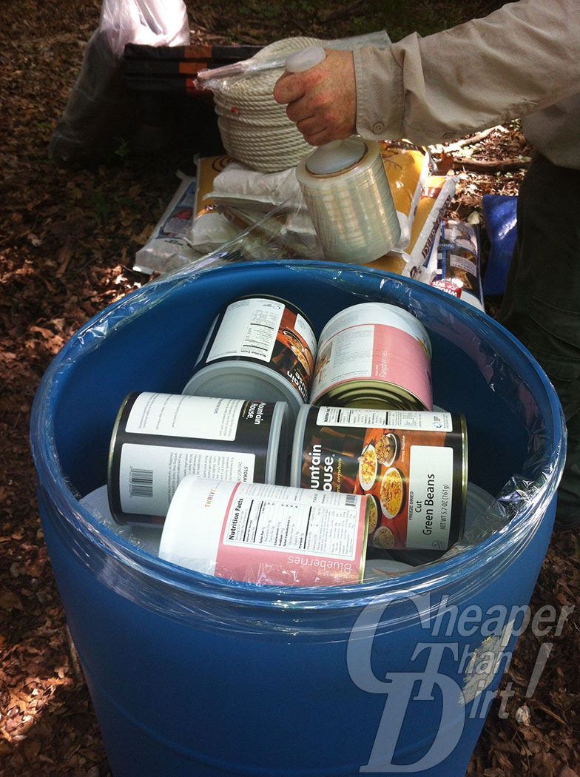
Use only food-grade, open top poly 55-gallon drums.
- How to Properly store #10 cans
- Caching Food
- Emergency Water Sources and Water Storage
- Building a Year’s Supply of Food Storage
- Keeping Your Powder Dry—How to Store Ammunition Using a FoodSaver
- When Filtering Won’t Work: Storing Potable Water
- Quick Prepper Tip: How to Stockpile Canned Goods
- Keep Your Stash Out of the Trash
- Introduction to Stockpiling Non-Perishable Food for Novice Preppers
- MTM Survivor Ammo Can and DIY Desiccant Packs

