Dumpster Diving Tips from a Pro
By Kelly @ Eclectically Vintage

Le Comprehensive Guide to Dumpster Diving, Part “Un”
I love to restore and refurbish furniture.
If I am lucky enough, I even use pieces I find on the side of the road, Craig’s list Free, or my favorite….DUMPSTERS!
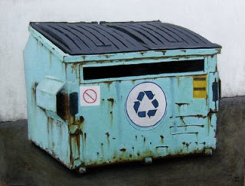
Dumpsters, my friends are not just repositories for stinky garbage and dirty diapers.

They are treasure troves of Architectural Elements, trim, cool moulding, old boards. They are often the secret place people go to get rid of broken chairs, ugly old mirrors, oil Paintings by Aunt Bertha, and any number of salvageable furniture items that may have a scratch, dent, or just be plain ugly. These items end up in various dumpsters because of one reason. People are lazy and don’t want to haul their stuff to the dump and pay the fee.

What is a cheater’s misdeeds can be your gain if you follow these simple rules:
In order to yield the best results from a dumpster dive, you need to keep these rules in mind.
1. Bring work gloves and a flashlight. You might have to dig around a bit for something good, and you don’t know what you might encounter in the process. (sidebar, I have NEVER encountered a live animal, i.e. mouse or rat)
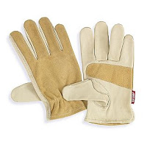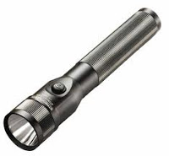
2. Wear old clothes, this goes without saying. (overalls are my personal favorite)
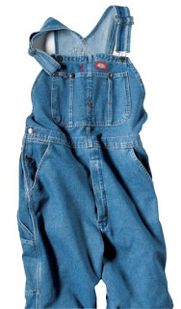
3. Go in the early morning hours, before the garbage trucks come and people start arriving at work for the day. It is slightly embarrassing to explain to people that the nice looking mom in the van is diving for garbage.
4. Bring a large vehicle. My van has seats that fold and stow, and it doubles as a pick up truck. You don’t want to discover an amazing collection of chairs, only to realize they won’t fit in your economy sized car.
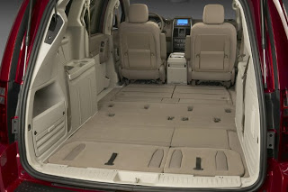

***If you don’t know where to begin a good dumpster dive, here are some suggestions. Take a tour around your city. Stick to the Mom and Pop type stores, independent furniture stores, flooring stores, etc. Don’t bother looking behind strip malls. Dumpsters here are always locked and most stores have industrial sized trash compactors that immediately destroy any goods you would hope to score.
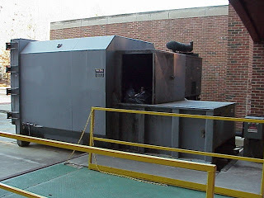
5. Look for smaller groupings of businesses that are not necessarily on busy roads. These dumpsters are not locked. This is where people will go to throw out their almost perfectly good items.
If there is an unlocked dumpster in your town, and it is in a secluded area, trust me, the trash rule breakers know about it and put their goods there. Often, the good stuff is not just in the dumpster, it is often behind, and next to the dumpster.

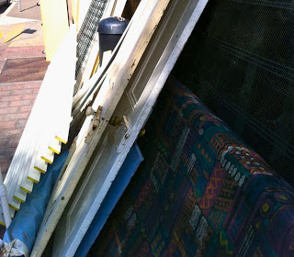
6. When running your daily errands, scan the roads, esp. residential neighborhoods for “reno” dumpsters. I have even trained my children to keep their eyes open for these. Reno dumpsters are gold mines for Architectural Salvaged pieces, old doors, cool mouldings and trims. And, if you are lucky, furniture! I always try to find the owner of the dumpster first before beginning my raid. Just to be on the safe side.
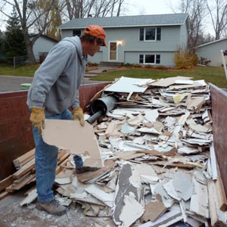
7. Once you have made your plans and pinpointed your dumpster locations, head out early. If you live in a city, I recommend you go with a friend. I live in a small city with a low crime rate. I feel comfortable diving on my own. However, I once encountered a man in a dumpster. I pulled up to a dumpster and heard noises. I paused in my car for a moment, and lo and behold a man popped out and waved at me. When coming upon a dumpster in the dark, I highly recommend giving a quick tap to your car horn to alert anyone that might be there of your presence. I don’t recommend joining them in the dump dive. Just say a few angry words under your breath and come back in a few days.
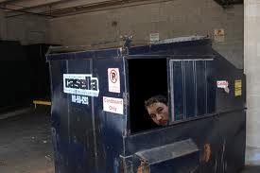

Did I mention Karen turns her finds into fabulousness …
like this privacy screen made from old garage doors.

Check out Karen’s Dumpster Diving Tips Part 2 and Dumpster Diving Tips Part 3 to learn even more tips and tricks.

