Disaster Probability
by Chris Ray
It has been some time since I covered this topic. There are enough new readers that I think it’s time to discuss again. Disaster probability is one of the fundamental building blocks of preparedness. By understanding it, we have a better idea of what our potential threats are and what we should actually be preparing for.
Possible, Plausible and Probable
If you’ve watched any of the prepper shows like Doomsday Preppers, any preparedness related YouTube videos, or read any preparedness forums you’ve no doubt heard people give a long list of events they’re preparing for. While all of these things might be possible, they aren’t all plausible or very probable.
There is also a relationship between how possible something is and the area of its effect. In the image below, you can see that in the inner ring there is a picture of a house, which represents you. The things that are most probable to happen are likely to affect only you or your neighborhood in some instances. This is sometimes called the “pebble in the shoe” effect. If you’re walking with other people and you have a pebble in your shoe, it might really affect you but doesn’t really impact those around you. For an example, when I lost my job it had no effect on my neighbors but had a severe impact on my family.
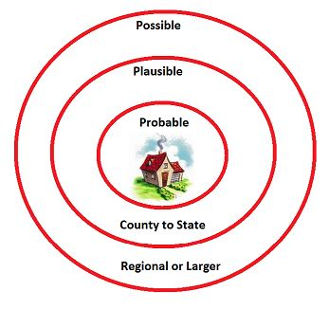
As we move further from the probable ring, there is less of a chance that the events in the outer rings will actually happen. If they do happen, they will have a larger area of impact. The events that fall in the “plausible” ring have a less likely chance of actually happening but if they do, they could impact a county or state. The events in the “possible” ring are possible but unlikely. However, if they do happen, the area of effect is very large and could happen on a regional or national level.
Here are some examples of events in the various rings.
Probable: Affects home, possibly neighborhood
Job loss
House fire
Theft
Neighborhood power outage
Plausible: Affects County to State
Are-wide blackout
Wildfire
Severe weather (tornado, flash flooding, hurricane, etc.)
Flu epidemic
Possible: Affects Regional or Larger
EMP
Pandemic
Economic collapse
Caldera eruption
Applying This to Our Preparedness
I don’t think we should prepare for specific events but, instead, have a general level of preparedness. However, we still must be aware of our greatest threats in the areas in which we live, in case we must take specific precautions. For instance, if I was brand new to preparedness, it makes much more sense for me to prepare for an ice storm or blizzard than it does for me to prepare for an EMP. Sure, an EMP is possible, but in Minnesota, blizzards and ice storms actually happen. Since ice storms often bring power outages with them, it makes more sense for me to make sure I have a means of keeping warm, keeping the food cold and so on. By being prepared for the most probable threats, we eventually become much better prepared for the less likely events that will have a far greater reach.

