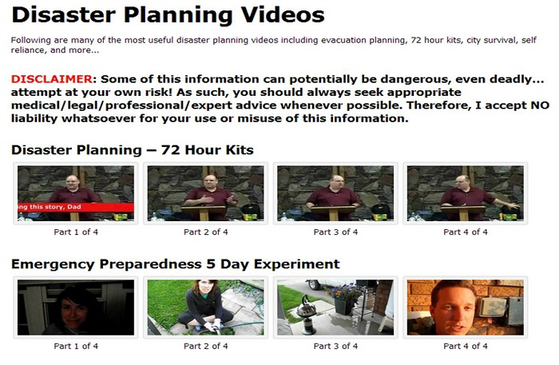

As is obvious from the screenshot above, my disclaimer is the first thing you’ll see. I put this here as a CYA (cover your ass) statement because who knows what you’ll try and no doubt some of the things you’ll watch others do could be hazardous to your health. Remember, safety first!
Moving on, I choose not to include any bookmarks at the top of each page since these sub-pages usually aren’t huge and so it’s easy enough to scroll down and read the headers. For example, this Disaster Planning sub-page includes the following groupings:
- Disaster Planning – 72 Hour Kits
- Emergency Preparedness 5 Day Experiment
- Off-Grid 7 Day Experiment by LDS Prepper
- Evacuation and Disaster Planning
- Moving from Preparedness to Self Reliance
- How to Prepare for Any Disaster
- Argentina Hyperinflation Interview – Real World Experience
- The Most Important Video You’ll Ever See
- Chris Martenson Crash Course
- Dirty Bomb Diaries (Fictional Account of Being Unprepared for an Attack)
- Miscellaneous
Honestly, this page turned into a “catch all” of things I liked but didn’t really fit anywhere else. Regardless, each group of videos usually includes anywhere from a few videos to dozens. Sometimes they could be a series (e.g., part 1, part 2, part 3, etc) as with the 5 Day Experiment, for example, or just a collection of unique videos that explain, teach, or show you how to do something… anything really. Just look at a portion of the Miscellaneous section of the Disaster Planning sub-page to see what I mean:
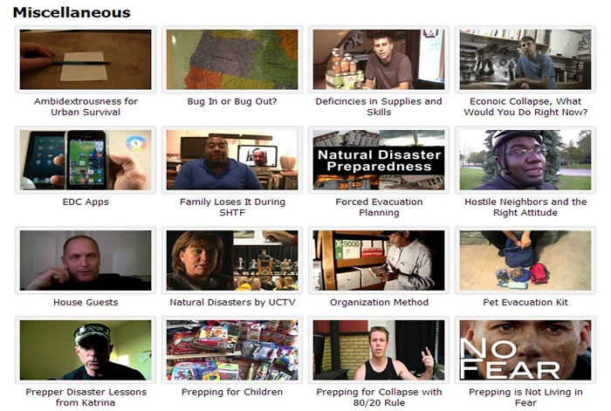

And there’s more that didn’t fit in the screenshot. Anyway, all of the other sub-pages are exactly the same… hundreds upon hundreds of videos that are meant to help you get better prepared, teach you things, and so on.
As with The “How To” Knowledge Base I don’t update these pages much any longer but it’s still an awesome collection of videos for you to reference and come back to time and again. Take some time and peruse The Video Vault when you can. I think you’ll be pleasantly surprised.

