Mobility = Security - Developing A Nomadic Survival Strategy
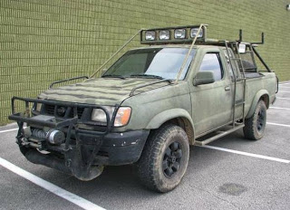
Uncertainty is the secret theme for this day and age. Stability has always meant security for most, but stability can be an illusion. Any number of disaster scenarios may happen that can knock people right off their sofas and onto the road. Think about it: Our society is teetering on the edge of catastrophic possibilities never before seen in all of history. When cities of people are hungry and the suburbs are no longer a safe place to live, it is important to be prepared for anything.

Stability Vs. Mobility
There might come a time when abandoning your home-embodied sense of security is the only logical thing to do. In the event of a major catastrophe, security sources often switch from stability to mobility. Those who are able to adapt to a nomadic lifestyle are often more likely to survive certain disasters. Mobility means transportation, and transportation means finding safety away from central or equally mobile danger. Take the necessary things that can be carried and move along; the rest is a burden that will only slow things down.

Life in a Mobile Home
Obviously, the most efficient and accessible means of transportation is going to be a vehicle. Pickup trucks are better than any other vehicle because they have storage room and can handle rougher terrain that other vehicles cannot. A good idea is to have a truck that runs on something other than gasoline. They can be rigged up to use bio-diesel or straight ethanol, and both have their advantages. Bio-diesel has better mileage and ethanol can easily be made and stored indefinitely. Storing gasoline isn't a bad idea, but it goes inert after about a year. A Bonnyville truck body specialists advises keeping a constant, rotating supply of fuel with lots of extra reserve.
Pickup trucks can carry a lot more, too. Put a camper shell on the back and suddenly there is a safe storage space for supplies and a secure place from the elements. Shutters can be made to rig on the windows so the whole thing is more like a tank.
Good, inexpensive options for this are plywood or sheet metal. Campers will also make decent sleeping areas, for when you make it to a safe location and have shuttered the windows.

Use What You Can Get Away With
There might be situations where you will not have any vehicles to choose from. However, anything with wheels is considered mobile. Wheel barrels, shopping carts or wagons are all viable options. They will take a load off of the back so nobody will be carrying more than they can handle.
The most important thing is preparedness. Stock up on fuel, non-perishable food and supplies and have them ready to go. The most successful survivors are always ready to move along when things get too crazy for comfort.

