DIY Liquid Castile Soap
By Gaye Levy
One of the really fun things I get to do is mess around with DIY cleaners. The inner chemist in me comes out and I play around with different formulas until I get something just right. My bloopers not withstanding, I can usually muddle my way through a recipe and make it work with minor adjustments here and there.
Today I would like to show you how to make your own liquid castile soap for pennies. Well not really pennies but a full quart of liquid castile soap for less than $1.50. Compare that to Dr. Bronner’s at $14 or $15 dollars and you will see why I am excited.
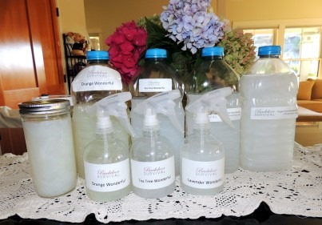

What is Castile Soap?
Castile soap is wonderful stuff. It is made from 100% plant oils – typically olive oil or coconut oil – and it includes no animal fat and no mysterious chemicals. It’s a true soap, not a chemical detergent, making castile soap completely biodegradable and very earth-friendly. This means it is also skin friendly unlike traditional soaps which can be extremely drying.
The big kahuna in castile soaps is Dr. Bronner’s which makes a great product that simply grows on you. It comes in many wonderful fragrances (I like the Rose and the Peppermint) and the liquid version is concentrated so that a little goes a long way. The downside is that at $14 or $15 for 32 ounces, it is expensive. Dr. Bronner’s also makes a bar soap that sells for about $4 to $5 per bar. I will tell you why all of this is important in a moment.

There is another brand of of castile soap that is widely available. Kirk’s Castile Soap has been around since 1839. As far as I am concerned, it is a hidden treasure in that it is priced at less than $1.50 per bar. Here are the ingredients: Coconut Soap, Water, Vegetable Glycerin, Coconut Oil, Natural Fragrance. There is also an unscented version.
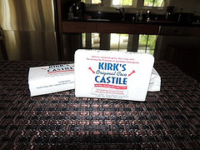
Being a relatively new fan of Dr. Bronner’s, and of course wanting a bottle in every single one of the luscious scents, I realized there had to be a better way. Enter Liquid Castile Soap “Wonderful”.

The Master Recipe
This is so easy it is a wee bit embarrassing but stay with me.
Ingredients:
1 bar of castile soap
2 quarts (8 cups) of boiling water (I used filtered water)
Equipment:
A large kitchen or vegetable grater
A bowl or pot large enough to hold 2 quarts
Directions:
1. Using your kitchen knife, slice and dice the bar of soap into small chunks. Or, if you are so inclined, grate it up with a vegetable grater instead. Castile soap in inherently soft so there is no reason to drag our the food processor or blender to do this.
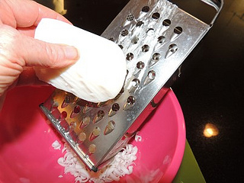
2. Measure out your boiling water and place it your bowl, pot or do as I did and use a large Pyrex measuring cup.
3. Add the chunks or flakes and walk away. Go do something else. Walk the dog. Catch up on Backdoor Survival. Just do something. When you come back in an hour or so, most if not all of the soap will be dissolved into a nice concentrated liquid. At this point, transfer your liquid castile soap to some mason jars, a squirt bottle or other container and you are ready to go.
Notes:
Within 24 hours, my batches of liquid soap turned gel-like and semi-solid. A quick run under hot water brought them back to liquid form. In a way, this makes sense because coconut oil does not liquefy until it reaches 76 degrees. Given the tremendous cost savings, this was something I could deal with.
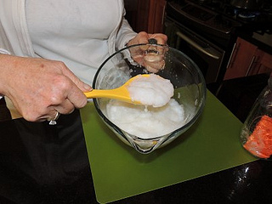
I tried both cutting the bar soap into chunks with a knife and grating it with my vegetable grater. I felt that the vegetable grater resulted in a better end product. I believe the soap dissolved more quickly and for some reason the resulting liquid was smoother. I don’t know – hard to describe.
As will all castile soaps, there will not be an abundant amount of sudsing. The suds in most soaps comes from sodium lauryl sulfates, a known irritant that does nothing but make suds. Be aware that you may get a few bubbles with this, but not many. Odd as it seems, it still clean very well and does not feel at all oily even though it is an oil based soap.
Those of you familiar with my Dirt Cheap Soft Soap will notice some similarities although there is no added glycerin in liquid Castile Soap Wonderful. Castile Soap Wonderful has a completely different texture plus it is highly concentrated.

Castile Soap Wonderful
This is the fun part. With a simple dilution and the addition of essential oils, I was able to make up multi-purpose household cleaners just like I do with Dr. Bronner’s. The addition of 1/8 to 1/4 teaspoon of essential oils results in such a useful cleaner that I started calling them “You Name It” Wonderful. I now have Tea Tree Wonderful, Lavender Wonderful, Orange Wonderful and Peppermint Wonderful. This is so fun.
After much trial and error, I came up with the following dilution:
3 TBL Liquid Castile Soap
1 quart (4 cups) filtered water
1/8 to 1/4 TSP Essential Oils
Shake everything together in a repurposed bottle or juice jug and use your premade brew to fill individual spray bottles (These spray bottles I purchased at Amazon work great.)

How to Use your Liquid Castile Soap
For the past three weeks I have been keeping a list of how I use my various castile soap wonderfuls. Amazingly, I have I found that a single dilution, poured into a spray bottle, does it all. So far I have not found any reason to use the soap undiluted or in a stronger or weaker dilution.
Household Cleaner: Depending on your mood, pick your favorite version and spray away. I use in on my black granite counters, wood floors, stainless appliances, everything. The Orange Wonderful seems to work best on really greasy things which makes sense because orange essential oil is made from orange peels and we all know what a good solvent orange can be. (By the way, a drop or two of orange essential oil neat – right out of the bottle – works just as good as petroleum based goo gone.)
Window and Mirror Cleaner: For some reason, my castile soap wonderful cleans windows and glass just fine and without leaving a residue while Dr. Bonner’s tended to streak on me.
Washington Hands: Instead of using soap in the pump bottle, spray your hands with a generous amount of Tea Tree Wonderful, rub your hands together and rinse. The tea tree serves as an effective anti-bacterial and sanitizer.
Body wash: Spray your favorite scented wonderful on a washcloth and give yourself a “sponge” type bath. (Does anyone even use that term anymore?) Anyway, for extra moisture, you could add a bit of vitamin E oil or even olive oil to your spray bottle – just make sure you mark the bottle “body wash”. While you are at it, add a few extra drops of essential oil so you smell heavenly.
Facial cleaner/facial wipes: Spray your Lavender Wonderful on to a microfiber cloth or plain old washcloth and use it to clean off every bit of makeup, even mascara. Your face will feel nice and soft afterward.
Toothpaste: I kid you not. Spray some Peppermint (or other) Wonderful onto a toothbrush and brush away. I do prefer regular toothpaste but if there were non available, this would work just fine.
Eyeglass Cleaner: Castile wonderful will make your eyeglasses sparkle. Because you are cleaning with soap, you do not have to worry about ruining your Transitions lenses (never use a vinegar solution on them).
Clean fruits and veggies: Spay and wipe to remove gems and pesticides from non-organic produce.
Doggie Shampoo: I used a combination of Peppermint and Lavender Wonderful for Tucker’s bath this weekend. After wetting him down, I got out the spray bottle and sprayed away. Are you detecting a common theme here?
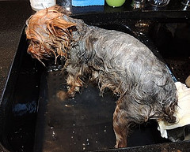
Clean Your Shoes: Spray and scrub. My 5 year old Clarks sandals came out looking nice and fresh and ready for another summer.
Clean Makeup Brushes: For those of you that wear makeup, spray your brushes every few days then wipe them clean with a microfiber cloth. The bristles stay nice and soft and smell great. No more built up makeup goo.
Dusting Spray: I have been using this spray for three weeks on my wood furniture and most notably my desk which get very grimy. I have also used it on my iPad and laptop screens and almost anything else you can think of.
One thing I did not try (but want to) is making a homemade soft scrub by combining 1 tablespoon liquid Castile soap and 1/3 cup baking soda in to a scrubbing paste. Just thinking about it, it seems to me I could sprinkle some baking soda on my crusty pan or gunky sink and just spray and scrub without making the paste. Even though it only costs pennies, using an undiluted tablespoon seems wasteful. Again, I have not tested this.
I am sure there are lots and lots of other uses – these are just the ones I have tried.

Magic versus Wonderful
In the past I have referred to “Rose Magic” and “Peppermint Magic”. The only difference between Peppermint (or other) Magic and Peppermint (or other) Wonderful is that “Magic” uses Dr. Bronner’s and “Wonderful” uses the DIY liquid soap make with Kirk’s. Same dilution, no difference.

Credit Where Credit Is Due
There are lots of websites that have similar instructions but as you will find, everyone has their own dilution and their own way of doing things. This is my way and it works for me so I have a high degree of confidence that it will work for you too.

The Final Word
Shop around and you might find a deal on Kirk’s bar soap. I initially picked some up at Safeway when I was in the Seattle area but by far, the cheapest place I found online was at drugstore.com. I paid $3.79 for 3 bars and since I also purchased some other products, shipping was free. I am told that some Wal-marts carry Kirk’s at a similar price so it is worth checking locally.
I have now stocked up on Kirk’s and will put some in deep storage. At this price, having the ability to make my own scented liquid castile soap any time I want to sounds like a good proposition. Not only that, I am convinced that being armed with vinegar, castile soap, spray bottles and microfiber cloths, I can clean anything!

