DIY Dollar Store Sewing Kit
By Shelle

Make a portable sewing kit for under $10
The ability to create and repair clothing has been a great benefit to me over the years. I had the foresight to learn to sew when I want a teenager. It was offered in a home-ec class I took. Even though I don’t sew regularly, I still keep up on my skills and I like to have a simple sewing kit on hand for emergencies. Sewing skills are an important part of your preps.
This is a completely portable kit (unlike the main sewing kit you may have at home), because you never know when you will lose an “essential” button or have a rip in the “wrong” place.
Make your own Dollar Store Sewing Kit with a few simple but essential items. Your DIY Sewing Kit should enable you to:
- -repair clothing in a pinch
- -hem a skirt or pair of pants
- -sew on a button
- -fix a ripped tarp or tent
- -mend sleeping bags or backpacks
- -maybe even stitch up a wound
Your DIY Dollar Store Sewing Kit should be kept small and it may contain items that you might not think about packing in a 72-hour kit, prepared purse, or car kit. For instance, instead of only storing regular sewing thread, add dental floss and fishing line. This gives you the ability to use your kit for more than just sewing.

What container should you use for your kit?
As I see it there are a couple options. The first is a handy quart size wide mouth Mason Jar. It’s portable and doesn’t take up much space. This may be the best choice is you are going to store your small sewing kit in the car trunk or your office desk. It can also double as a handy drinking vessel or water collection container. Canning jars are made of glass, as you know, so be careful and think about where you want to take it.
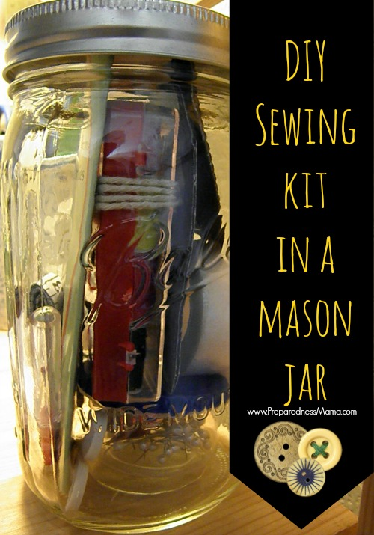
I was able to get this rugged 7 x 5 inch Sterlite container at the dollar store for $1. It is the perfect size for the items I purchased.
You can even use a plastic bag with a zipper. This is going to lay flat in your emergency kit.
No matter which option you choose, make sure it is waterproof, easy to store, and easy to carry.
Here are a few things that you may want to add to your DIY dollar store sewing kit:
- *Buttons – several sizes
- *A packet of straight needles of various size
- *A thimble to push needles through heavy tarps or jeans
- *Small scissors
- *Several colors and thicknesses of thread
- *A needle threader, which comes with many packages of assorted sewing needles. Learn how to use one here
- *Straight pins
- *Seam ripper
- *Cloth measuring tape
- *18 inches of heavy string (or a shoestring)
- *Self cutting grommets for tarps and tents
- *Fishing line is a lot stronger than thread and can be used for sewing wounds
- *Dental floss is strong and also has many uses
- *18 inches of Duct Tape (see this article at The Art of Manliness to see how to make it small and easily accessible)
- *Thick rubber, plastic and/or canvas patches

These are the items I purchased (and their cost) for my DIY dollar store sewing kit. All for under $10
The foundation of my kit is this little 5 piece gem. You can stop here and purchase a dollar store sewing kit for $1, but making a DIY kit with additional items will be of more use in an emergency.
– 10 colors of thread, buttons, small scissors, thimble, straight needles and a needle threader in a small kit($1) – 50 straight pins ($1) – seam ripper and cloth measuring tape combined in one package ($1) – a roll of fabric bond ($1) – 18 inches of duct tape from a roll I already had ($.50) – 18 inches of heavy string from around the house (free) – heavy duty household needles (2.50) – dental floss ($1) = $8.00

