D.I.Y “Mom’s Super Laundry Sauce”

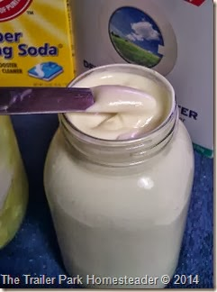
So for a while now, I had been seeing these posts all over Facebook for this “Mom’s Super Laundry Sauce” Recipe From Liss Burnell at Budget101.com. After reading a lot of the reviews about how amazing this stuff is, I thought I would make some to try out for myself using the “No-Cook” version of the recipe. I documented the process with pictures for future reference and here is what I did:

First I had my daughter Moo, dice up one bar of Fels-Naptha which is a laundry & stain remover bar that is made by Purex and can be found in the laundry isle of most stores. You split the one bar between two quart size mason jars.
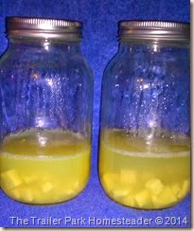
After we split the bar of soap between the two jars, we added 1 1/2 cups of hot distilled water (we have very hard water) that I ran through our coffee maker, into each jar. We let the jars then sit overnight.
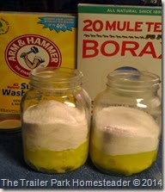
The next day the liquid will be a gel like product, take a butter knife and break up the gel! Next, you add in one cup of mule team borax and one cup of washing soda.
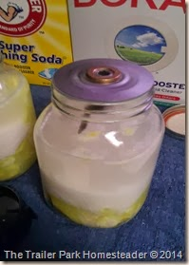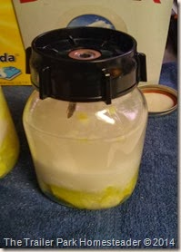
Next, make sure your jar tops are dry and clean then put your blender seal on the jar and insert your blade. Then just screw the bottom part on and then blend together on the “whip” setting until it comes out with a mayonnaise like texture.
Word of Advice:
Make sure after you mix the first jar of soap, you rinse and DRY your seal and blade BEFORE putting it onto the second jar to mix. I did not, and I broke my seal !!!
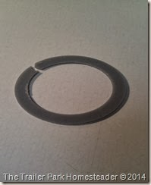
Since I broke my seal and did not have a spare, I had to improvise to complete my mixing! I hot glued the blade onto the jar top and mixed it….it worked good, but afterwards I ordered new seals!
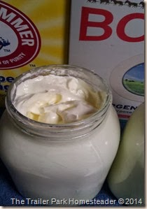
This was the final product, creamy with a bit of a gritty texture.
The Real Test:
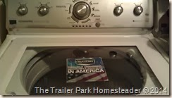
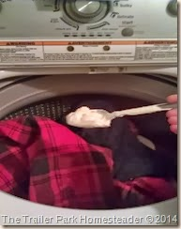
I was worried that this product would not work well with my brand of washer because it is a H.E. and is a low water washer, meaning that it has a sensor in it the detects the amount of clothing in the washer and only fills it to cover the clothes to a certain point. It does not fill the whole tub with water, ever. Because of this, I can not use powered laundry soap because it never dissolves completely and comes out on the clothing.
Surprisingly….This Product Worked Well !
You simply add one tablespoon into each load, makes enough for 128 loads!
The clothes came out clean, smelling good, and there was no extra product left in my washer..what a relief!
I would definitely recommend this product to everyone to try!
Liss Burnell has a recipe for either a cooked version or a no-cook version.
Here is the link to both:
Cook Version -
http://www.budget101.com/myo-household-items/whipped-cream-super-laundry-soap-3993.html
No-Cook Version-
http://www.budget101.com/myo-household-items/5-minute-no-cook-laundry-detergent-recipe-4075.html

