Condition Factor Monitoring

I remember back in the 80′s when the military had “DEFCON” levels. DEFCON indicated the level of readiness the military was at. DEFCON 5 was lowest while DEFCON 1 was “get in your bunker”. I decided to create and formulate my own system which to summarize current general levels of threat.
This has not been an easy task. The Condition Factor Monitoring (CFM) takes into account numerous indicators such as gas prices, inflation, food prices, unemployment rates, Federal deficits, significant world events, domestic terrorism, and a multitude of government and corporate indicators related to privacy invasion and “people control”. It is a complicated algorithm.
Here is the breakdown of the Level’s:
Condition 1 (50-59)
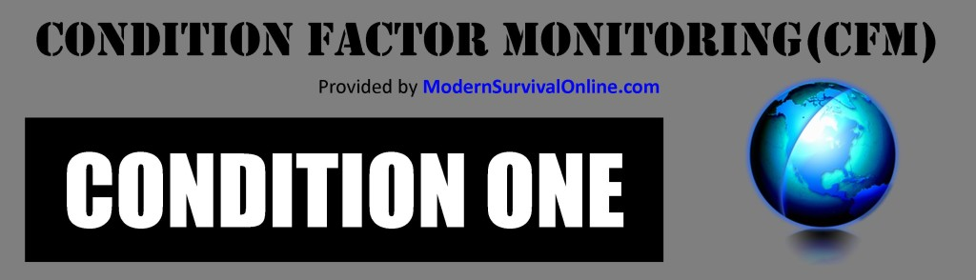
Condition One means peace and harmony throughout much of the world. Middle East would be totally at peace, unemployment would be below 3%, salaries going way up, crime way down, and Congress is working together for the benefit of all citizens.
Condition 2 (60-69)
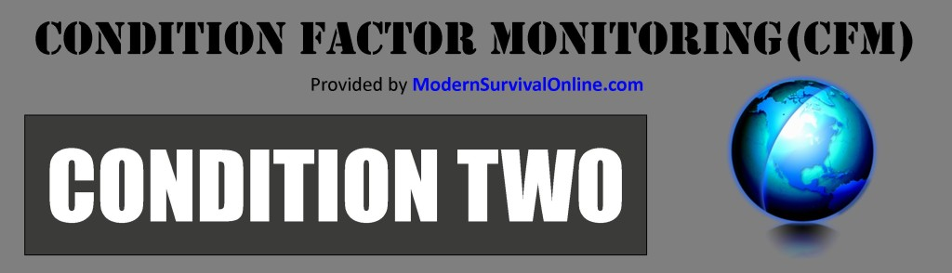
Condition Two represents some unsettling activity in various parts of the word. Middle East would be stressful – but at peace for the most part. Unemployment would be below 5%, salaries are increasing at least at the rate of inflation which is minimal. Government is acting as positive representatives for the people in making decisions however government deficits may be growing. Overall – things are good for most people.
Condition 3 (70-79)
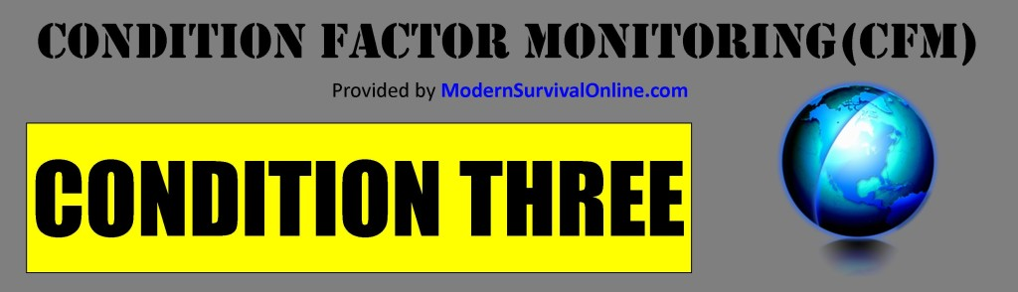
Condition Three represents a stepped, negative trend towards peace in the world. The Middle East would be at high tension with skirmishes breaking out periodically as well as political unrest in some countries. Terrorism – domestic as well as international is on the rise and ever present. Unemployment would likely be above 6% but below 10% (government reported numbers). The economy is stagnant and wages are steady or slightly decreasing. Real inflation is on the rise. Government intrusion into peoples lives is on the increase while the civilian population overall has been consumed with a feeling of uncertainty. Overall – things are on a decline and people need to be preparing.
Condition 4 (80-89)
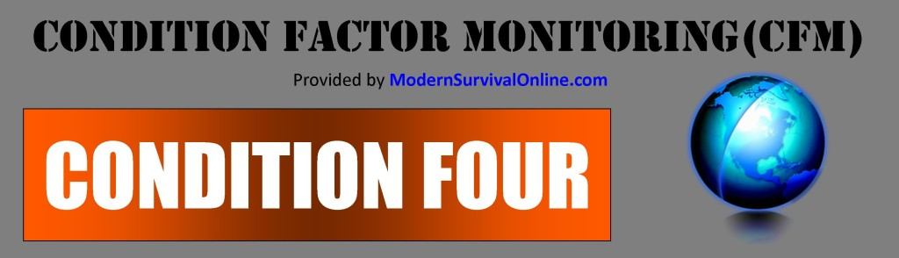
Condition Four represents a marked increase in governmental corruption and control over its people. The economy will be in serious decline although the government and media will under-report the severity. Reported unemployment is nearing 10%+. Various areas of the world will be in turmoil due to civil wars, economic problems, religious conflict, and governmental changes. People will be making less money while essentials will cost much more. Potential conflict with other countries increases the risk of the United States getting involves in military action abroad. Societal conflict over race, morals, economics, immigration, and other issues may create division within the population. Crime rates may be on the rise. Potential “False Flags” will provide an environment which the American people allow laws to pass that they otherwise wouldn’t. Prepare now while you still can.
Condition 5 (90 – 100)
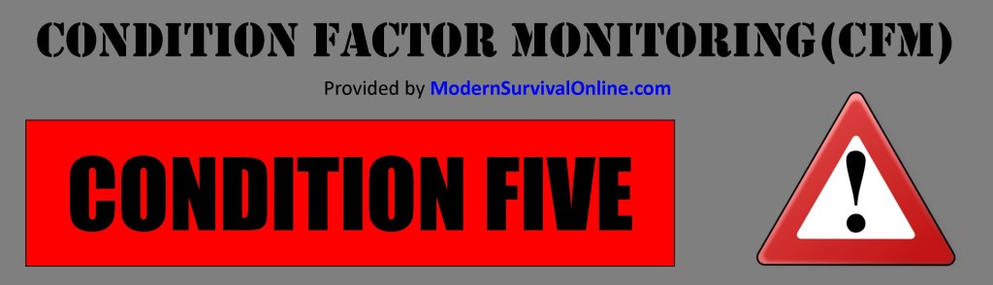
DANGER! DANGER! Condition Five brings on dangerous conditions for most of America. Conditions in many areas of the world may be represented by war, civil disturbance, rioting, and economic turmoil. A combination of high unemployment, societal breakdown, overpowering governmental intrusion, and elevated rates of crime via organized criminal groups mark a dangerous situation for much of the United States. High inflation and potentially domestic and/or international terrorism may be frequent. Many individual freedoms have been taken away. Food and gas shortages ($10+ per gallon) are likely characteristics at CONDITION LEVEL FIVE. Unemployment approaching record levels. Bank closures not uncommon and many businesses closing.
A negative trend in relation to most aspects of peoples lives is irreversible. People are struggling to find ways to provide food for their families, put gas in their vehicles, and a roof over their heads. It is not getting any better.
Right around the corner is the end of the world as people know it.

