Complete List of SHTF Prepper Lingo (Terms, Abbreviations, Acronyms)

Especially for newbie but also veteran preppers alike, the multitude of jargon used in the prepper community can be confusing.
For your easy reference, (and my own), I decided to create what I’m proud to say should be one of the most comprehensive lists of the most commonly used terms, abbreviations, and acronyms used in the SHTF prepper community.
If you think any terms are missing that should be added, please comment on this post and I will add them.
72-hour kit
This is a kit that contains useful materials that would enable you survive an emergency situation for 72 hours, that is, 3 days. From this definition, we understand that ’72-hour kit’ is a vague and relative concept and could really include anything depending on the situation.
ALICE pack
ALICE is an acronym for All-purpose Lightweight Individual Carrying Equipment and is a pack system invented by the military to create efficient carrying of items so that carrying materials is only convenient but you are enabled to effectively carry everything you could possibly need on the go.
AR-15 Cleaning
The AR-15 is the civilian version of the M-16 or M-4.’ AR’ in this context does not stand for “automatic rifle” or “assault rifle” contrary to popular conception; It stands for “Armalite rifle”, which is the name of the first company that started manufacturing it in 50s. Today, AR-15 is common rifle, even used in sporting events.
Bugging Out
This means to move away from a current position and move to safer location. It is a military term which directly means to retreat, or more specifically, to flee in panic.
Bugging in
Bugging in means to stay at a specific current location until it is safer to move out. Although, it depends on the kind of SHTF situation, when in crises, bugging in, alongside bugging out, is among the first actions preppers consider.
B.O.B
BOB is acronym for Bug out Bag. Bug out bag refers to a bag which could be a backpack or a duffle bag or whatever style as it is not the bag itself that is important in this context but its content. It mainly consists of emergency materials that you can use to survive during or after a disaster. If it comes with a time frame of 3 days, then it is referred to as a 72-hour kit, however, B.O.B tends to contain materials that can keep you going indefinitely. These materials include a first aid kit, ammos, cash, water, water filter, sleeping bags, emergency medicine, clothing, means of identification, the lists go on. Also, BOB tends to be a relative concept and could involve different things for different people.
B.O.L
B.O.L is acronym that means Bug out Location. This includes a place other than a home in which the survivalist can retreat in terms of danger or crises. These retreats are supposed to be very dependent and sufficient so that you are not stranded while you secure yourself from danger. Normally, it is located in rural areas with scanty population as BOL involves having a safe place to retreat to hide from the dangers that is certain to plague urban areas.
B.O.V
B.O.V stands for Bugged out Vehicle. It is a car that the prepper has that is already packed and ready in case of emergency evacuations. Technically, B.O.V is the wheeled variation of the BOB with larger space to pack in more emergency materials like food and supplies. SUV’s are mostly preferred for this task as they have great road abilities.
Carrington Event
In 1959, there was a geomagnetic storm that hit earth’s magnetosphere. Numerous sun spot was first noticed in August 28 to September 2, 1959 and Richard Carrington and Richard Hodgson, who were amateur astronomers then, noticed the first solar flare. It was one of the largest geomagnetic storms to hit earth as Aurorae, that is colored polar lights, which is a result of solar wind disturbing the earth’s magnetosphere, was seen everywhere, making night become as bright as day.
It was referred to as Carrington Event and Preppers use this term to refer, generally, to solar storm events. Although, little effect was recorded at the time of the event, however, subsequent geomagnetic storms have revealed that this disturbance on our magnetosphere can cause huge impact on our civilizations, especially in the aspect of terrestrial communications, telecommunications to be precise. Also there would be drastic effects as these disturbances would also affect electricity, capable of sending an entire area into darkness for several hours.

C.M.E
C.M.E stands for Coronal Mass Ejection. It is one of the harbingers of Carrington events, including flares and aurorae. C.M.E is observed by coronagraph and is a huge surge of magnetic energy generated from the corona of the sun and is being released into the solar wind.
E.M.P
E.M.P which stands for Electromagnetic Pulse can be a natural or artificial occurrence. It usually occurs in a radiated, electric or magnetic field and is usually hazardous to electronic equipment and other infrastructure depending on the magnitude of the energy.
E.D.C
This is automatically translated to “Everyday carry”. It refers to the things a person carries on them on an everyday basis. E.D.C included items that you carry on you at all times, or very frequently. Depending on the individual, it might include anything from a fire arm to stuff as basic as a cell phone, or even a handkerchief.
Faraday Case
This refers to a metal casing that protects a person’s electronics from an E.M.P. It is formed from conductive materials and used to block electric fields.
F.I.F.O
This is an acronym that stands for First in; first out. It is a method used in food storage and food rotation and it involves serving out items that are first stored before serving out the recent ones.
Genny
This is slang for generator.
G.M.O
Genetically Modified Organism (GMO). This involves the use of genetic altering techniques to alter the genetic mutation of organism. This is done in organic food to improve certain qualities like size and taste.
GOOD
Get out of Dodge (GOOD) is a term that refers to the process of getting out of a bad or/and dangerous situation.

H.E.M.P
This refers to High Altitude Electromagnetic Pulse. It is an electromagnetic field that is caused by the detonation of a nuclear weapon at a high altitude which results in a gamma radiation that reacts with the atmosphere. It does not have an effect on human beings but it does damage on electronic equipment and computer circuits. Depending on the altitude and the power of the nuclear surge, HEMP can reach several miles as they travel swiftly through metallic conductors and cause more devastating effects that lightning.
Ham Radio
A term used to refer to amateur radio operators. It is a term used to refer to people who use the equipment provided by amateur radio station to create a two-way communication with other people in other amateur radio stations on radio frequencies that is being assigned to the amateur radio service.
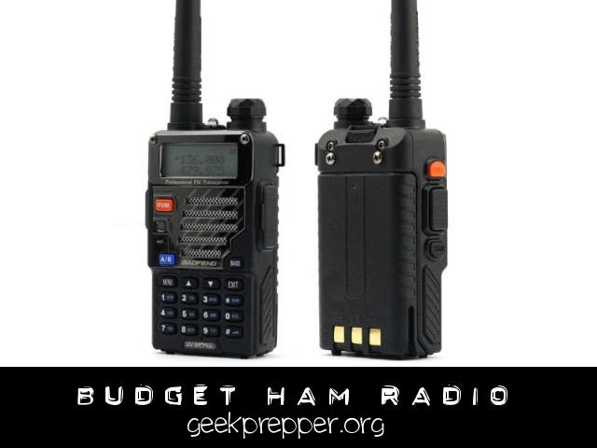
I.F.A.K
This is an acronym that stands for Individual First aid Kit. They include medical supplies that help prevent preventable deaths or treat deep injuries. Examples of the contents of IFAK are: Personal Protective Equipment like hand sanitizers, nitrile gloves and cleansing wipes; Band aids; Sterile roll gauze; Water proof medical tape; glue, clotting agent; Cravats, etc.
I.N.C.H
This is an acronym that represents a short message code for your family and/or friends in case you have to Bug out. It means “I’m never coming Home’’.
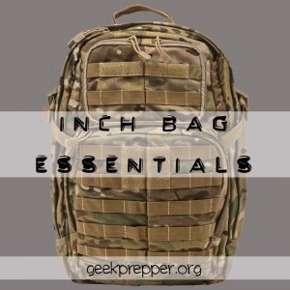J.I.C
This is an Acronym for “Just in case”.
Junk Silver
This is a term used in referring to silver coins in circulation in the US around 1964 or earlier. The coins are 90% silver. It does not have any collectible or numistic value apart from the value of the silver contained in it.
M.A.G
M.A.G is an acronym for Mutual Aid Group which consists of people who meet to discuss ideas, plans and strategies on emergencies in that particular area.
Multi Tool
This is a tool that combines the functions of several other tools and is usually powered by batteries. The tool integrates the function of sawing, sanding, cutting, polishing, scraping, etc.
M.R.E
This is an acronym that stands for Meal, Ready-to-Eat. It is a self-contained ratio n with lightweight packaging that is meant for the individual and is served when organized food is unavailable.

OPSEC
OPSEC, like M.R.E originates from the US military. It is the abbreviation for Operational Security. Its general idea is to keep whatever you are doing or any other vital information as far away as possible from the enemy. The basic purpose is to deprive the enemy of any helpful data.
Prep
Prep is a shortened version of the word “prepare”.
Prepper
This is a term to describe an individual, who is always prepared. A survivalist.
Peak Oil
Peak Oil is term used to describe a period in which the peak of the extraction of oil is reached, and what follows is a steady decline, until there is no more oil to be consumed. It follows a basic path; an observed rise in the aggregate production rate of oil, and then there is the period where the rise gradually climbs to a peak period, and after that there is a gradual fall into depletion.
P.E.R.K
This is an acronym for Personal Emergency relocation kit. This is a variant of a BOB that is used for an emergency relocation, maybe a retreat from imminent danger. Although preppers usually carry about E.D.C which includes things needed in day to day activities, bugged out Bags (See BOB above), and Personal Survival Kit (See PSK below), PERK is set of items that are needed for an emergency retreat.
P.S.K
This is an acronym that means Personal Survival Kit. It involves items needed to survive in harsh conditions. The kit consists of lists of signaling items which includes rescue reflectors, emergency whistles, Rescue laser flare, and emergency devices in which a pocket chainsaw, survival candle, fishing kits, sewing kits, among other things are all included. Basically, there are two types of P.S.K: Military or tactic P.S.K and Civilian P.S.K. While not perfectly complete, I personally recommend the Lifeline 26-Piece Ultralight Survival Kit as it is a great start for a P.S.K.
Although the two types of kits contain similar groups of items, the major differences between them is that while the civilian kits contain colors that aid visibility for rescue purposes, the military kit has more of dull colors that would enable preppers easily blend with the environment as they retreat from danger.
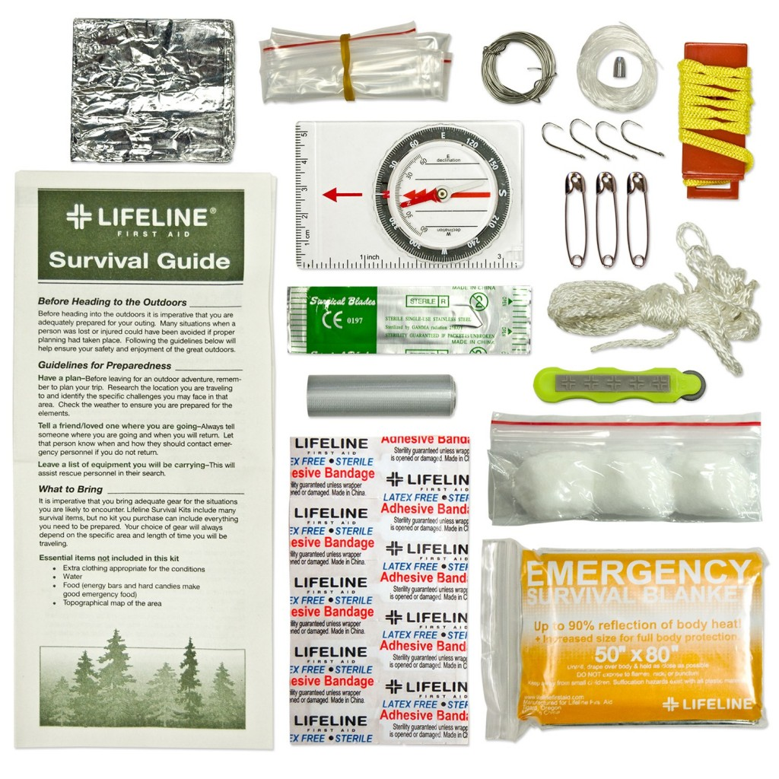
SHTF
Sh*t Hits the Fan (SHTF) is a term that preppers use to describe events that are catastrophic. Examples of such events are natural disasters like earthquakes, terrorist attack and/or financial collapse.
TEOTWAWKI
TEOTWAWKI is a term mostly used online by survivalist. It means “The End of the World as we know it”. TEOTWAWKI is often synonymous with SHTF, with a few exceptions in some cases.
WROL
WROL is a term that is used to describe a situation in which the police and every institutional body that functions to uphold the law have lost control. The Police and other organizations in this category have lost all functions in this situation and there is a lawless environment. The term is an acronym for “Without Rule of law”. These situations mostly occur after intense catastrophic happenings.
Zombie
This is a slang that is used to refer to people who are often not always prepared and are aggressive enough to want to take the resources of preppers when SHTF.
SOL
This is an acronym that means Sh*t out of luck. It is used to describe a helpless situation, and it is a variation of the phrase “out of luck”.
Golden horde
This term is synonymous to Zombies and is used to describe a group of fleeing people who are unprepared and desperate so that they loot everything in their path in a WROL situation.
Pollyanna
This is a person who is optimistic, even when there is trouble or when SHTF. The term is originated from a classic novel of 1913 in which main character, Pollyanna, is an optimist in the face of adversary.
Sheeple
Sheeple refers to people who always follow the crowd and are mostly unable to think for themselves.
MOLLE
MOLLE stands for Modular Lightweight Load-carrying Equipment and it is a convenient system invented by the military for Bugging Out. It replaced the ALICE system.
EOTWBFL
This is an acronym that means End Of The World Buddy For Life.
4WD
4WD means a four-wheel drive. This type of vehicle and the SUV are mostly used in BOV.
90% Silver
90% silver is a synonym for Junk Silver.

