Cast Iron Cooking
The iron kettles and pots have been around since the 7th and 8th centuries, but by the 16 century Europe, the art of casting iron was widespread and cast iron cookware had become a valued commodity. Although the Colonists brought their cast iron pots with them to the New World, soon they were casting skillets and kettles of their own. Iron cookware was treasured so much that George Washington’s mother even specified the recipient of her cast iron kitchenware in her will. (Camp Dutch Oven Cooking 101, from Backyard to Backwoods, Lodge Manufacturing Company 2004, p 6.)
The great thing about cast iron is that it is completely versatile. You can do almost anything, bake a cake, fry a hamburger, make an omelet, sear a steak, etc. I do almost all of my cooking with cast iron, both at home and when camping.
The Dutch Oven
Dutch ovens are made by several different companies and come in a wide range of sizes. Below are the three dutch ovens that I own and use for camping and at home. I also have several sizes of enameled cast iron pots that I use at home, but would probably not use when camping. These are not designed to be used over a fire, with briquets or on the Camp Chef stove. This article will cover regular cast iron.
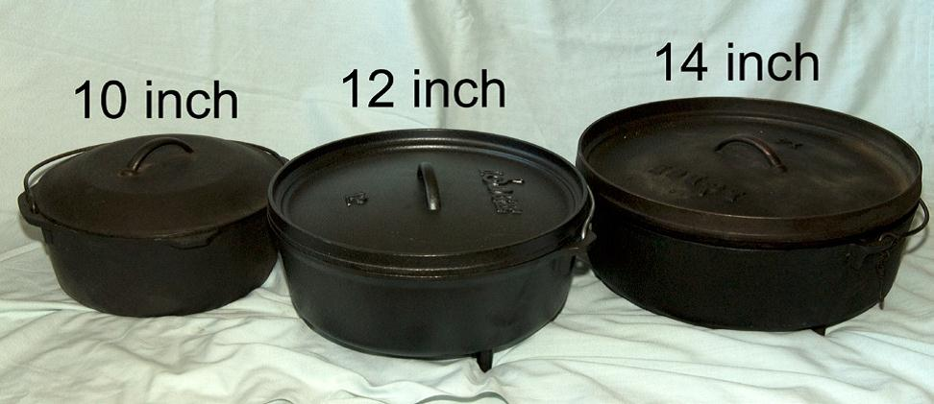
Cheaper is not always better when purchasing a _dutch oven. I have known of people having lids that do not fit snugly or the thickness of the cast iron is not even. My cast iron is from Lodge and Camp Chef and I have never had any problems with them. They are the ones I feel I can recommend.
The two dutch ovens below belong to my daughter-in-law. While they are 10-inch and 12-inch pots like mine, they differ from mine because they are deeper. Each are designed for different purposes, which I will explain below.
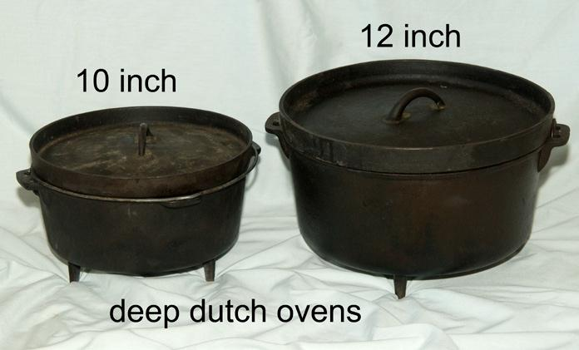
Short vs Tall
- Short ovens are generally used for cooking foods like bread or cake that are shorter and you want to brown on the top and the bottom.
- Deep ovens are generally used for cooking meats, vegetables, soups and stews.
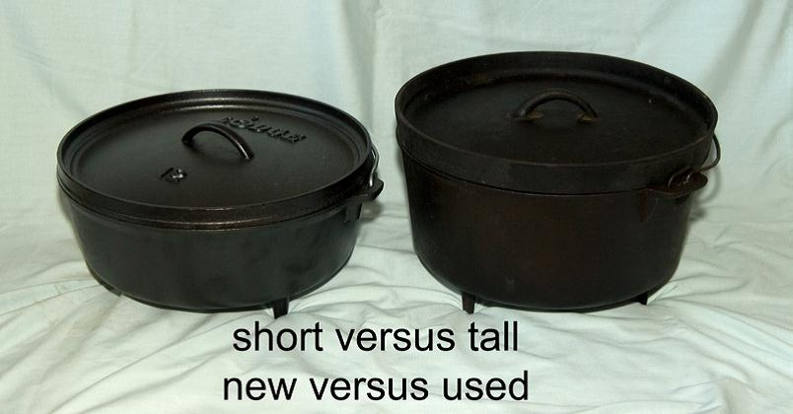

How many briquets to use:
The flanged lids for these dutch ovens is to hold the briquets in place during cooking. The general rule for the number of briquets to use is one less than twice the size of your oven, i.e., 10-inch oven would need 19 briquets for about 325 _degrees for cooking. Use one more briquet for each 25 degrees more heat. Place 1/3 of the briquets evenly under the oven and the rest go around the outside top of the lid or can be placed in a checkered pattern across the top.
Cast Iron Skillets
I love cooking with my cast iron skillets. As you can see I have a wide variety of sizes. I also have a 12-inch enameled skillet, but these are the ones that go camping with me. These skillets are easy to clean and can be used in many ways. I use the lids from the corresponding sized dutch oven when I need to cover a skillet.
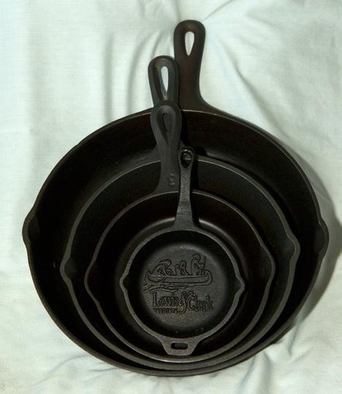
This cast iron pie plate from Camp Chef is one of my recent acquisitions and has become one of my favorite pans. It works great on the stove top, in the oven and camping. It cooks very evenly. I have not yet made a pie in it, but have used it in many other ways.
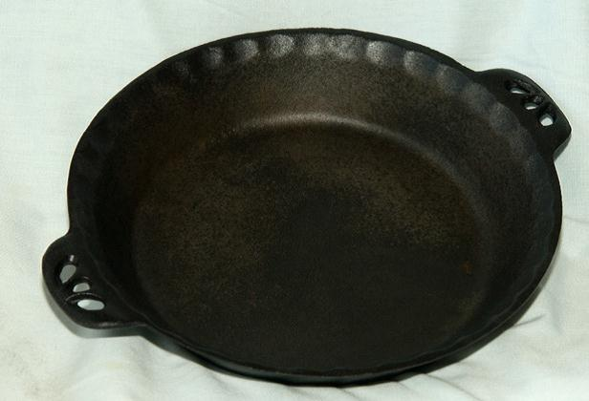
Legs vs No Legs
For some reason this confused me when I first started using cast iron. It is really very simple. The legs on the Dutch Ovens are to provide space for placing briquets under the oven. Some legs are longer than others, but that is their purpose. Those without legs, like these are for use on a stove or in an oven. I use mine all the time and the smaller size is just right for my husband and myself.
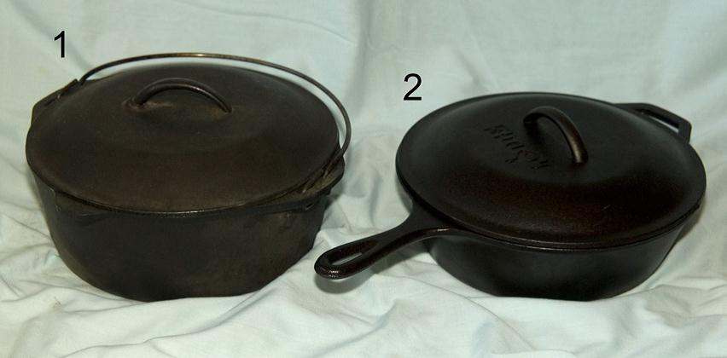
Caring for your Cast Iron
Cast iron is extremely durable, but it is not indestructible. If you place a hot cast iron oven into cold water you could cause it to warp or crack. Do not use washing detergent to wash your cast iron. Just scrape out any left-over food and wash well with hot water and a stiff brush. Dry it well with a paper towel or a dish towel and let it set to finish drying. Be sure to clean the lid as well. Then I oil it.

1. I use coconut oil to protect my cast iron. I have used other oils and always had a rancid smell in my dutch ovens. I have not had that problem since using the coconut oil.
2. I use a larger brush to clean the ashes off the lid and outside of the oven.
3. I use a pastry brush to brush on a thin layer of coconut oil.
4. I have a dish cloth I use for this purpose only, to wipe off the excess oil. This is used until it is saturated and then I just wipe a clean pan with it, without using any more oil until it is used up. Then I put more oil on with the brush and begin the process again.
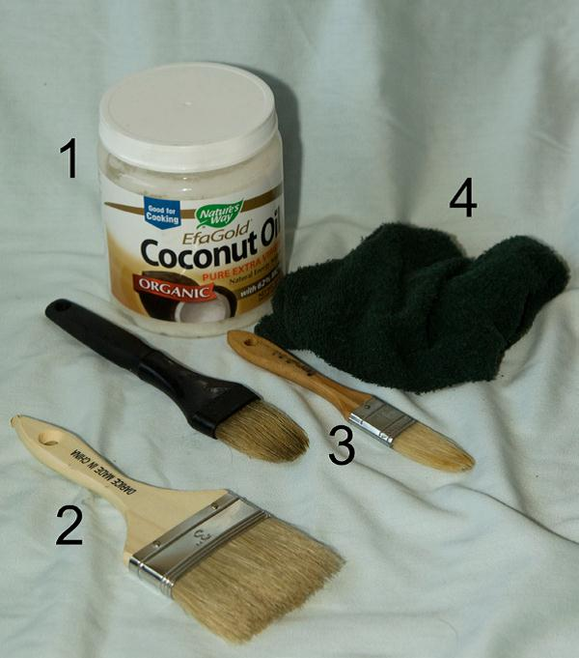
Some Helpful Tools
1. This is a Weber Briquet Starter. You crumple up some newspaper under the bottom of the burner, and then pour the number of briquets you are going to use into the top. Light the newspaper and it will start the briquets burning. It usually takes about 12-15 minutes. When they are white around the edges, they are ready to use.
2. This is a lid remover for dutch ovens. It is an invaluable tool and highly recommended.
3. This is a wide brush or whisk broom to brush the ashes off the lid and outside of the oven when you are finished and before washing the ovens.
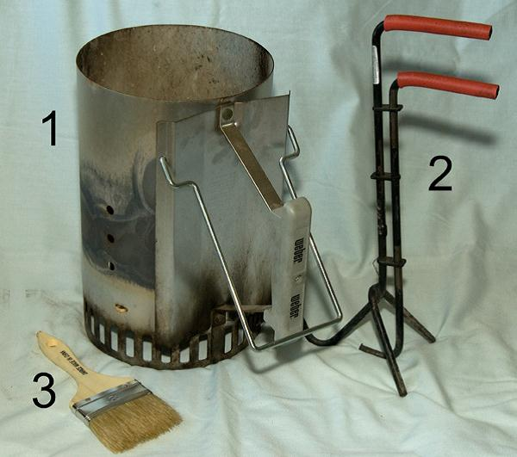
Some other nice Accessories
1. Dutch Oven Dome: This has been a wonderful addition to my dutch oven equipment. It is designed to be used with a camp stove. You can put it over an open skillet or the pie place and it will brown the top of biscuits or other breads. You can put it over a dutch oven with a lid and cook foods over a camp stove flame.
2. A Diffuser Plate: This is used over the flame to diffuse the flame and keep food from burning on the bottom.
3. A Trivet: This is placed on the diffuser to lift skillets, pie plates and dutch ovens with no legs up off the plate. This gives you more control over the heat.
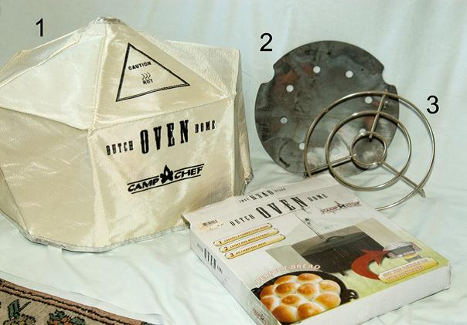
This is just a brief overview of cast iron cooking items and how to use them. I highly recommend the Camp Dutch Oven Cooking 101, from Backyard to Backwoods, by the Lodge Manufacturing Company for more in-depth information. This book comes free with the purchase of any Dutch Oven from Lodge. I also recommend the Log Cabin Campfire Cookn’ and other cookbooks by Colleen Sloan. There are a lot of other dutch oven cook books available, as well.

