Camp Kitchen My Way
When we go, I set up a kitchen tent as it’s a lot easier to have one than not. My kitchen tent is no-where near a luxury, it’s a 10×10 easy-up. What it does do is to keep the kitchen out of our living and work spaces. This is huge when you’re alternately living in heat and rain, the occasional raccoon and out of the same 600 sq. ft. as the rest of your large family. So, here’s what I do. I break down both my packs and set up into 3 categories. They are:
Food: I’ve found lidded 5 gallon buckets work best for this. A little inconvenient, yes, but it keeps everything dry and clean. It also helps to prevent breakage and spoilage. I bring a fair amount of home canned goods, and they all come in glass jars. If I can pack ‘em in with the flour, it provides some cushion. Plus, they stack, so you can go vertical with them and keep them out of the way. I typically take 4-5 buckets, depending on how many days we’re going to be gone. Each has a category, for example, last year I took the following: Spices, Dried goods, Canned goods x 2, and Snacks. Each bucket had the general category written on the lid for ease of use.
Structural: This is everything that makes the kitchen work, a tent, side walls for the tent (it’s easier to cook in a tent with walls when it’s raining than in a tent with no-walls), tables, a sink (we’re lucky enough to have a drain!), the stove, the stove top oven and the grill.
Other: This is all the other stuff that makes a kitchen work, pots, pans, silver, knives, the dish strainer, dish soap, an onion & garlic hanger (prevents rot) etc. I have scaled down my kit as much as I can for a family of 6, and can fit all of the above into 3 large bins and two milk crates – the crates make great ad-hoc shelving for frequently used items.
Please note, we do carry chairs and a table to eat at, but they’re part of our living space and thus part of that kit.
So what does it look like? This is pictures of each wall in a clockwise manner – one follows the other. Because I’ve got 3 doors going into and out of my space, I take one wall and devote it to water. Dish washing on a 4×4 table, the sink, laundry, etc. If it involves water, it’s on that wall. (you can see one of the doors on in the picture on the left - a second is just to the left of that and the other is on the right hand side, in the right hand photo.)
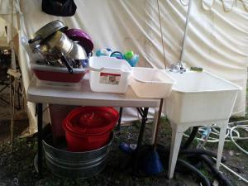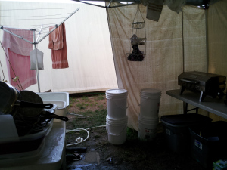
The rest of the space is carved up by 2 five foot tables into an L shape against the outer walls. On the longer of the two tables, and the one on which I’ve got full access are the cooking implements. Both grills, the propane tanks, the oven, etc., all live here. Under this table live the 3 bins that held gear, one of which has, by this point, been emptied and it’s contents put into use. That bin is nested under one of the other two to save space. The second holds the pans, and the third, other extraneous kitchen gear – can openers, etc. At the end of this table, on our downhill side, lives the garbage. It’s as far away from food prep and living space as I can get it and still keep things clean.
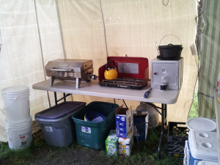
The other table is my prep space. It has those milk crates with frequently used items, the knives, the cutting board, and anything else I can jam on it but still have space to work. Under this table lives our two coolers. After years of working with sub-par crappy coolers, I’ve been upgrading us, over the past 3 years, to the Coleman Xtreme 6 day coolers. They have handles, they have wheels, and most importantly? A drain. I can pull those puppies over to our camp drain and just let them go. No more dumping food and everything else out. Plus, they keep really cold on very little ice. Bonus all around!
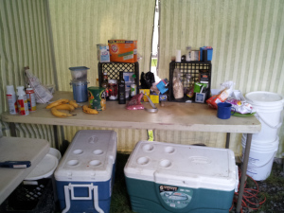
Methane Creator: I like having the 4-legged portable plastic sinks sold at Lowes on-hand. I rig a drain hose in the bottom to funnel waste water away from the camp. You can also put a 5 gallon bucket under it, but it will fill up fast and I have a tendency to slosh most of it out while carrying it to the dump site. Tables for food prep is a must. Get something light and durable. Use cutting boards!!!!. Rig a rope/chain to hang a water storage bottle above the sink. Using the spigot to fill the sink sure makes it a lot easier. I’m not sold on the Yeti coolers yet. For their price, I think I can keep using my Coleman coolers. Ice will not last forever, but I also have a small portable icemaker that will fun off the Inverter in my truck. 3 pounds of ice every 8 hours isn’t too bad.

