Burying a Survival Cache - Things to Consider
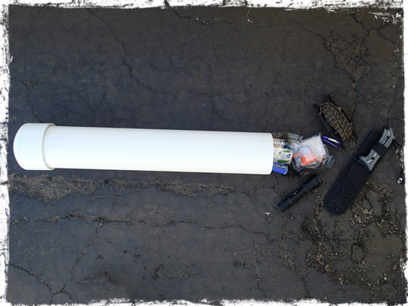

A cache is a secret hiding place where valuables are hidden with the assumption you would come back at some point to retrieve what you have cached. Caches do not have to be buried in the ground necessarily but burying a survival cache in the ground makes sense in most situations.
As a Prepper, if you were to hide supplies in your home they can be destroyed by fire or some other event. Obviously, some supplies will be in the home, but having them all in one place means they can all be stolen or destroyed at the same time.
For most people the reason for a cache is so they can resupply themselves if they have to evacuate their homes and community during a catastrophe or if the supplies they do have are stolen or destroyed.
In some situations, however, rural homes may be overrun by those fleeing the large metropolitan areas. Imagine you are out doing a perimeter check or hunting and when you return, you find your home has been taken over.
If you do not have a cache of supplies well off site, then you have a serious problem. Not being prepared with a supply cache would mean you have to retrieve the supplies inside your home and this can be dangerous. The failure to think ahead in a survival situation may mean you have to take more risks to survive.
Some people may also fear the authorities will confiscate supplies during a crisis, so if this is a fear the supplies must be well hidden and certainly not cached inside the home or even close to the home.
Some people believe that hoarding, or hoarding certain items may become illegal in some situations, and that federal troops may be tasked with gathering up these supplies from private citizens. To make sure you had adequate supplies they would have to be well hidden off site.
Locations
Where Not To Hide Your Supplies
Hiding supplies in abandoned buildings is not usually recommended. You may think that hiding supplies in an abandoned church for example will make it easier to find them. This may be true but the building can be set on fire during a crisis or at any time for that matter or a natural disaster may destroy it at any time as well. Additionally, people will take refuge in abandoned buildings during a crisis.
Do not use commercial storage sheds, or the basement storage of your apartment/condominium complex as a storage cache. You must have a high degree of certainty that you can retrieve your caches during a crisis. If you have to evacuate your building, it would be very difficult to come back and retrieve your supplies and looters may have already discovered them before you could get back.
Caches should be in a remote area so you can gather up your supplies without people observing you. This may not always be the case, but you must do what you can to minimize human contact as you retrieve your emergency supplies.
What to Store Your Supplies In
Now that you have determined the ground is the most logical choice you need to make sure everything is protected from moisture and is insect and rodent proof.
By the time, you constructed one storage container you could probably have gathered up all the plastic buckets, barrels and PVC tubing you would need. Wooden crates are not idea for ground storage nor are metal ones unless they are stainless steel and stainless steel boxes would be cost prohibitive.
Certain ammunition boxes have waterproof seals but the container itself is susceptible to rust and corrosion. They can be used for short periods but you cannot always predict how long your cache will be buried.
PVC tubing can be used along with heavy plastic buckets and even plastic water barrels that have a large enough opening so you can get items in and out. The buckets and barrels would need a waterproof lid. Certain food storage buckets have waterproof seals and the lids are screw on types instead of the ones that have to be pried open.
It would take considerable effort to bury a plastic 50-gallon water barrel, but if your needs demand it then they make ideal in ground storage containers for bulk supplies. Remember if you are packing multiple items in the same barrel you will have to remove items to get to the ones on the bottom and this will be time consuming so keep this in mind.
If you use PVC, tubes you would probably want a screw on cap on one end. You can of course cap both ends and secure the caps using PVC glue but then you would have to cut into the tubing to retrieve your goods, which means you would need a tool handy. Once again, you must think ahead because you do not want to dig up a PVC tube full of money and ammunition to find out you do not have any tools to cut into the tubing.
Where to Begin Digging
If you do bury supplies along an evacuation route make, sure the site is well off the highway so people along the highway cannot see you. Burying supplies along evacuation routes is not ideal but if you do use the highway as a reference marker make sure the site is remote.
Keep in mind landmarks that are used to find your way back may be destroyed during the crisis. Learn how to use a topographical map so you can determine grid coordinates. You cannot rely on GPS systems during a crisis. Once you have the grid coordinates of your cache you can always find your way back if you have a map, the coordinates and a compass, and it goes without saying keep your coordinates hidden from others.
Make sure the area you bury your supplies in is not in a flood zone. Any area can be flooded regardless so always opt for the high ground, well above any flood zones. Do not disturb anymore of the cache site than is necessary. You do not want hikers, hunters or anyone else getting curious about the site. Blazing trees and driving stakes in the ground to mark the spot would obviously not be recommended.
What Supplies
A survival cache would need the basics for survival. Shelter, water, means to create fire and nutrition. It is best to assume you would arrive at the cache with nothing, and thus store the things you will need to survive for an extended period. Burying food and water here and weapons and ammo there means more work for you and you may not be able to get to all of them.
Each cache should be such that it can sustain you from the point you uncover it without having to hike all over to gather the other essentials.

