Building the Ultimate Survival Tablet
The relationship between electronic devices and survival is not always a good one; in fact, most preppers hate counting on electronic gear, fearing that it may become useless during a long-term survival situation. But the fact is we live in a world of electronics, and ignoring their usefulness in a survival situation is not only foolish, but it could put you far behind the curve once things go bad.

Using Smart Phones, Tablets and Electronic Devices for Emergency Preparedness
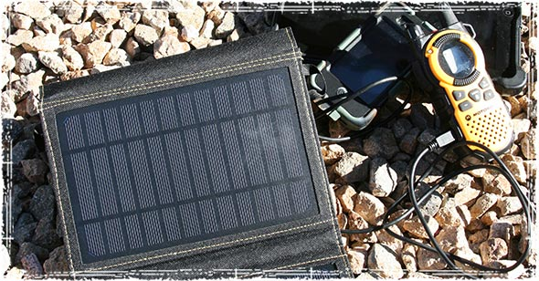
To begin, I must point out that without knowledge, training, and a good understanding of what it really takes to survive during times of crisis there isn’t a piece of gear in the world that can guarantee your survival during an emergency situation. Nothing, and I repeat NOTHING can take the place of knowledge and real world experience.
Despite my reluctance to rely on electronics, there are a number of good reasons to consider adding some of these devices to your emergency preparedness gear. In today’s world, most people carry these devices with them on a daily basis; that alone is reason enough to convert them into useful pieces of survival gear.
If you carry it anyways, why not turn it into a useful survival tool?
Today’s smart phones and tablet devices offer a number of useful emergency tools that can help you during a disaster.

The Benefits of carrying a Tablet as part of your Every Day Carry

Emergency Communication
This first one is really a no-brainer, and is probably the number one reason to carry some sort of smart phone or tablet device.
These devices are probably going to be your first line of communication, and give you the ability to communicate through either voice, text, or the Internet. Even when the cell towers are jammed, most text messages will still go through.
If you haven’t thought about how you’ll communicate during an emergency situation, you might want to take a look at our article on emergency communication planning.

A Mini Electronic Survival Kit
A tablet is so much more than just a communication device; in fact, they are multipurpose tools that can be turned into valuable mini electronic survival kits.
Today’s tablets have more computing power than most computers from ten years ago. They can be stocked full of useful things like topographical maps, survival books and manuals, and personal data backups.
Tablets are also great morale boosters, and can play an important role in keeping kids calm during a disaster. Don’t underestimate the need for entertainment — especially if you have kids. Make sure your device is stocked full of games, movies, and music that can help keep a kid mentally sharp during times of crisis.

E-book readers
One of my favorite things about these devices is the ability to carry thousands of survival books, field guides, manuals, and PDFs — all in a device that weighs less than a pound. From storing medical files and first aid information, to field maps and survival guides, the ability to store information makes these devices one of the top reasons they should be added to any good EDC.
Check out my full list of Survival eBooks that should be on everyone’s tablets.

Maps & GPS
Most smartphones and tablets can be used as a portable GPS device. During an emergency this can be a great way to find alternative routes in and out of a disaster zone.
While GPS does require a data connection to be fully functional, you can still load detailed maps and satellite imagery onto these devices, which can then be accessed even when the cell networks and GPS go down.

Field Notes & Scouting
When hunting and fishing, I often take detailed notes on game patterns and behaviors, the environment I plan on being in, and a number of other useful bits of data that can help me on future trips. For this reason, I like having a small portable device where I can not only keep track of this information, but also take detailed pictures of everything I’m putting in my notes.
In the past, I would draw quick sketches in a notebook; but now, thanks to my iPad, I can now add actual photographs to my field journals.

Survival Apps Smart Phones & Tablet Apps
These days there’s an App for just about everything, and that includes survival. The Red Cross has a pretty good app that can help you learn the essential skills you need to save a life. It can be downloaded here.

Making sure your tablet will be there when you need it.
The last thing you need during a disaster is a device that doesn’t work, that’s why I recommend adding the following items to your bag of tricks.

Lifeproof Cases: Turning your Tablet into an All-Weather Piece of Gear
These cases are built for survival; they will protect your tablets from water, dirt, snow, and even drops from up to 6.6 feet. They are military rated, and carry a IP-68 waterproof rating that guarantees your devices will withstand water immersions of up to 8 hours.
I tested mine over the winter, bringing it both hunting and fishing, and I wouldn’t carry a device into the field without one of these cases on it. It helped protect my iPad while out in the snow, and it protected it from the water while out on the river. Check out the full line of Lifeproof Cases.

Portable Solar Panels: Keep the Tablet Going when the Grid Goes Down
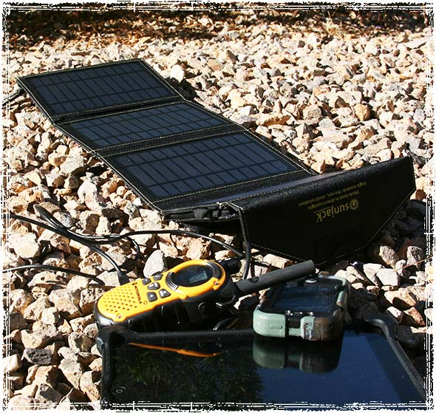
One reason people shy away from using these devices during an emergency is the fear that you will not be able to rely on them once the grid goes down. That really isn’t a problem anymore thanks to a new line of portable solar devices that are now so small they can be carried in any bug out bag or EDC bag.
These small portable devices are not only great for camping and hiking adventures, but when disaster strikes they can help keep devices like cell phones, small tablets, flashlights, emergency radios, ham radios, and GPS devices up and running. Check out our list of emergency solar panels.

Backup Batteries: One more step to Ensuring Emergency Power
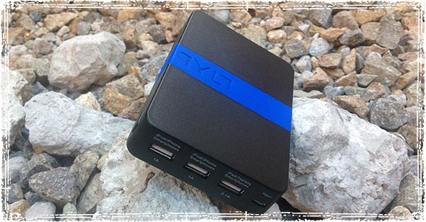
On top of the portable solar devices, a new generation of back-up batteries can help ensure you have power when things go bad. Devices like the TYLT Energi 10K Battery Pack are so small that they can even be carried in a coat pocket; they also provide the typical tablet with up to 2-3 extra recharges.

