Boiling Water With Stones
by USMC0311

When I mention to someone that you can boil water with hot stones, they always ask me two questions… Why would you do that? How do you do it? Why would you ever boil water using stones? Why don’t you use the fire to heat it. Well, in a perfect situation, in a camping situation, that is ideal, and you can just put your pot or container over the fire and wait for it to boil. What if you were in a survival situation, and the only container you had could not be placed over a fire? Either it will melt, or if heated with a flame, it would leach toxins into the water. Having the knowledge of accomplishing a mission as critical as boiling water could be a matter of life and death. So we have a container we can’t heat directly, so we use stones to heat the water and get it boiling. we are heating the water, not the container.
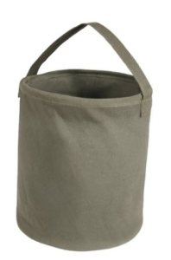
This is a canvas water bucket. This is something that can fit well in a bug out bag. It collapses fully to be compact, is lightweight, can carry items you forage, or water. This container holds 2 gallons. You can not put this over a fire to boil water. You can pick one of these up for about $13.00 by Clicking Here
Now you have the water, you have to prepare to boil. The next thing you have to do is to find some stones. The stones you need should be a little smaller than your fist, and solid. You do not want stones that are porous, or have cracks in them as they can explode and hurt you. You want to locate 5-10 stones.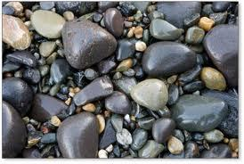 You are going to be dropping the stones in water you will be drinking, so you should clean the stones as best as possible. Remove any dirt or debris from the stones. Once clean, do not set your stones directly into the fire, but along the side in the coals. These stones could explode…I can not stress that enough, this can be dangerous. Being hit with hot rock shrapnel is not a fun thing. While the stones are being heated, you should find a way to extract the stones from the fire, other than your hands for obvious reasons. In a perfect world, tongs are ideal. You should also have a way to extract them from the water as well if you have limited stones. Once the stones are heated, one at a time you should drop the heated stones into the water. The water will pull the heat from the rocks and as you add more stones, the temp of the water will increase. At some point, the water will begin to boil, once it reaches the proper temp. In some cases you may have to line the bottom of your container with something to prevent the stones from burning through. as the water heats, the stones will not cool as quickly. things you can use are large green leaves, or evergreens layered in the bottom of the container. 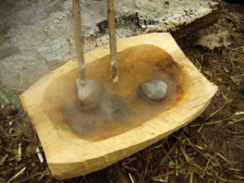
As you can see from the pictures, you may not always have a pot to boil or purify water, and thinking outside the box and knowing a few tricks may indeed save your life. I would highly suggest practicing this, or trying it next time you go camping

. 