Bitcoin - Virtual Crypto Currencies Basics
by Great Northern Prepper
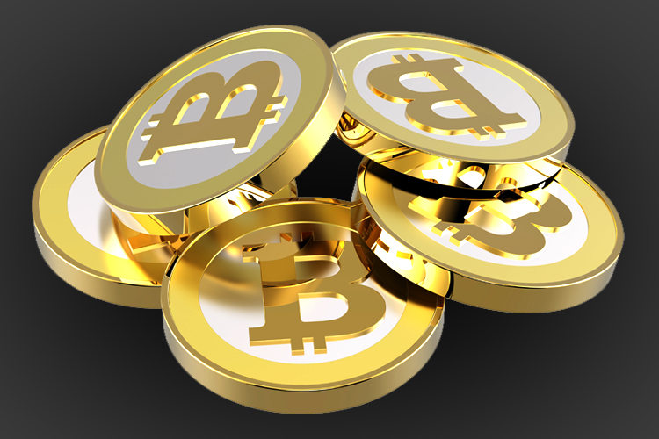
There has been a lot of talk in the past year about “Bitcoin” and other virtual crypto currencies, LiteCoin being another, many people who are used to just working and putting a little into their 401k or other retirement are barely familiar with how the U.S. Dollar functions, and are stumped by what a “Bitcoin” really is.
Below I will explain…
- What is Bitcoin and other Virtual Crypto currencies?
- How do they work?
- How do people use them?
- Why does the government fear them?
- Why are some government embracing them and others not?
- What is the future of these currencies.

WHAT IS BITCOIN?
5 years ago an individual (or a group, we don’t know) who goes by the fictional name of Satoshi Nakamoto built the Bitcoin Software system and released it onto the internet. This system was designed to run through hundreds, thousands, etc., of individuals called “miners” who made up the Bitcoin network, it was decentralized, anyone could become part of the network with the right hardware and know how.
Basically the “Miner” built a system that could become part of the network, at first this was relatively simple and cheap, one could do it for under a 1000 dollars worth of computer parts, now it is much more difficult (I will explain further on). Once they built the system they downloaded the software, which was free to all and this “seeded” the initial few Bitcoins that went into the marketplace. I will explain further on as well how more bitcoins are created, and what the “miners” really do.
Bitcoin is a complete Fiat Currency, one without any backed value (A backed currency means there is silver, gold or other commodities that are behind every dollar, unit of currency, in circulation).
Bitcoin has no value but what the market dictates it has, and is exactly like the U.S. dollar or Euro, however there is one important difference. There can be NO manipulation of the currency in the ways that the FED does with our Dollar. Bitcoins are created through the network at intervals and will eventually Stop being created around 2140, at that point the currency will not stop being used as they can be split into 100 million pieces called “Satoshis” after the fictional founder. The point is that no central bank can just create more of the currency as they wish and destroy the savings of those who hold it to finance this war or that program.

HOW DO THEY WORK
So lets say that you went to a Bitcoin exchange like MT. GOX and bought a Bitcoin ( $830 at current value 12/8/13) , so now you have exchanged $830 dollars and now have 1 shiny virtual bitcoin. The way these virtual currencies work to keep your money safe but allow you to use it as you see fit is that you have a ‘wallet’ this wallet is unique to you, and is much like an email address so that people can send you the ‘coins’, however your ‘private’ key (password) is what keeps it safe. So what now?
Well you can do pretty much anything You can Save it or Spend it.
- ON YOUR COMPUTER: You download the Bitcoin client software and a ‘wallet’ will be created for you with a unique address, much like an email address so those coins are sent to your wallet and stored on your computer. Each Coin is just basically a set of numbers and wherever those numbers are stored, that’s where your money is, In this case stored on your computer. This is a decent option, but has some downsides. Mainly that some of the issues with the Bitcoin software that can arise is not easy for newcomers to handle (errors); you are also very vulnerable to malware/spyware, if your computer gets compromised you could lose everything you have.
- ON THE INTERNET: Much like online banking you can engage a third party service who will take all of the hassle out of buying and using Bitcoins for you. While this is the easiest option for people who are not that tech savvy, this is the least safest option. If the operator of this service doesn’t take proper precautions and do not backup the information stored there, if they are hacked you could lost it all. Another issue is if a key-logging program was able to record the password to the website that you use….its gone.
- ON A THUMBDRIVE: You can store the information on a thumb drive by saving the wallet.dat file which is a store of all your private keys, you save the copy of this file on the thumb drive and then delete it from your computer. This is one of the safest options however you need a bit of technical knowledge to deal with the Bitcoin client, etc., however it eliminates the worry of someone stealing your keys. Given that some media can fail, you will want to make a few backups of the wallet.dat file, if you lose the thumb drive or it malfunctions, you lose everything.
- ON A PAPER WALLET/BANK CARD: A Paper wallet is what it sounds like, on it you have your Bitcoin ‘address’ printed on it, in which you can give to people to send the Bitcoins to, as well as your private keys. A Bank card is a printed bank card with a single address for sending and receiving as well as a single private key (often the key and the address are printed on separate cards). This is VERY SECURE, if created securely there is no chance it can be stolen (unless you lose it), however if you go through a third party to make the card then…you will have given someone your private key. This is also hard to do, and requires technical savvy.
- ON A BEARER ITEM: These are pretty much the exact same thing as a paper wallet, however the key is imbedded into an object that has to be torn open to gain access to it. Basically this is a card that is denominated in a certain amount of bitcoin, say 1 BTC, so you would send 1 BTC to the company, who would then create a brand new address and private key for each “card” you have, then they embed the private key into the coin so only if the card is destroyed can you convert the card into digital currency and spend it. This way you can hand someone the card which is as good as “cash” and only when someone wants to convert it to digital do they need to ‘destroy’ the card. While these cards prevent remote theft of the bitcoin, they are not perfect for ease of use in every situation, and depending on the provider they could be counterfeited.

HOW DO YOU USE THEM
Ive explained bits and pieces, but here is how it works and why it works.
Lets say you send Steve a Bitcoin, it isn’t instantaneous, it will take a bit of time from the moment you click send to the time it is received in his ‘wallet’. During this time the transaction is sent out and analyzed in the network, and this is where “miners” come in. The Miners are not actually creating any currency, the systems they operate in the network is actually fact checking transactions done in Bitcoin, where basically they check all the numbers and make sure they add up and are legit, and then once approved become part of the “blockchain” which is just a long string of blocks that make up all the transactions done in the Bitcoin world. This is a Public Ledger, so anyone that REALLLY wants to delve into Bitcoin and make sure that the system is on the up and up can, this public nature is what makes it so attractive when compared to the secrecy and deceit of the worlds central banks.
So now the Miners have confirmed the transaction and Steve has his Bitcoin, the transaction is added into the “blockchain” (i.e. Public Ledger) and for the service the miners offer the system kicks out a certain amount of coins to the miners, this fluctuates depending on demand, and complex algorithm’s that make up Bitcoin, but this is how the currency expands to over time, miners are paid for their services and they then go to exchanges to sell them or just sell them to individuals in a private manner.
Now to use them, well that’s up to you, many sites take bitcoin now, and they are fast becoming a ‘barter’ implement in tech savvy cities across the nation, where you can just meet up with someone at a mall exchange cash for Bitcoin and be on your way. There are some online retailers that have specifically come online just to sell you everything from cars to electronics online using Bitcoins you can see a list here .

WHY DOES THE GOVERNMENT FEAR THEM?
The Government fears them because they are a form of exchange that they cannot control, sure people barter on craigslist and sell stuff at garage sales that are supposed to be reported and taxed, but bitcoin is public, on the news and a direct threat to the established FIAT currency in the country, that being the U.S. Dollar.
If something like bitcoin gained wide acceptance, say even just 30% of the country, it would signal major issues for the dollar, because people would not be using dollars for transactions but Bitcoin, dollars can be controlled, bitcoin cannot. Bitcoin is not like paypal who is an intermediary, Paypal can be pressured with threats to do as the government would like them to do, however Bitcoin is not controlled by any person or any company it is freeware, anyone can use it and it cant be manipulated. The decentralized nature of the currency and its algorithm makes it impossible to, there are hundreds and thousands and probably hundreds of thousands of computers out there in the network, all individuals, no way to get ALL of them to be in on a scam or pressure to do what the government wants.

WHY DO SOME GOVERNMENTS EMBRACE THEM WHILE OTHERS DO NOT?
The U.S. Government has made many statements and arrests specifically to instill fear that if Bitcoin is allowed to continue well then everyone will become a drug addict, because…bitcoins can be used to buy drugs….Well so can dollars and…well we havent stopped drug use then either.
China has embraced Bitcoin up until recently mainly by allowing it to hold about 60%+ of the market share of all bitcoin transactions. Recently the Chinese Central Bank made a statement saying that Chinese banks cannot do business in Bitcoin which was not much of a surprise, but the value of Bitcoin dropped from 1000+ down to 800. So why did China play the game and still to a point play the game of allowing Bitcoin to flourish despite our governments seeming antipathy to it? Well China is playing the long game looking steps and steps ahead, right now their main goal is to destabilize the U.S. dollar so that they can take that mantle as the worlds reserve currency. Anything that makes the dollar look weaker is good for them, thus they supported Bitcoin. However Bitcoin began to become so popular that it was starting to appear to be a threat to the Yuan internally, thus they took a few steps back.
Basically in the U.S. and China, its all about control.

WHAT IS THE FUTURE OF VIRTUAL CURRENCIES?
My opinion is mixed.
Bitcoin and other virtual currencies will stay, they are not going anywhere however I feel as though Bitcoin is in a bit of a bubble right now and a recent statement by the Chinese version of Google, disallowing use of bitcoin for payment in their system (which was in reaction to the Central Banks statement earlier this week) showed that with a major dip in the price of Bitcoin.
I don’t know where Bitcoins equilibrium will be found, I just don’t feel that 1000+ is a valid value for it at this moment, much of the price bubble is due to speculators jumping on the bandwagon in the past 10 months. Like I said though, It isn’t going anywhere.
I don’t like Fiat Currencies, I am a gold guy, and think that our currency should return to a backed or semi-backed status for us to ensure the safety of our savings and our economy. However I do like Bitcoin because they act in a manner that FIAT currencies should, by demand, with a cap. The U.S. Dollar would be a hell of a lot more secure if they operated in the same way, when people are confident in the U.S. Economy they buy more bonds, they buy more bonds more money is created, when they dont they stop buying and the money contracts to a point where people think its value is more reasonable, etc. It is because of this that I support Bitcoin, LiteCoin and other virtual currencies, that and they offer competition, and that is always good.
Detractors of these virtual currencies usually have two arguments.
1) These currencies are anonymous so people can buy drugs and do bad things…well you can do that with a wad of cash, but on the other hand people will continue to buy drugs and find ways to buy them no matter what controls you put on a currency, so why let a few bad apples ruin the whole cargo ship full?
2) This is a demand driven currency and prone to deflation, well then it does, and when demand drops the value drops, when people want it, its worth more, thats reality and how the world works. And all those folks have to point to in regards to an alternative is the Centrally planned U.S. dollar who’s value has shrunk 98% since the Central Bank was founded…well you don’t have much credence with that argument.
All in all Bitcoin is a good thing for the world, would I go out and buy as much Bitcoin and LiteCoin as you can right now? NO. If you are interested and want to become part of a new revolution of currency and financial markets, try it out, I am.

