Be Informed
According to FEMA, at their emergency preparedness website, the very first step is to Be Informed.
For this step in our Prep-Along, you will need a binder, tabs, and patience with tedious websites as we explore the following two questions:
- What hazards are most likely?
- How will I get alerts and warnings?
- Does my municipality have emergency plans (shelters, evacuation routes)?

Question #1 What hazards are most likely?
Depending on your geographic area, you are more or less likely to experience certain natural disasters. The difficulty is determining which ones apply to you. If you are lucky like me, your county has a preparedness website that tells you all of the disasters common to our region. If you don’t have access to a site tailored to your area, you have a few choices:
- Pop through the pages FEMA wrote for kids and check each in the “Am I at Risk?” remarks under the cartoon kid at the bottom left.
- Read ALL of the descriptions for each disaster here (and not all of them even tell you, BTW)
- I hear tell that you can find out through the Red Cross site, but I can’t figure out how.
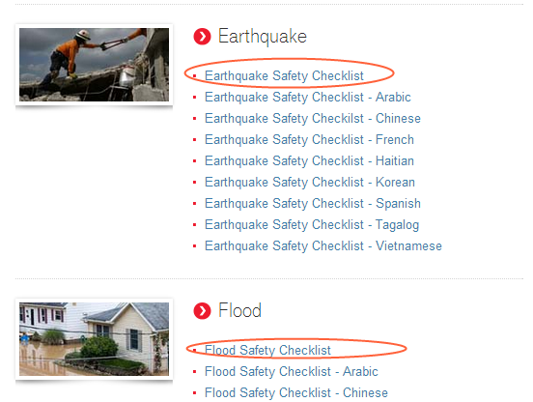
Once you have established your list, you need to print out the “what to do before, during, and after details” for your notebook. You have several options:
- My favorite option is to go to the online Red Cross Library (pictured above) and print out the documents that apply to your most probable disasters.
- If you have a county site like mine, you can just click down the “Be Prepared For” links and print the web pages for each disaster, but they may not be formatted for your printer.
- Another choice is to print out the FEMA tip sheets for kids, but these may not be complete enough for an adult.
- FEMA doesn’t appear to have disaster-specific pdfs for grown-ups, but I suppose you could click through the tabs at the bottom of each description and print each one….yikes.
Once you have all the sheets ready, put them in your notebook….and read over them.
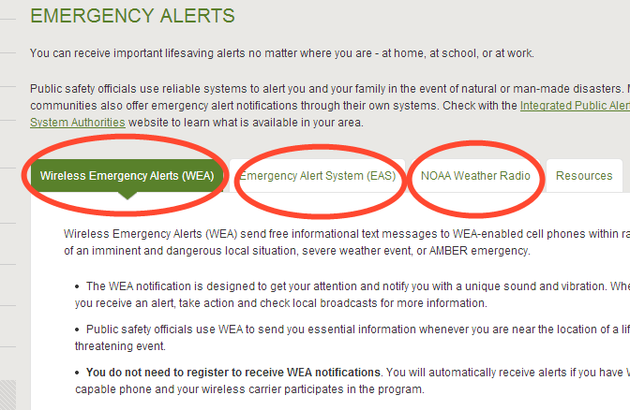

Question #2 How Will I Get Alerts and Warnings?
You have several ways to be alerted to disaster warnings if you don’t have the TV on when it happens. Your next assignment is to browse the following links and shop around for the warning apps or alerts that fit your family best.
- There are several recommended national emergency alerts on the FEMA site (above)
- The Red Cross has a host of apps (below) for emergency warnings and community information
- Check your town and county websites for local texting/calling programs for alerts, like mine has.
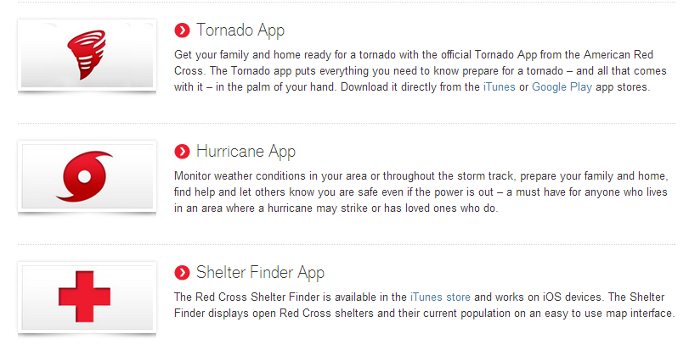

Question #3 Does my municipality have emergency plans (shelter, evacuation)?
Actually, FEMA has a pile of questions you are supposed to ask about community plans. I don’t see anything on our town website or the county one, so I’m going to call up the Fire Department tomorrow and see if they know where I can get that information. I know back in the day there were designated fall-out shelters, but it’s been a while since the 1960′s.
If you can find out this information, write it on the applicable pages for each disaster in your notebook.

