Backpacking Tips and Tricks

Backpacking in the wilderness can be some of the most exhilarating and satisfying experiences of your life. A sense of wonder and curiosity, combined with heightened senses and just a hint of danger make it a habit worth getting addicted to. Nothing can replicate the satisfaction of being in the wilderness over an extended period of time, leaving the trappings of civilization behind.
There are many factors that can determine whether the trip will be memorable or miserable. Planning is essential. I have been backpacking for over 36 years, rarely going to the same destination twice, and have learned a few valuable tips and tricks to help make your trip a positive one.

Step 1: Awareness of Hazards
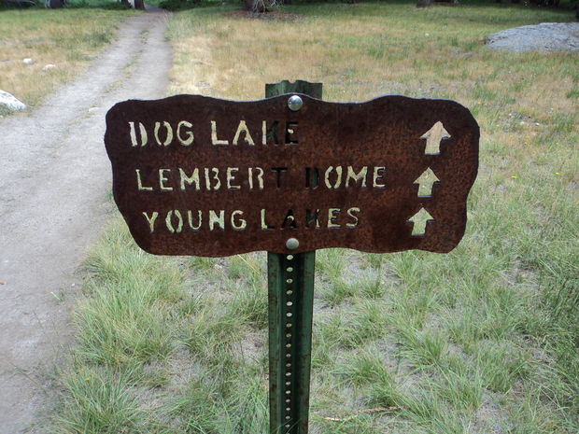
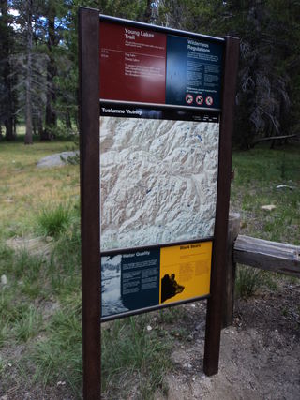

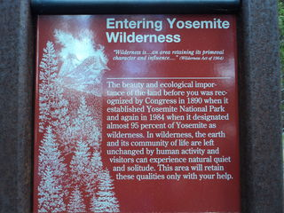
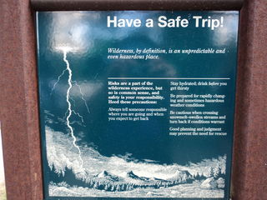
Read all signs at trailheads to learn about fire, lightning, bear activity, etc. Understand the distances you are covering and become familiar with your map. At all junctions, read the signs carefully and make sure everyone is together making the correct turns.

Step 2: Socks
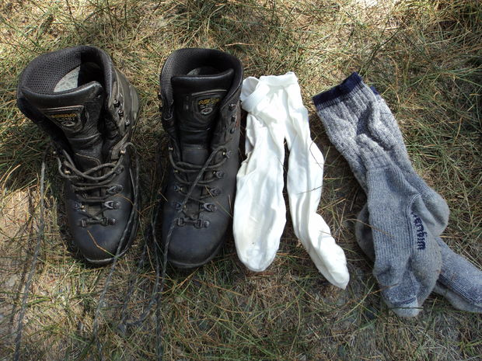
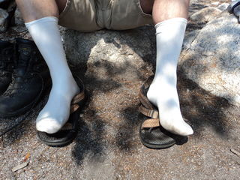

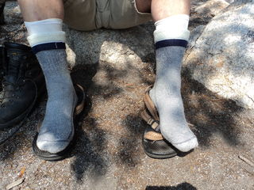

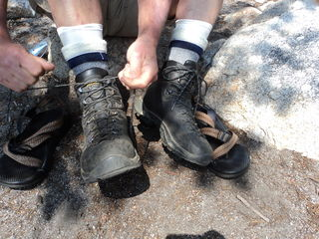
Using two layers of socks can substantially reduce your chances of getting blisters. A thin polypropylene under layer, with a wool blend on top will be very comfortable. If you sense a "hot spot" of rubbing after a while, immediately put a piece of moleskin over the spot to absorb the rubbing and keep your feet happy.

Step 3: Boots
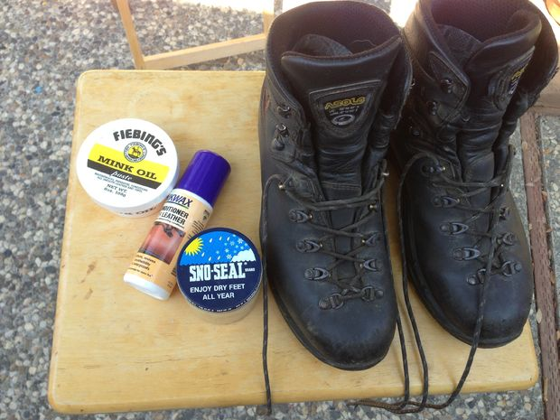

Clean, condition, and waterproof your boots. This will help them last longer and keep your feet dry. You can clean dust off your boots with a damp rag.
Step 4: Warm Your Clothes At Night
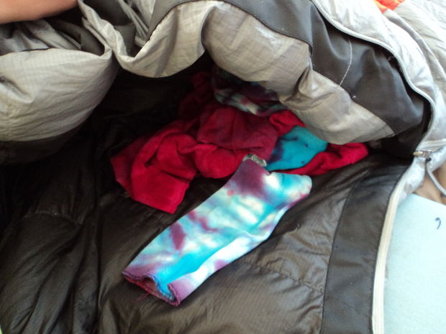
Many mountain mornings can be cool, even in the summer. Consider putting your next day's clothes in the bottom of your sleeping bag at night so they will be toasty warm when you put them on in the morning.

Step 5: Camp Footwear
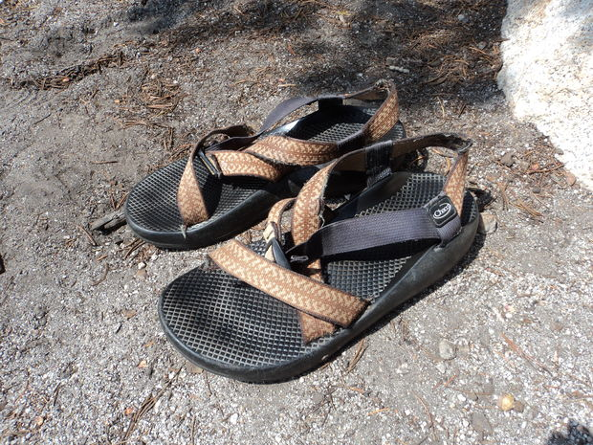
It's great to get out of you heavy hiking boots once you get to your camp spot. You will also want to spend time there and not always be on the go. An old pair of sandals or Teva's are great to wear around camp for swimming and lounging. Your feet will love you!
Step 6: Mosquito Net
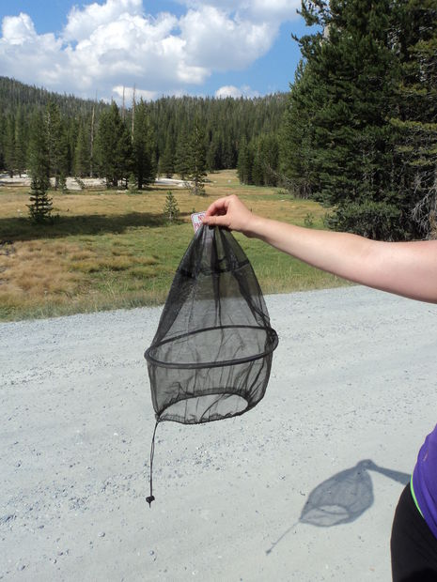

In the Sierras, mid to late August is a time when mosquitoes have mostly faded away, and your life will be immeasurably better for it. Try to do your backpacking trip during this time. However, if you must go earlier, or if it has been a wet year, a mosquito net will keep you from going insane. They tend to be mostly active at dawn and dusk, so if you had to wear one, it would probably just be during those times. This is my all-time most important piece of equipment!

Step 7: Mountain Pillow
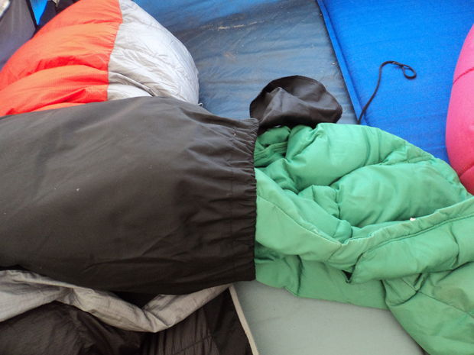
Use your sleeping bag stuff sack to create a comfortable pillow. Put a down jacket or other soft clothing items in your stuff sack. put everything inside of a t-shirt for softness against your face.

Step 8: Shade
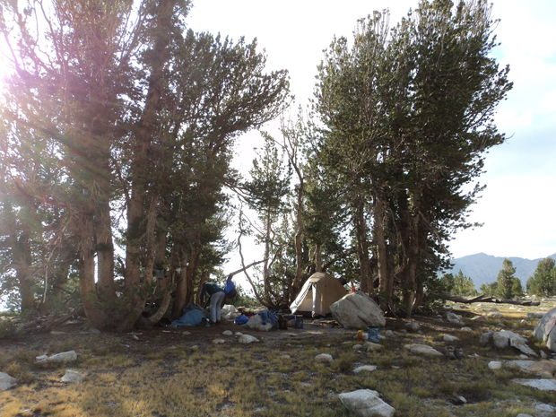
Pitch your tents in the trees to provide shade from the morning or afternoon sun, whichever you prefer. Or both!
Step 9: Water
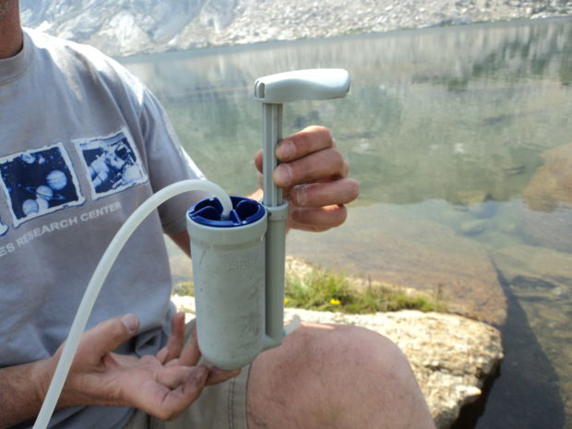
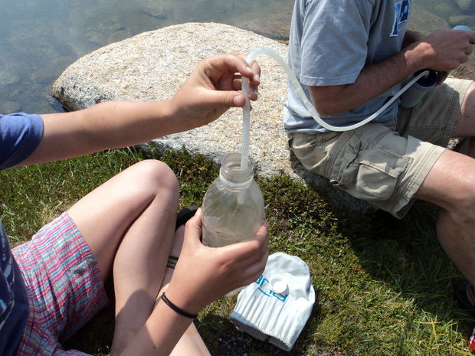

For unlimited and clean tasting water, bring a legitimate water filter. It's a bit of work each time, but you don't want to risk getting parasites or have to taste the iodine from tablets. Use two people so you don't accidentally drop the spout into the lake and contaminate it.
Step 10: Food Storage
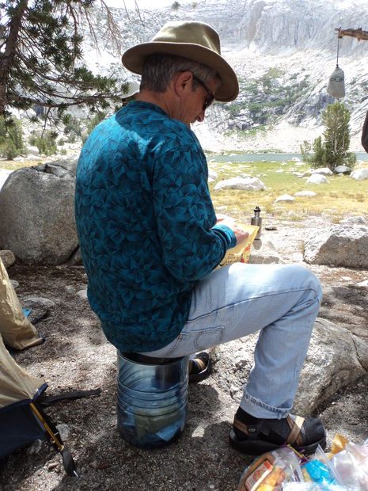
Some wilderness areas require you to store food in portable bear canisters or "vaults." They fit into your backpack, and you should include your toothpaste, sunscreen, lip balm, and anything with a scent besides your food when you close it at night. They are kind of expensive, but you can rent them cheaply at ranger stations if you don't want to buy them. They also make great seats!

Step 11: Reading
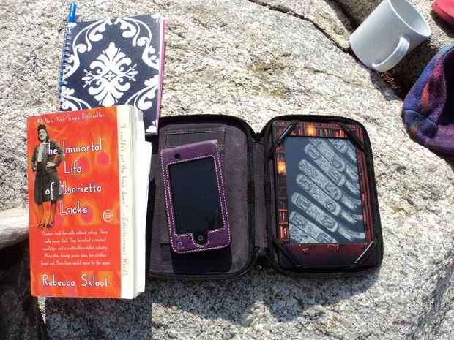

Some folks enjoy sitting in the shade by a lake by a towering mountain and reading a good book. Consider bringing a kindle or lightweight paperback for you down time (my daughter brings massive "Game of Thrones" volumes, but what can you do?). Besides, it could rain all afternoon, so it's nice to have something to do for that possibility.

Step 12: End of the Trip, part 1
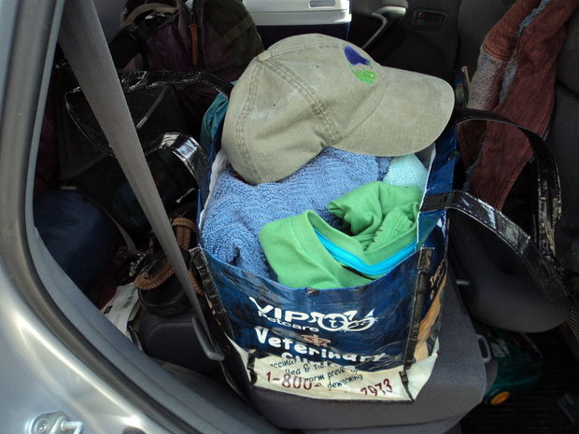

Have some clean clothes waiting for you in the car when you get back to the trailhead. What a luxury!
Step 13: End of the Trip, part 2
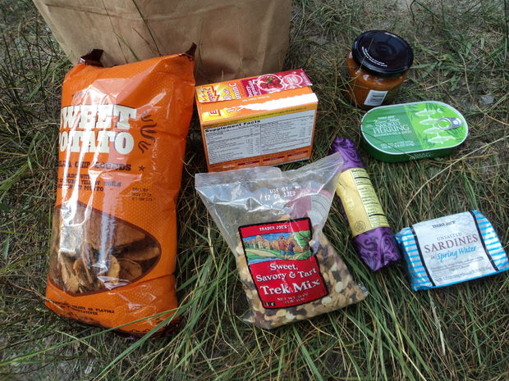
Have a nice snack waiting for you when you get back. If you are in a heavily impacted area, you might be required to store your food in a bear-proof locker.

Step 14: End of the Trip, part 3
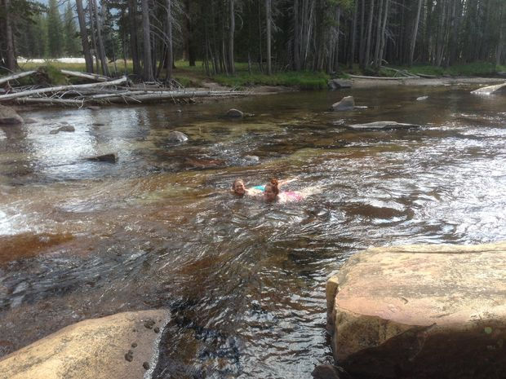
Waste no time in finding a nearby river or lake to rinse off the trail grime. It's the best, most satisfying feeling in the world!

