Another Post-SHTF Worry
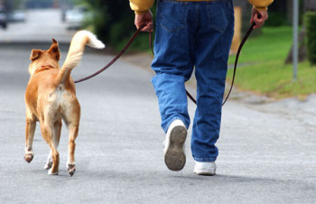
From regular contributor Corey Naughton
This article will start with a story. I had a little incident this weekend that brought about this realization and I’d like to share it with you all.
I took Friday off work in order to make sure I had some extra time this weekend to build a barn. Of course we had high winds all weekend so that plan went to … poop. So on Friday I was sitting around with little to do and decided to take the dog for a long walk. We got a new puppy recently and she needed a work out.
Meet Cinnamon

I decided we’d walk all the way to our mailbox and back (several miles). On the way, as I was about 300m from my driveway, I heard a quick movement in the gravel behind me. I quickly wrapped Cinnamon’s leash up in my left hand to draw her close, spun on my heel, and drew my sidearm.
It’s a good thing I did.
A pair of vicious local dogs, whose irresponsible owners allow to run free, had snuck up on us from behind and sprinted the last bit as they were intent on attacking myself and Cinnamon.
Upon turning around the closest dog stopped short just 8 or 9 feet (3m) away. Hackles raised, head low, ears back, and growly/barking ferociously.
Keeping my gun drawn but at my side I yelled at the dogs to go away. They didn’t care. After a tense minute I sharply kicked some gravel at them. Finally, they back away a little but stayed low and growling. I was able to slowly move away from them and get back to the house even though they stalked us at a distance for the next 100m or so.
And now we come to the realization …
After the first few weeks of any SHTF scenario it will become impossible for people to take care of their pets. Many will be let free to scavenge and fend for themselves. Being pack animals by nature this will lead to an epidemic of attacks.
It is EXTREMELY important that you keep your situational awareness high. Animals will have a much easier time sneaking up on you than the average person. You’ll also need a handy weapon that can be implemented quickly.
You don’t want to turn around and see this …

Now, if you’re not the “prepping type” you should still realize that this happened just a little ways from my house THIS WEEKEND in a non-shtf scenario. Please be safe when on foot as something like this can happen anywhere and anytime.

