An Overview of Making Supply Caches
by homesteaddreamer
People have been burying and stashing valuables for thousands of years. The types of containers have changed dramatically from the pottery and wooden chests of old but they all served the same purpose: keeping the items safe. The need to make supply caches or ‘bury your treasure’ will vary from person to person. In this article, I will focus on the things to consider when making supply caches of items needed for restocking, or to help you get to your Bug Out Location (BOL), or as a way to help others in your group get life-saving supplies.
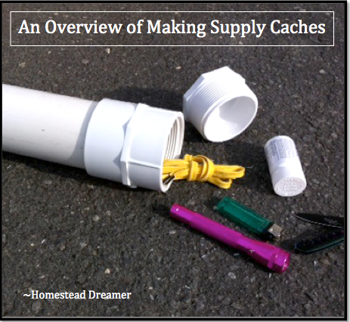
This is not a step by step guide on what to make your caches out of, what to put in them, or where you should place them. It’s an overview that will help you consider what requirements you specifically have based on your needs, who you have with you, your climate, and location. It will help you decide why you should be making supply caches.
Some may be asking, “Why would I need to make supply caches? I will have my backpack or car and it is only X miles away to my location, I can walk if I need to!” The main reason for making supply caches is the same one that has you preparing in the first place; because you do not know what can or will happen! That being said, burying supplies or stashing a waterproof pack in a hollow tree is not just for getting from point A to B; it can be useful for so many other things.
How about your favorite fishing hole? Let’s say it is well hidden and you have to hike to get there. You could make a stash of hooks and line which would come in handy if you find you have forgotten something, or even so you can pack in less and lower your carried weight.
Having the cache of hooks and line would also serve as a great way to ensure you can get food if needed; even though you didn’t stash the goods for an emergency, it will still serve you well in case of one. Some people bury guns and ammo for fear of the government taking them away for whatever reason (of course that is a little extreme).

The main reason for making a supply cache is the same reason that has you preparing in the first place…
Thankfully, the materials available to the modern world are superior to the pottery and wooden chests of old. I have seen and heard people using all sorts of materials from Rubbermaid totes to crafting PVC pipe containers that can be weighted down in lakes and ponds after being sealed. Some people go to great lengths to craft their containers but no matter what you use, there are a few criteria that must be met for a successful stash.
It must be:
- Waterproof
- Preferably darker materials to protect from sunlight (especially if not burying)
- Strong enough material so it will not crack in extreme temperatures
- Able to keep rodents and pests out. If it is airtight (waterproof) then no scent should escape out which will attract unwanted attention.
- If buried: able to handle weight going over it (if being driven over)
The location of where to place your supply cache(s) is also extremely important and will require as much thought and attention to detail as what type of container you use and what goes in it. Abandoned buildings or old work sites are not good locations. Fires, sudden occupancy of the property, and construction are only some of the possible threats to your supplies. Nature itself is threat enough so, choose your locations wisely and with logical purpose. If you have a Bug Out Location (BOL), a few stashes of food, first aid supplies, maybe some ammo or medication along the way may be the very thing to save you and help you get there.
In a situation where you need to get away from your home, it’s likely that thousands of others are thinking the same thing. You may have to give up the car and go it on foot. You won’t be able to carry everything but if you also have a Bug Out Bag (BOB), you should be able to make it to the next ‘buried treasure’ you made. Consider placing caches on or across bridges. If there is a bridge between you and your destination on a bug out, it is best to have the cache on the far side. In the event that you lose your items downstream, you have more on the other side waiting for you in a cache.
Other feasible locations for a tote filled with some goodies would be someone in your group or a trusted family member where their location is a wise place to have some supplies to be picked up. Consider the factors and possibilities and I am sure you can find better places than an abandoned building to trust your possible life-saving supplies. Friend’s property along the way may also be an option. Be sure your emergency supplies and food meet your criteria with thoughtful research!

