Alternative uses for common items

By P. Tabakaru
In a post-apocalyptic world there will be no more running to the store for items.
As a modern world species we have become complacent in a comfortable life style of readily available items and services. Truth of the matter is, all it will take is the power grid to go down to send us all back into the 19th century.
Here is an exercise in frugality that might just save your life.
Take a look around your home, or surroundings and try to find alternate uses for items you see.
Let your imagination run wild, once you start seeing other uses for common items, it becomes difficult not to. You may start to tuck away things for later use. Be careful not to become a hoarder saving something for later use is very different than hoarding.
I did this exercise with my grandchildren just a few days ago, some of their ideas were stretching it a bit but it was a fun exercise.
Here are a few examples of what they found:

- Re use cardboard Toilet paper rolls to stuff with dryer lint for fire starters.

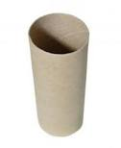

- Prescription Pill bottles make great small item storage containers, excellent for matches, batteries, emergency fishing kits, etc.

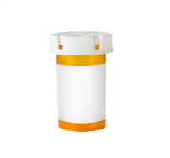

- The plastic container bulk blank DVD’s come in, if large enough (50-100 disc) they can house a roll of Toilet paper for camping, keep bagels or donuts fresher, spool twine, rope, Para cord, etc.
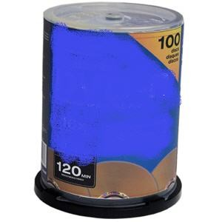

- Nylons or stockings (pantyhose), can be used to make a fishing net, minnow trap, use it to strain cheese if no cheese cloth is available, coffee filter, pasta strainer, (make sure they are clean.) tourniquet, headband, hat, handcuffs. You name it; there are even stories where people have used them for fan belts…

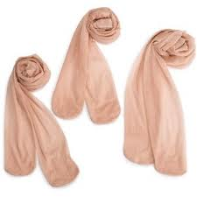

- I found in an Asian market a bag of little plastic bottles for putting in various oils or sauces for cooking, I found that by putting dry spices in these they take up very little space and can make any bland meal taste better, or heat sealing drinking straws filled with your favorite spices.
Once society collapses there will be so much trash and discarded items that the possibilities are endless for finding useful items from even the most obscure items, here are a few.
- People that have been in the military have realized that there is more than one use for a condom.
- Old socks soak them with oil then you can store metal items (such as guns) in them for extended periods without the fear of rust (perfect for a survival cache).
- Old shoe laces are perfect for lashing items together.
- Remember wonder bread bags when you were kids going out to play in the snow, keeping your feet dry.
- Old newspapers can insulate your clothing from the cold.
- A trash bag can become a poncho in seconds.
- Old projections TVs have a very large Fresnel lens in them that can be made into a very powerful solar cooker.
- The projector lens can be used as fire starter (magnifier lens)
- Most DC motors, can be used as a generator, they are a ready-made generator by turning the shaft to charge batteries. (You will need to install a Diode between the motor and the battery you are charging to keep the electricity flowing in the direction of the battery; this will prevent the battery from running the motor when it is charged up.
- A cordless drill can become a windmill (with a little engineering), charging deep cycle batteries.
- A car alternator (or generator) can charge batteries with a little ingenuity, a paddle wheel, and a fast moving stream.
- You can use low voltage lighting in your home, recycled from old cars and trucks.
- A butter churn can be made from a plastic jug and a marble.
- A #10 Food can be cut down and made into a frying pan.
- A cinder block or a side walk can be used to open a can if no opener is available, rub the can against it to wear away the ring on the can so you can open it.
The point is that everyday items around you can have many alternate uses, make yourself aware and let out your inner MacGyver, use your imagination. Once you get to the point where you see other uses for common items automatically, you have become one step closer to surviving any disaster. You may even find that you won’t need to carry as much in you bug-out bag. Reduce, Reuse, And Recycle.

