A useful Small Survival Kit
by admin
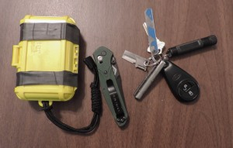
The Otterbox containing the kit measures 41/2 inch long by 3 inces wide and 13/8 inches thick. Notice the two inner tube bands on the exterior. The key ring and knife are on the right side.
I try to spend a lot of time hiking in the mountains, they are beautiful, but can be dangerous. As a result, I always carry at least a pocket survival kit, if not a backpack. The pocket kit is small and light enough to carry in the side pocket of BDU style pants. So you can use it for everyday carry. The following list is the contents of my kit.
- An Otterbox, model LLC 1000
- Two small sheets of paper for leaving notes
- A Fresnel magnifying lens, for removing splinters, thorns and fire starting.
- Four band-aids in two sizes for treatment of small cuts.
- Two number 22 scalpel blades
- One Bacitracin antibiotic ointment package for treatment of minor cuts and scrapes.
- Six Micropur MP-1 water purification tablets.
- One small pencil.
- Two safety pins for repair of clothing and gear.
- One sewing Needle, #16, for clothing repair or removing thorns, treating blister etc.
- One sewing Thread, Bobbin #69, Nylon, clothing repair or light fishing line.
- Nylon Cord, #18, Braided, (10 ft. 100lb test)
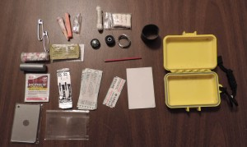
The contents of the kit spread out.
- Fish Hook, #10
- One snap swivel, size 12
- Two split shot, lead
- Six foot of stainless steel, (0.020″) for use in snares or equipment repair.
- One button compass, US made.
- Twenty six inches of duct tape.
- One Spark-lite fire starter.
- Four Tinder Quick Fire Tabs for starting fires.
- Three strike anywhere matches.
- One small container of Aspirin, Benzedrine and allergy pills.
- One signal mirror
- Two sections of rubber bike inner tube on the outside of the box, can be used to make a sling shot.
All of the above fits in the Otterbox.
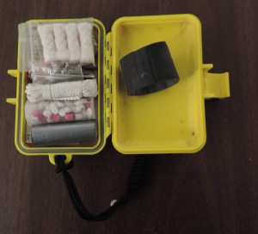
The Kit with the lids open
In addition, I carry on my key ring a Strike Master K1 Magnesium Fire Starter, a Fenix E01 flashlight, and a P38 can opener. I also carry a Benchmade Osborne Design Knife model 940BK.
Now I am not saying that I can survive anywhere for long periods with this kits. If I am going far of the beaten path, I carry a backpack with additional gear. But if something unexpected happens, this kit and the other items in my pocket give me a fighting chance.

