A Prepper Gift List for the Non-Prepper

by Dave Dolbee
I know, I hate the holiday gift lists that come out too early too. However, preppers by their very nature get things done early. So, I decided to put together my own spin on a holiday shopping list for your favorite prepper. In doing so, I left off many of the obvious choices that preppers, hikers, hunters and general outdoors people already own or make such as batteries, compasses and fire starters.
So what do you get that prepper on your gift list that they might not already have?
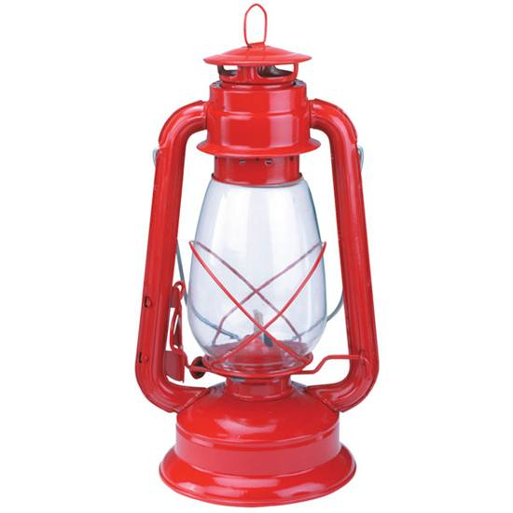

A great kerosene lamp doesn’t need batteries that run out of juice just when you need them.

Light Up Your Loved One
Anyone could benefit from a little more light in his or her life. And that will be doubly appreciated when grid goes down. Battery operated lights have a certain advantage particularly in small spaces without much ventilation. However, batteries have a limited life—both on the shelf and run time—so choose wisely between battery or kerosene power. Better yet, choose both and make sure your prepper is has all of them.
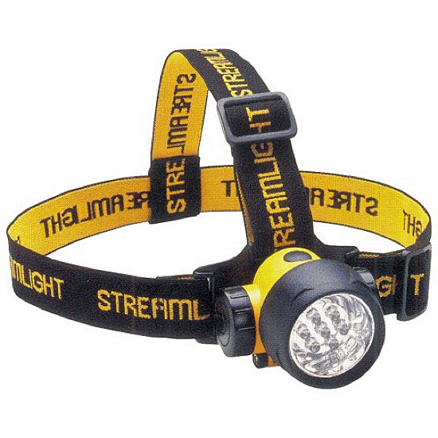

There are times when you are going to need a third hand. While a headlamp won’t quite fill that requirement, it does free up one of your other hands.

You Have to See the Trail to Blaze a Path
There are times when you are going to need a third hand. While a headlamp won’t quite fill that requirement, in can free up one of your prepper’s hands so they can get their work done, grab on to the rack of the big buck they are dragging back to camp. When navigating at night, lights with colored filters reduce the distance the light can be seen (a great tip if your prepper is puttting the sneak on their buddies’ candy bar stash).
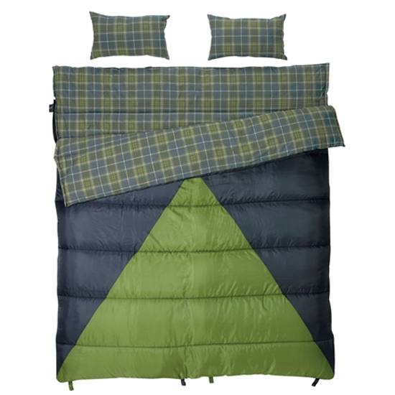

A larger bag can be an advantage in a survival situation and you can even throw extra gear inside with you.

Slumberjack Bonnie and Clyde 30/40 Double Sleeping Bag
Sleeping bags are an important survival tool, but in a bug out situation where you are the only one with extra room in their sleeping bag and… well… ya know, someone has to start populating the world—just sayin’. In all seriousness, a larger bag can be an advantage. Plus-size people may not fare well in a mummy bag and I like the extra room on occasion to throw my clothes or other gear in the bag with me. It ensures certain items are handy in an emergency and your duds are warm in the morning. One large bag may be easier to transport than two smaller bags. The downside to a two person sleeping bag is only one person carries it.
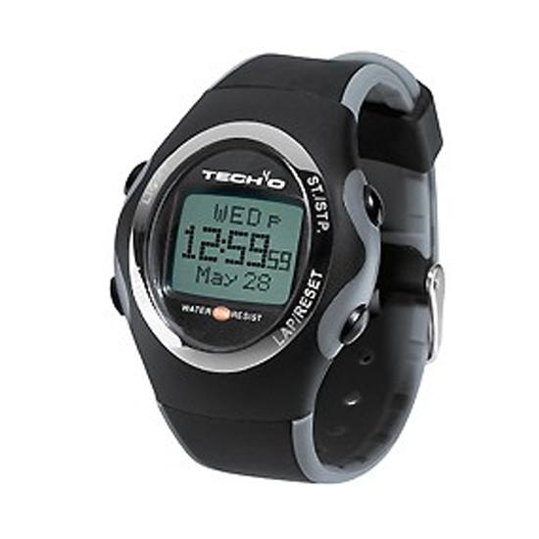

With the Silva Tech40 you can thrive in any environment and navigate off the beaten path.

Silva Tech40 Accelerator Multifunction Fitness Watch
When the grid goes down your prepper may not care what time it is. I am far too blonde and fair-skinned to point my baby blues at the sun for long. So once the iPhone dies, a wristwatch is going to come in handy. Until then, it is pretty handy just to get and stay in shape. With the Silva Tech40 your prepper can thrive in any environment and navigate off the beaten path with accurate altitude, temperature, and weather readings and more.
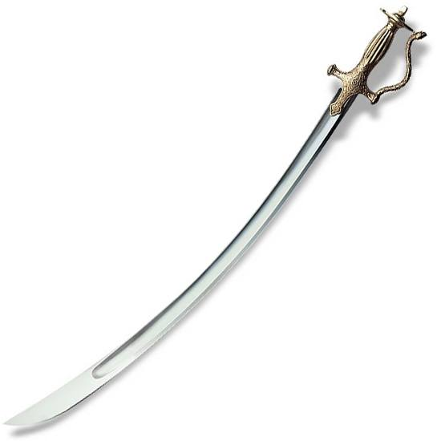

The blade is hand forged from tough 1055 Carbon steel and features a broad fuller and a razor edge. The hilt is equally well made. Fashioned from brass with an intricately decorated surface, it offers short, thick quillons, a single knuckle bow and the traditional dish shaped pommel to lock in your hand

Cold Steel Talwar 33″ Blade Leather/Wood Scabbard
When I planned for my last zombie slaying adventure, I carried a thrusting type sword as a back up weapon. Well, I am still here so I can’t say it didn’t work but after reading the product description, I am wondering about the sanity of my decision.
The blade is hand forged from tough 1055 Carbon steel and features a broad fuller and a razor edge. The hilt is equally well made. Fashioned from brass with an intricately decorated surface, it offers short, thick quillons, a single knuckle bow and the traditional dish shaped pommel to lock in your hand.
Supplied with an excellent scabbard made of wood covered in black leather and capped at either end with a thick brass throat and chape, our Indian Talwar is a ferociously effective cutting sword that will serve you well on or off the battlefield.
One thing is for sure with the Talwar, it will be a gift like no other under the tree!
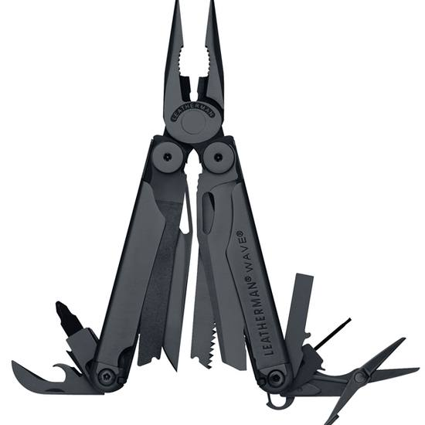

The Leatherman Wave Multi Tool has so many options and uses…make sure you get more than one!

Leatherman Wave Multi Tool
If my boss paid me by the word, I would take the time to write down all of the tools, attachments, features and uses of the Leatherman Wave. However, to keep prices low and me from retiring early, you’ll have to check it out for yourself. However, I will say that having one of these great tools is not enough. I’d plan to have one for the house, car, bug out bag, and…

ModGear Complete Tactical Assault Gear UTG Black
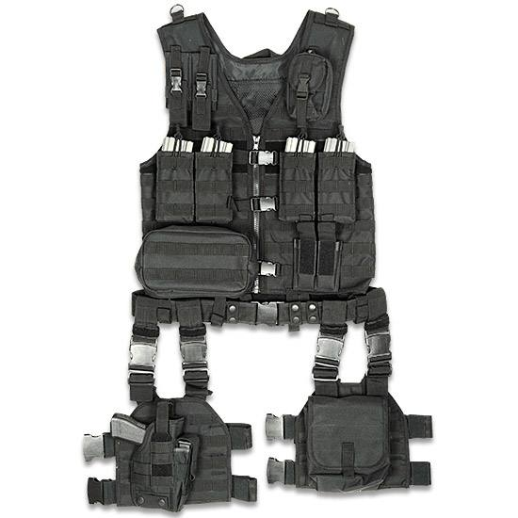

UTG’s ModGear comes in black—and we all know that black goes with everything!
Hey, imagine your prepper is planning a night out in a tux or that new strapless dress. They would still want to carry their new multi-tool, of course, but do not have any pockets. UTG’s ModGear comes in black—and we all know that black goes with everything!

ModGear Tracker Three-Day Assault Pack
Even if you are not a prepper, you should have a bug out bag (a prepacked bag with essentials ready to go). Disaster can happen anywhere and at anytime. You could be running from tornadoes, floods, hurricanes (or his-a-canes after all we don’t want to be gender blaming), or you may even need to outrun an earthquake.
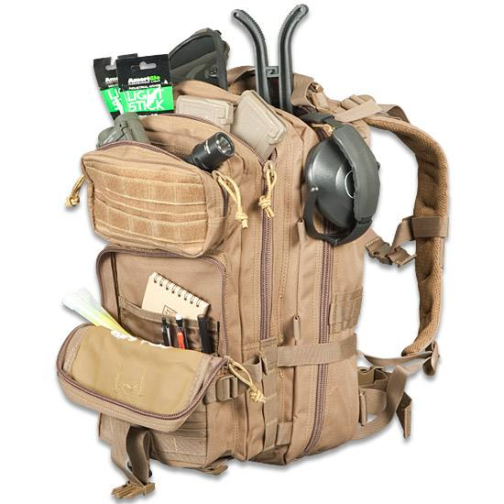

Whether you’re a prepper, or not, this ModGear Tracker Three-Day Assault Pack is a great store-all for your survival gear (do you do have a bug out bag, right?)
Okay, you got me. You can’t outrun an earthquake, but a prepacked bag is a handy get away companion when you just want some time away from your spouse and claiming you bugged out in case of an earthquake is better than no excuse at all. You may want to get you your prepper a vintage steel pot too. I do not know if it will minimize the damage from a frying pan, but it’s worth a shot if you try to tell a prepper wife you tried to out run an earthquake.

Chinook Heavy Duty Padded Outfitter Cot
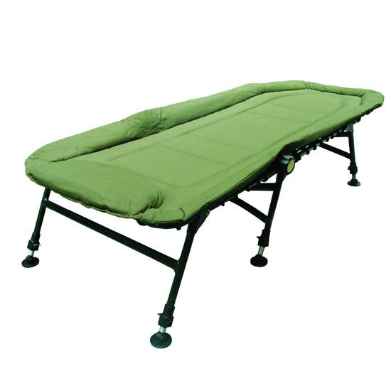

The Chinook Heavy Duty Padded Outfitter Cot offers great protection from the rock that always ends up in the middle of your back on a camping trip.
Speaking of coming home to a spouse equipped with a hot tongue and a cold shoulder, why not grab a comfy cot that can serve double duty. It offers great protection from the rock that always ends up in the middle of the back on a camping trip and it won’t smell like the dog—unlike the couch… Editor’s note: We do NOT recommend the double sleeping bag with this one!
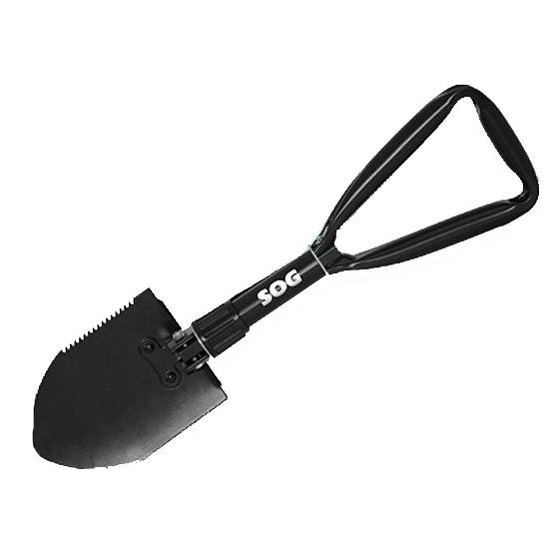

The E-Tool or Entrenching Tool (a fancy name for a small shovel) is an essential tool whether you’re camping or digging your car out of the snow.

E-Tool or Entrenching Tool – (Fancy Name for a Small Shovel)
Whether your prepper is digging up a hidden cache or burying the morning constitutional a shovel is essential. It’s also a handy little creature to keep in the trunk of a car or behind the seat of a truck. You can use it in an emergency to dig your vehicle out of the snow or mud. In fact there are probably thousands of uses for E-Tool. Be sure to drop a few hints in the comment section. Worse case scenario, you can use it to return those poor undead bodies back to a respectable depth (and spare your nostrils from the rising effluvia that will never be confused with roses…).

Power From on High
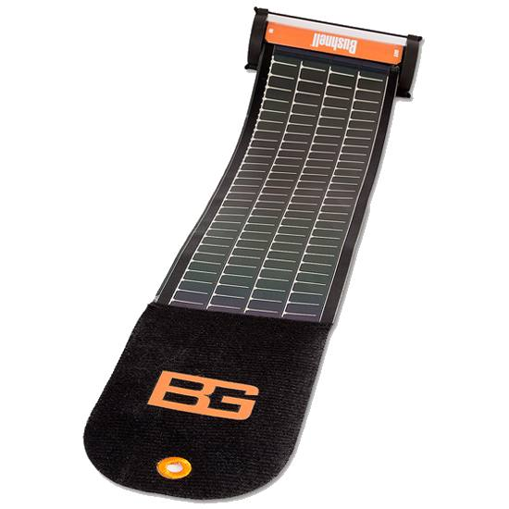

A solar charger must have for any BOB, for use while camping or hiking if your addicted to your electronics or, most importantly, charging emergency radios.
For unbelievably low prices these days we can recharge e-book readers, Mp3 players, smart phones and other USB powered devices. A solar charger is a must have for any BOB (Bug Out Bag) or for use while camping or hiking when your favorite prepper is addicted to electronics. More important than entertainment, a solar charger is perfect for emergency radios and communication devices. Give that e-reader a boost and refer to all of the survival and emergency manuals stored in that library. Kids and those around you may also be suffering and a little luxury and comfort can go a long way.

Grab Your B.O.O.B.S.
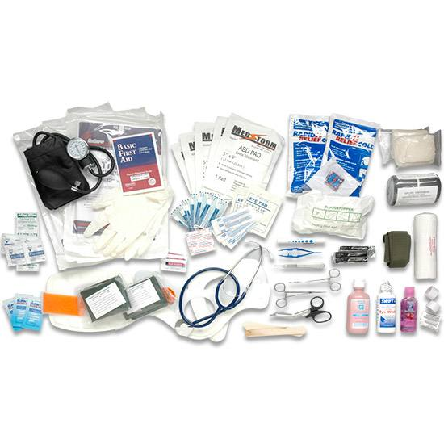

Essential medical supplies for a bug out bag..whether you build your own or purchase one, make sure you have these supplies on hand..

If you are heading out, I recommend Bringing Our Own Bag of Supplies—medical supplies to be precise. I know, I know, we like to build our own first aid kit. However, your favorite prepper may not have the time, knowledge or mindset to put together a kit. Look for a commercial kit with more than aspirin and Band-Aids. I agree, it has to be sufficient to take care of the small stuff, but don’t neglect the large-scale emergencies either. In fact, I would recommend the most comprehensive kit you can afford. You may not know how to start an IV or have the stomach to stitch up a wound, but who knows who will be around and what skills they may have when an emergency happens. I carry a complete medical kit, including everything I need to start an IV when I travel internationally. I may not be able to render self-care, but I trust the needles and supplies I brought more than some remote third world locations.

Water – Liquid Gold
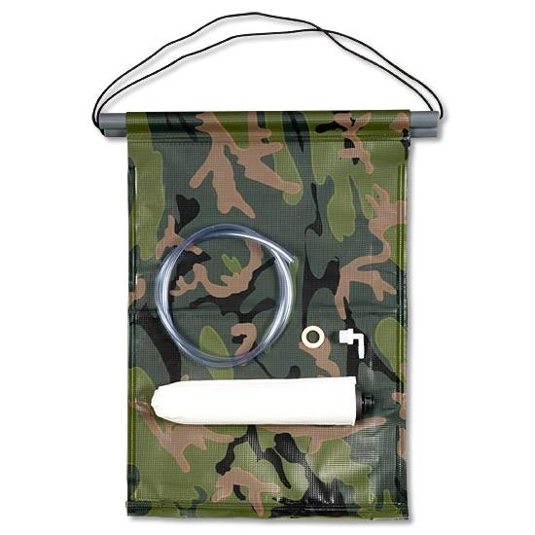

Personal water filtration systems are great for, well, personal use. Look at larger systems for rehydrating food and supplying water to a larger group.
Your favorite prepper may already have a water filtration system, but have you ever tried to suck enough water to cook a pasta dinner for four through a straw? Water filtration systems come in all sizes. Personal filtration systems are an absolute necessity, but so are larger systems to handle certain tasks. When it comes to water filtration remember: one is none and two is one. And dehydrated emergency food is really hard to swallow dry—don’t ask how I know, just take my word for it…

If You Build It They Will Come
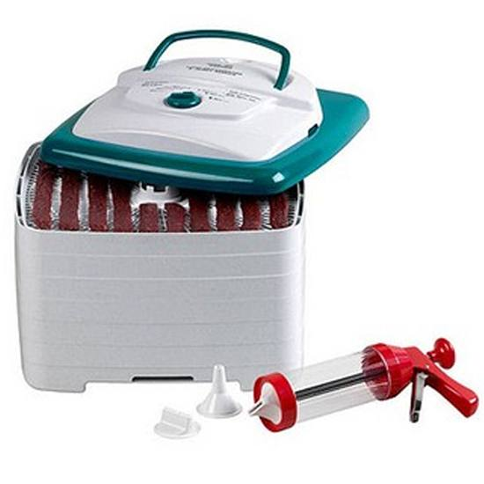

Making great beef jerky is easy when you have the right dehydration system.
I don’t know what to build, but in my experience if preppers make beef jerk using a food dehydrator they never have to hunt for their kid past the pantry. However, my recipe seems to cause hearing loss, so I would appreciate any recipes you could leave in the comment section. It seems when I yell, “Hey, what are doing in there!” my little ones turn toward me with a deer in the headlights look, chipmunk cheeks full of jerky and always reply, “Huh? What?”

Conclusion
A common saying among certain groups of prepared people is that “two is one and one is none.” This simply states the importance of redundancy, so if this short list does not tickle your fancy, take a look at what your prepper already owns. He or she can always use one more of an item they already have. After all, they bought it once so you know it is exactly what they wanted.

