6 Simple Machines for Smart Preppers
by Todd Walker
Hobby farming, homesteading, and other self-sufficiency activities require physical work. Having the right simple tool makes doing the stuff easier – and more enjoyable.
I use complicated machines in my shop that are powered by electricity and other fossil fuels. But the projects that give me the most satisfaction are the ones I’ve made with simple hand tools. If you’re like me, a back-to-basics handicrafter, you have a true appreciation for forgotten, yet indispensable, simple tools and machines.
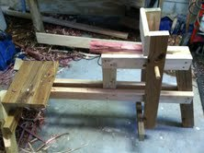
A simple shaving horse I built to make legs for DRG’s cedar bench. My feet press the bottom of the lever which pivots on the fulcrum and holds the wood in place as I use a draw knife.
These deserve to be displayed on the wall next to cherished family photos. No, really! They make great wall art for country decorating.
You could survive without these. But why would you want to? You’re survival kit is ‘screwed’ if you don’t have a few of these packed away.

K.I.S.S. Machines (Keep It Simple Sherpa)
Simple machines have been used for thousands of years to make work easier. You don’t have to be student of physics to appreciate these uncomplicated tools. For example, a wooden board laying on the ground was of no use to help me move DRG’s Farmhouse Table into our dinning room. Yet, when I raised one end of the board to the top of the steps, I was able to move a heavy object the needed distance and save energy with a simple machine called an incline plane.
What is work? Applying force over distance. We work when we push, pull, and lift stuff. Two kids on a see-saw are doing work they call play. Simple tools enable you to multiply pushing, pulling, and lifting without being an actual superhero.
Below are 6 simple machines with examples to help you overcome everyday obstacles and giving you a mechanical advantage in your work. As my daddy is fond of saying, “work smarter, not harder.”
1.) Levers. Any rigid object can be used as a lever. A lever also needs a point of support (fulcrum). That’s the problem with Archimedes’ famous quote, he had no immovable point to rest his metaphorical lever.
Give me a lever long enough and a fulcrum on which to place it, and I shall move the world.
Archimedes
How it works. Levers trade distance for force. Pulling a nail from a piece of wood is best performed using a lever. The longer the lever, the less work on your part. Tools that pry thing are levers. Common levers are claw hammers and crow bars. Levers are useful for lifting stuff. I recently used a metal pry bar, a strap, and a stick of firewood to pry metal t-posts out of the ground to build DRG’s garden fence.
Other examples include: wheelbarrows, manual well pump, shovels, and ‘found objects’ like wooden poles or a length of pipe.
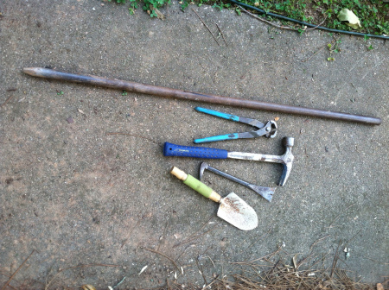
Here are a few levers in my arsenal.
2.) Inclined Plane. This is the fancy word for a ramp. By slanting two 8 foot boards to the top of my steps, I easily moved a very heavy table by myself (DRG helped a little and cheered me on). The pushing and pulling (work) was spread out over 8 feet instead of 3 very strenuous vertical feet without the inclined plane. That’s smart work!
3.) Wedge. The tip of an incline plane forms a wedge, my favorite simple machine. If I’ve got my pants on, I’m carrying a wedge. A wedge is used to cut things apart. If I only had one simple machine to choose from in a survival situation, I’d choose a very sharp, fixed blade knife. With this wedge, you can make other simple tools like a lever trap to harvest food… and eat calories.
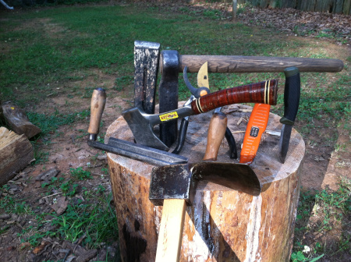
Extra credit if you can you spot the froe?
All wedges have smooth, slanted surfaces. Depending on the application, some are sharp, some are dull. My adze is not near as sharp as my Swiss Army knife.
How about a simple task like opening a can of beans. Try it without a wedge. Not fun! Enter the P-38 can opener – simplicity at it’s best. You have a handfull of these, right?
4.) Screw. What a great concept. Take an inclined plane and wrap it around a cylinder. Why is the screw so important. Try to apply enough torque and twist to drive a nail into a piece of wood. Possible I guess, but a really stupid idea. A screw is simply an inclined plane with sharp edges twisted around its length to move stuff over distance easier.
Brute force (expending limited calories) in building stuff usually ends in a big screw up. SmartPreppers just screw it!
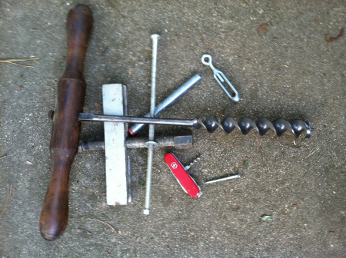
The Swiss Army cork screw for opening that last bottle of dandelion wine!
SmartPrepper Tip: Stock up on a wide assortment of screws and other hardware. These items are hard to DiY and would be a great barter item when rebuilding after a collapse.
5.) Wheel and Axle. Caveman simple. This is another type of lever. Like a hammer rotates on its fulcrum to pry (move) a nail from a board, the wheel and axle is used to moves stuff over distance. On old grist mills, the force of water moved a water wheel attached to an axle that rotated gears to provide crushing power.
Hydroelectricity and other alternative forms of energy are produced through this simple machine. In pioneer days, a good wheel and axle man was alway in high demand. Loads had to be carried. The wheel and axle was the simple tool for the job.
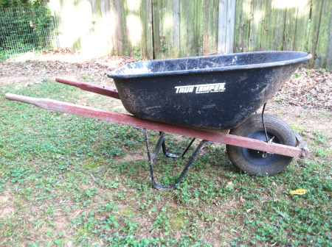
Connect a lever to a wheel and axle to move stuff over distance. You’ve just created a compound machine.
6.) Pulley. Here we have another form of the wheel and axle. Only a rope or cable wraps around the wheel instead of an axle going through the wheel. Attach the end of a rope, threaded through a pulley, to lift water out of a well, lower hay bails from the loft, or raise harvested wild game for skinning.
More complex pulley systems can ease the workload of moving heavy objects. I watched my daddy lift and move a twenty-foot metal water holding tank into a block house with nothing but pulleys and levers when I was a kid. I thought he was super strong! He was strong. But he was even smarter.
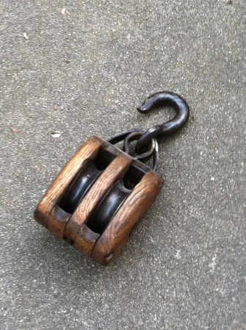
Stock up on pulleys when you can.

