5 Paperback Notebooks for EDC
by Ashley
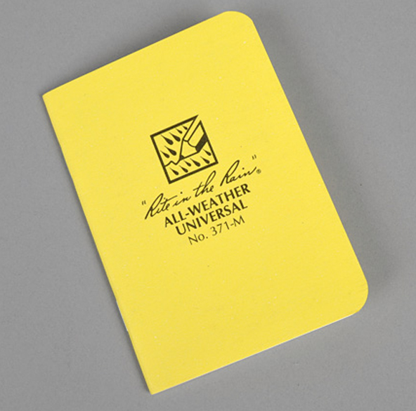
You don’t have to be a writer to include a notebook in your everyday carry (although for those of us who are writers, it’s a no-brainer). Despite the many great note-taking apps available for smartphones, there’s something satisfying about the tactile experience of jotting down thoughts, lists, and more into a notebook. The problem is that there are so many cool notebooks on the market, so how do you choose just one? Here are some of our favorites.

Field Notes

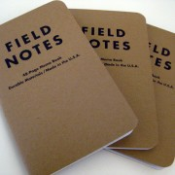
These are the quintessential EDC notebooks. Because they’re so popular, they’ve become the standard size for EDC notebook covers and wallets. Field Notes are available in a multitude of colors, and the special editions are worth collecting. These notebooks come in a pack of four for $9.95 and have four paper options: lined, graph, blank, and mixed. Even with the many options available, I’m personally a fan of the original ones, which have 48 pages.
Moleskine Cahier

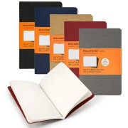
Aside from Field Notes, Moleskine notebooks are some of the most iconic personal journals ever made. This is what I’ve been using as my EDC notebook for the past few months. I like these because they have the same high quality of Moleskine notebooks, but at a much cheaper price. Cahiers come in different colors and different sizes. I use the 3.5 x 5.5 in black because I like that it’s compact, but still large enough to write in easily. A pack of 3 is $8.95, and they’re available at stores like Target, Walmart, or Barnes & Noble.
Rite in the Rain

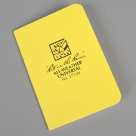
These notebooks are not for the faint of heart. They’ve been designed to withstand harsh conditions. Perfect for the outdoor adventurer—or someone prone to spilling coffee on notebooks (not that I’m speaking from experience or anything). These might not be as cleverly designed as the others (although I like their little logo), but they have a simple and pleasing aesthetic. They also have different sizes available. A 12-pack costs $45.95. (Check out a review of the waterproof paper here.)

Word

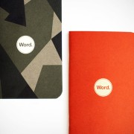
I don’t see these as often as Field Notes, but I think they have a similar feel with a few more color options. These remind me a lot of the Moleskine Cahier, too. I particularly like the modern take on camo. That pattern would be a good fit for a rugged or tactical EDC. These notebooks also feature great interior design, such as to-do list layouts and various line or grid options. Intended for productivity, these notebooks are great for the office or outdoors (especially for travel). Pack of 3 for $9.99. 48 pages.

Doane Paper


I stumbled upon these on an EDC forum, and they look comparable to Field Notes and Word. These capitalize on the 3.5 x 5.5 form factor and have a simple, black and white color scheme. Like Field Notes, the logo is displayed on the cover, but the minimalistic design makes these neutral enough to match any EDC scheme. I enjoy both the wide ruling and the grid paper. A pack of 3 is $9.95. 48 pages.

