37 Woodlore Lessons

by Todd Walker
I sat in the front of our aluminum jon boat as my daddy silently paddled us down Little Echeconnee Creek from the wooden bridge. A seven-year old boy with his daddy's single-shot 20 gauge in his lap... I was living every country boy's dream. Daddy had killed wild game with this same Stevens shotgun since he received it as a gift on his 14th birthday. My love of woodlore began that cool autumn day.
Going to the woods has always meant going home for me. Among the trees, rocks, animals, and streams I find peace. The reality is that we are all dependent on nature no matter how domesticated we've become. Our wild ancestors coaxed all the resources needed to live from the same trails you and I walk.
Many woods lessons came to me the hard way. Mistakes make us wiser... if we live to tell the stories around the campfire. You may know these lessons in your head, but until you've experienced them, your knowledge is not knowing. You must get out there.
“Reading about nature is fine, but if a person walks in the woods and listens carefully, he can learn more than what is in books, for they speak with the voice of God.” ~ George Washington Carver
Knowing is different from knowledge. Knowledge is acquired intellectually. Knowing equals knowledge plus experience. Knowing is the spiritual and emotional connection... the stuff that sticks with us and becomes second nature.

Woodlore
What is woodlore?
Woodlore ~ "skills relating to living in a woodland environment; woodcraft."
Woodcraft ~ "skill in anything that pertains to the woods or forest, especially in making one’s way through the woods or in hunting, trapping, etc."
There is no graduation date in the school of woodlore. Our journey to knowing will take a lifetime. Below are a few lessons I've learned. My hope is that you find these helpful on your journey of knowing woodlore.
- Walk slowly and make frequent stops to observe your surroundings. Like a leaf softly landing on still water, try to send faint ripples in the woods not tidal-waves.
- Take notice of the story nature is telling: Bird songs, animal behavior, weather patterns, etc.
- Step on top of fallen logs/obstacles in your path before crossing. Step and look back to see if a snake rests underneath.
- When selecting a camp site, give attention to the 4 W's: Wood, Water, Wind, and Widow Makers.
- Collect resources as you go. These may not be available at your destination.
- Conserve resources. A forked tree can process firewood saving the edge of your saw or ax.
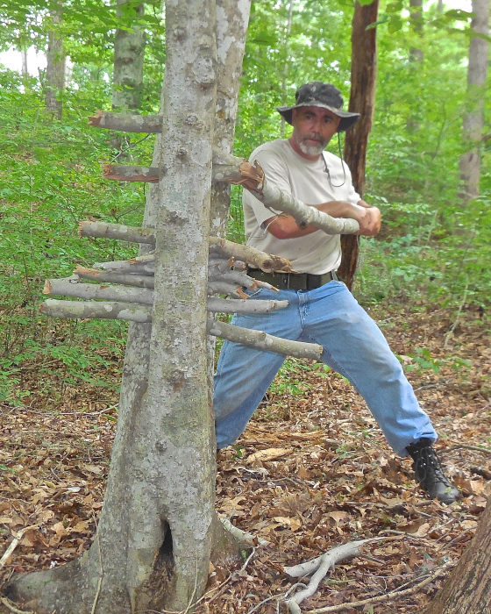
This forked tree caught the firewood as it broke
- Learn to find dry fire-making material in wet conditions.
- Go light when packing. Fatigue makes cowards of us all. Leave the shiny survival objects home. Practicing skills with multi-purpose gear lightens your load.
- Whether in a group or alone, leave a detailed itinerary with a trusted friend or family member in case you need to be rescued.
- Carry easily accessible no-cook trail food for energy boosts while hiking. Click here for my pemmican, jerky, and parched corn recipes.
- Stay hydrated, especially on winter trips.
- River rocks hold water. When heated around a fire, the water expands rapidly and may blast shards of stone in all directions.
- Layer clothing in such a way that you can regulate core temperature. Don't sweat it! If your clothing becomes wet on winter trips, build a fire to dry them.
- Learn to sleep well in the woods. Carry a pair of wool socks dedicated for sleeping.
- Take care to clear your camp area of debris for fire safety and tripping hazards.
- Stow your weapon close at hand as you sleep in camp.
- Eat well. Pack food and comfort items for an enjoyable trip. Coconut oil and hot cocoa not only give me comfort but add calories and energy to my meals. You can't go wrong with home cured bacon! Supplement meals with wild foods if available and only when sure of their safe use.
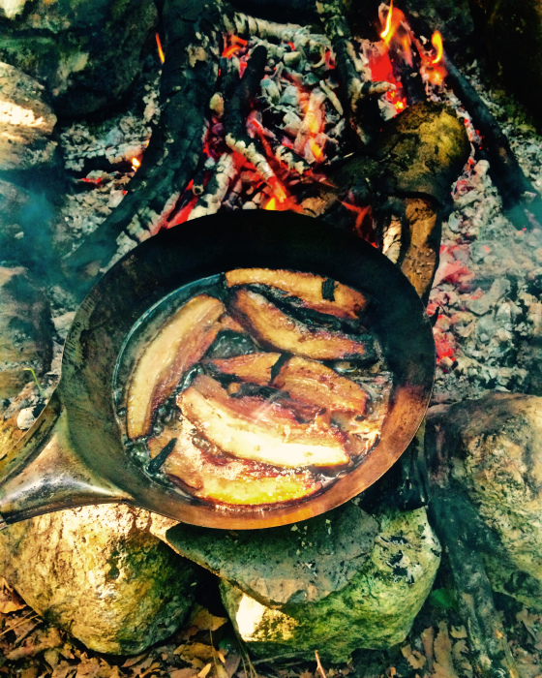
Dry-cured bacon in a metal frying pan
- Coals are for cooking; flames are for boiling.
- Listen to your gut. If you get a gnawing feeling something is not right, pay attention and proceed with caution.
- Always offer the best seat around the fire to others.
- Don't do stupid stuff you may have seen on "reality" survival shows. How do you know if something is stupid? Your knower will tell you. Physical injury in the wilderness turns camping into survival.
- Carry at least two knifes. If one is lost or fails, you have a spare.
- Practice situational awareness. Sounds mean something in the woods. A twig snapping could be an approaching animal (four or two-legged) or a falling limb. View the landscape with relaxed eyes to detect movement in a wide-angle. Once movement is spotted, your eyes will focus on that point.
- Listen more than you talk around the campfire.
- Keep a small amount of dry tinder in your pack and some kindling and fuel under your shelter for the morning fire in the case of rain. Heavy-duty garbage bags are modern marvels. Carry two.
- Ax work is a daylight job.
- Maintain sharp cutting tools in the field.
- Water is life. Fill your water container(s) at every chance. You'll not only find hydration at the water's edge but many food sources... both small and large.
- Carry a pair of leather work gloves. Nicks and cuts to your two most useful tools is not advisable.
- That goes for your only means of conveyance, too... your feet. Wear comfortable, reliable footwear. Waterproof boots are non-breathable and eventually lead to sweat-soaked feet.
- Never walk through the woods with an un-sheathed ax.
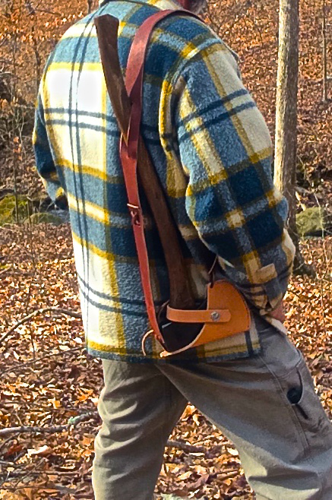
- Resupply your tinder box with charred material for your next fire as needed.
- Learn to administer self-aid with common items on the occasion you have no dedicated first aid kit.
- Spend more time collecting/processing tinder and kindling material than fuel size wood. Fire needs to eat small stuff before consuming larger wood.
- A wax candle conserves fire ignition sources and aids in drying damp tinder.
- Even on "short" hikes in the woods, carry these tools as a minimum: Knife, fire starter, poncho or emergency space blanket, water bottle, cordage.
- Go prepared with modern gear and equipment but practice primitive skills.
- Always remain a student.
Woods wisdom comes with time. Spend more time in the woods to turn knowledge into knowing. These are a few lessons I've learned by spending time in the woods.

