36 More Weekend Projects For Preppers
By Stephanie
Looking for some cool DIY weekend projects for preparedness?
You loved our weekend emergency preparedness projects so much the first time, we thought we’d give you even more!
Only this time, we’ve only included even better and more useful survival gear and perfect prepare projects.
With our friends over at DIY Ready, we’ve created a list of the best disaster preparedness projects for you and your family to work on in your down time.
So check out this list of the best weekend preparedness projects and be ready for when the SHTF!
Missed the first one? Check out the first 36 Weekend Preparedness Projects List
Check out this list of the best weekend preparedness projects and be ready for anything!

36 More Favorite Weekend Preparedness Projects:

1. How To Make A Moonshine Still
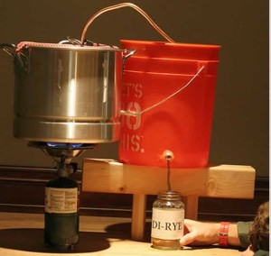
A still comes in handy for lots of reasons. We’d hate to be without a way to purify water, so we made a DIY still along with a step-by-step tutorial that shows you how to make one of your own.All you need is a big pot, a drill, a bucket and a couple of inexpensive parts from your local hardware store.

Find our step-by-step instructions here!
[This information is provided for entertainment purposes only and should not be used for illegal activities]

2. Learn How To Build An Awesome Chicken Coop.
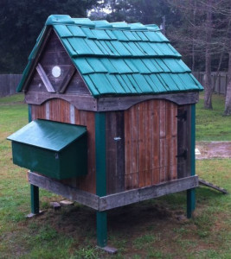
Want to live off the grid and learn homesteading? You are probably going to want some chickens, and those chickens will need somewhere to live. There are lots of different chicken coops you can buy or build, but we liked this one best. The water resistant roofing is our favorite part, plus it looks great! Guess what it is built from?
Learn how to build your own chicken coop! Instructions here.

3. Stock up with some homemade survival bars

With our first project list, we brought you fruit flavored survival bars, which we still love. We decided to add a new twist to the recipe by adding chocolate and also chia seeds, one of the most perfect survival foods around. These bars last (almost) forever and taste amazing.

Recipe and instructions for Chocolate Chia Survival Bars.

4. Create your own Giant Monkey Fist for self defense.
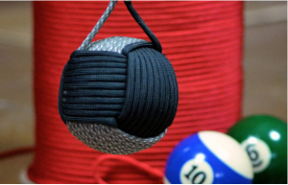
Yep. There’s a pool ball in there. Pretty cool little homemade weapon, we must say.
A paracord monkey fist is beneficial to carry on you for survival and self defense purposes. It’s super easy to conceal and carries enough power to slow down any attacker.
In this tutorial you’ll learn how to make a paracord monkey fist with a lanyard, with a pool ball inside. This giant monkey fist weighs in at a hefty 6 ounces!
How to make a monkey fist

5. Practice creating an Emergency Survival Shelter for ultimate emergency preparedness.
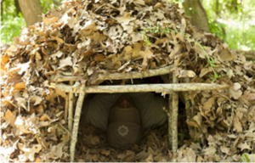
Learn how to build an emergency preparedness survival shelter that you can build with nothing more than what you can find in nature. This one uses leaves and branches, and has everything you need to protect yourself from the elements in case of emergency.
Learn this survival skill and never be without shelter!

6. Make your own Paracord Dog Collar.
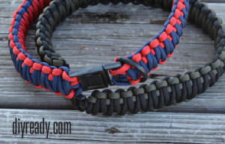
There are so many fun paracord projects out there. Right now, our favorite one is this DIY paracord dog collar. It’s the ultimate dog collar made with about 40ft of 550 paracord. This paracord dog collar uses a double cobra braid and is your best bet if you are looking for a stylish collar that is also super strong and durable.

7. Make you own Paracord Keychain Survival Kit.
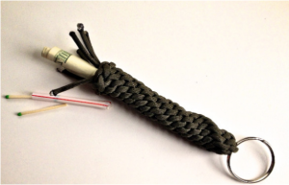
This little paracord project is one of our favorites- you can stash your emergency kit in the hidden compartment. You can keep money, matches, lockpicks, anything small you want to keep hidden but handy.

8. Hack your home defense with this Cell Phone Trip Wire Alarm System.
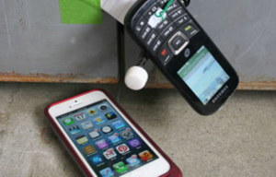
Ever wanted to know how to make your own DIY alarm system? Believe it or not, you can make your own wireless home security system for about $10 with a few simple hacks to a prepaid cellphone. This DIY hack allows you to create a tripwire that will alert to to any intruders by calling you cell phone.

9. Build your own Solar Cellphone Charger.
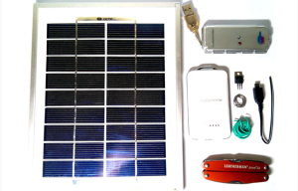
Worried about not having power to charge your phone? We prefer not to spend the money to pay for an expensive solar charger and love this DIY tutorial that shows you how to make a solar cell phone charger.
Full instructions here.

10. Build your own Quick Draw Sleeve Gun for concealed carry.
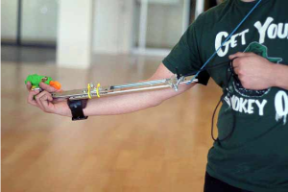
Check out this crazy cool homemade gun sleeve for the ultimate quick draw concealed carry experience. You may have seen the original off which it is based in the movie, Taxi Driver. Now, we show you how to make your own DIY version of this cool weapon accessory. Whether for fun or extreme tactical use, you’ll have a blast making this project.

11. Personalize your favorite gun with these Best AR15 Gun Hacks.
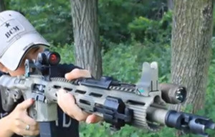
From hacking your handle to picking different pins, we have tips we bet you’ve never thought of. You can easily become a better shot and enjoy shooting your AR15 even more.
Using this list of tips, you’ll have your gun souped-up and tricked-out in no time.

12. Learn these easy and useful Paracord Knots and Hitches.
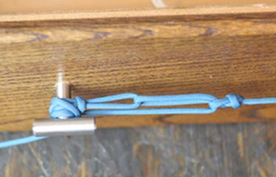
These knots and hitches will come in handy in a crunch! Practice these paracord knots this weekend!

For the full list of 36 projects, check out the entire article on DIY Ready!

Want more preparedness DIY projects? Check out these posts:

36 Weekend Preparedness Projects

36 Paracord Projects For Preppers

7 Easy Prepper Projects

