35 Lifechanging Ways To Use Everyday Objects

1. Use a can opener to open sealed plastic packaging.
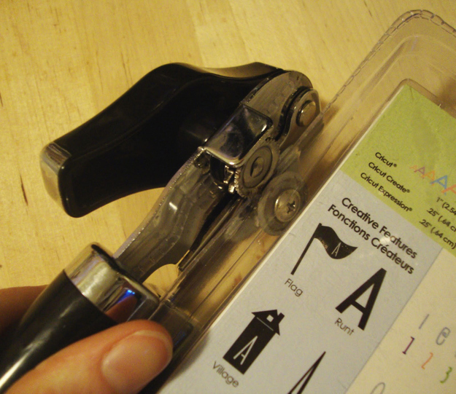

This tip would have saved me approximately 22.8 hours of my life.

2. Add saline solution to refresh dried-out mascara.
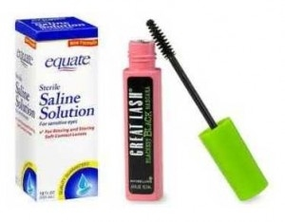
Just a couple of drops will do.

3. Use a toilet seat cover to blot the oil from a greasy face.

Don’t use one left on the seat….
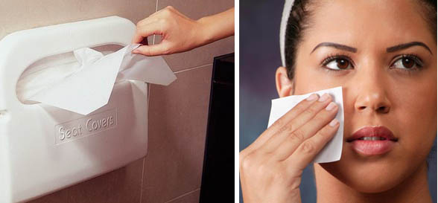

4. Use pretty wine corks to make planters for tiny succulents.
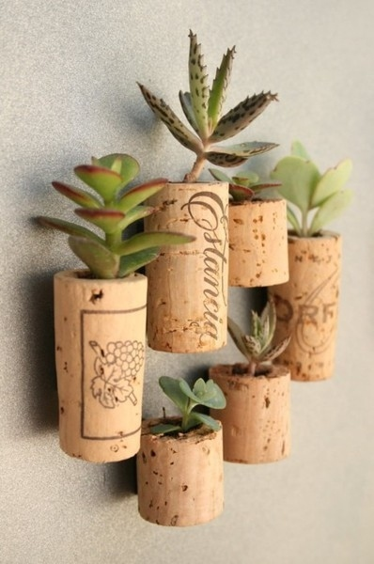

Put magnets on them and hang them on your fridge.

5. Amplify the volume of your iPhone or iPod by placing it in a bowl.
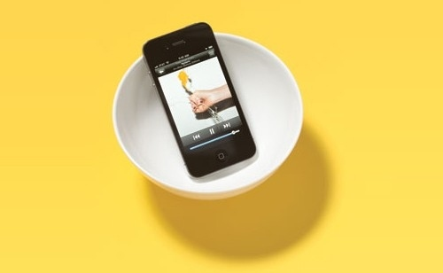

6. Use paper hole reinforcements to give yourself a half-moon manicure.
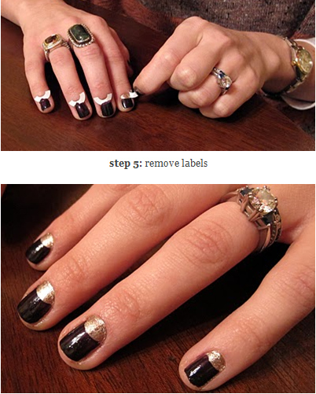

7. Use a banana to fix a DVD.
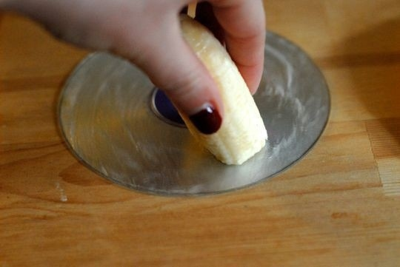

8. Use Jello as a lipstain.
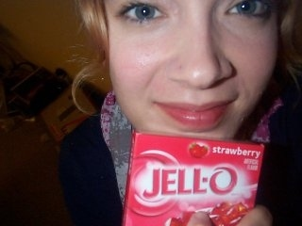

Directions: Pour the powder mix into a bowl and moisten a Q-Tip with water. Then, being very careful not to use your fingers since the red stains stay put, dip the Q-Tip into the powder and apply it directly to your lips.

9. Use diluted fabric softener as a leave-in hair conditioner.
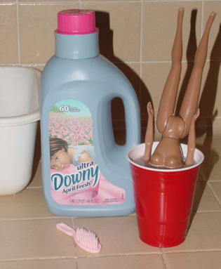

10. Use a lint roller to clean out the debris in your handbag.
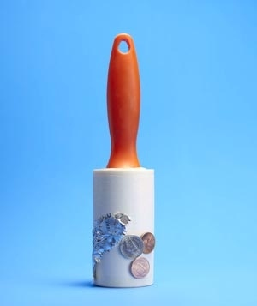

I am the queen of cookie crumbs in my handbag.

11. Use nonstick spray on the inside of your votive holders.
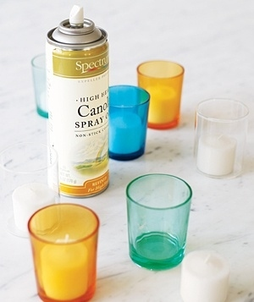

When the candle has burned out, the remaining wax will just slip out.

12. Eat marshmallows to soothe a sore throat.
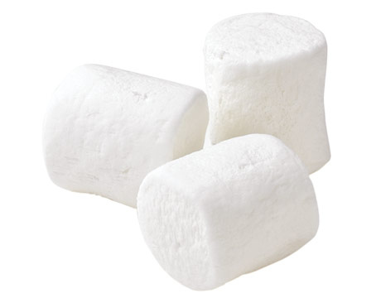

There’s a scientific explanation behind this.
(You can also use marshmallows to separate your toes during a home pedicure.)

13. Use newspaper as an odor absorber.
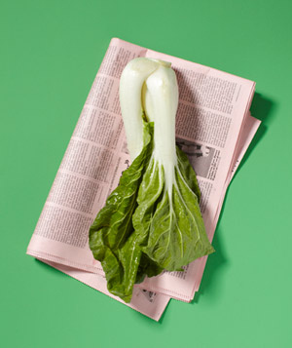

You can put it in Tupperware, or the crisper bin of your fridge, or in a purse with any lingering leather smells.

14. Use aspirin to turn hair made green by chlorine back to its natural color.
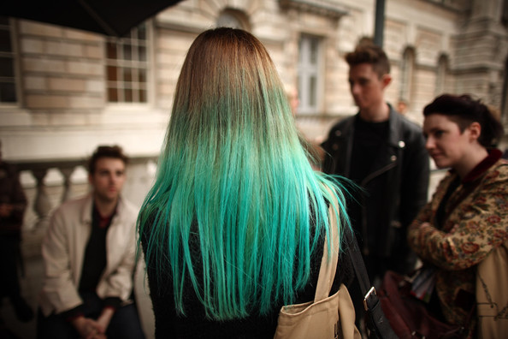

www2.pictures.zimbio.com
Dissolve six to eight aspirin pills in a glass of warm water, coat hair with the solution, let it sit for 10 to 15 minutes, then rinse.

15. Use a sock to create a big perfect hair bun.
youtube.com

16. Use a spoon to open a sealed-tight jar.
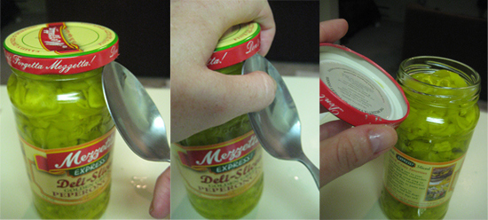

17. Use a rubber band for perfect French tips.
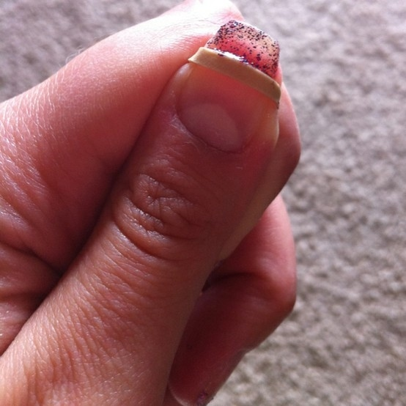

18. Hang a picture using a pop tab.
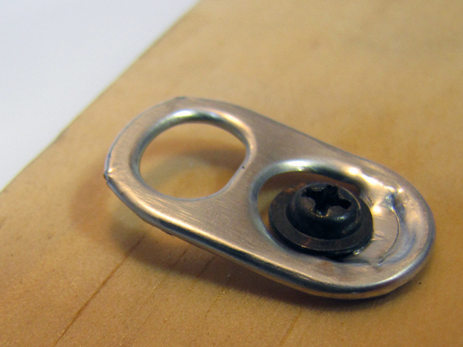

The pop tab is surprisingly sturdy.

19. Use VapoRub to train your pets.
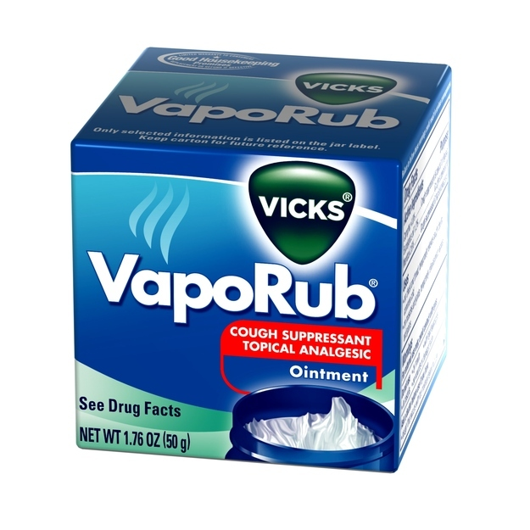

Apply VapoRub on things you don’t want chewed up or peed on by your cat or dog — they’re turned off by the taste and smell.
It also supposedly cures toenail fungus.

20. Use mayonnaise to erase water stains from wooden furniture.
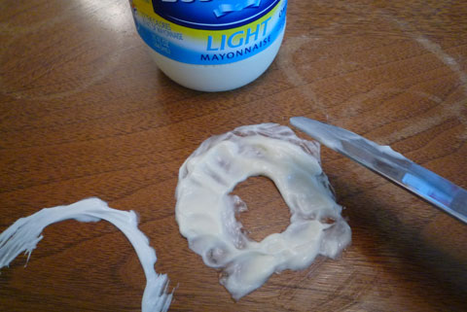

charlesandhudson.com

21. Use fabric softener and vinegar in a spray bottle to release wrinkles from clothing.
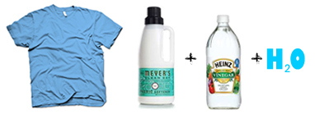

22. Use a cereal container as a trash disposal in your car.
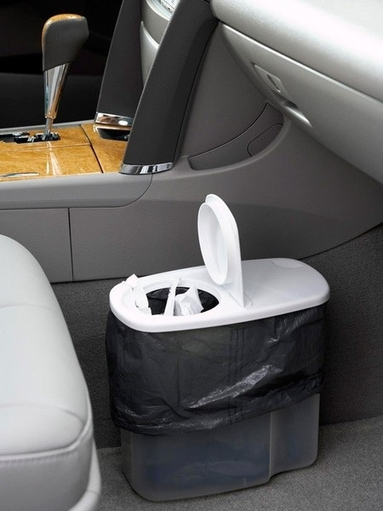

23. Add a few drops of vodka and a teaspoon of sugar to make cut flowers last longer.
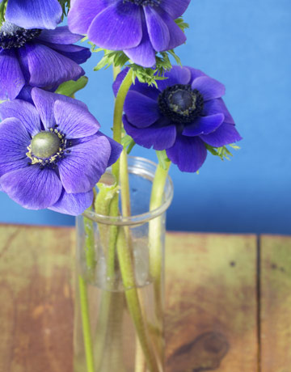

24. Use Alka-Seltzer to clean your toilet.
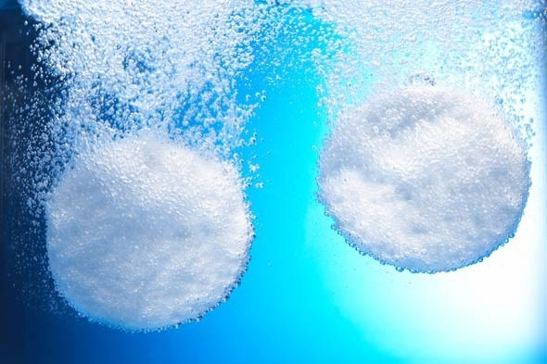

Drop a couple tablets in, wait 20 minutes. The citric acid will dissolve the grime.

25. Use hand sanitizer to dissolve ink stains.
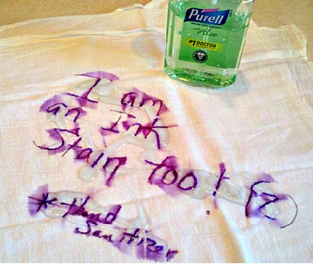

26. Use (unscented) dental floss to cut soft cheeses and cakes.
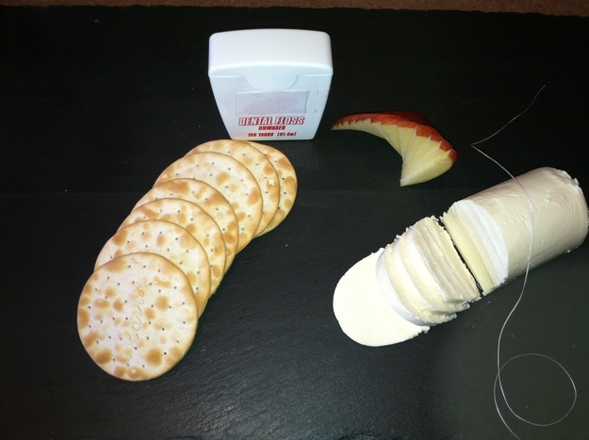

27. Pack your shoes in a shower cap to keep the soles from touching your clothes.
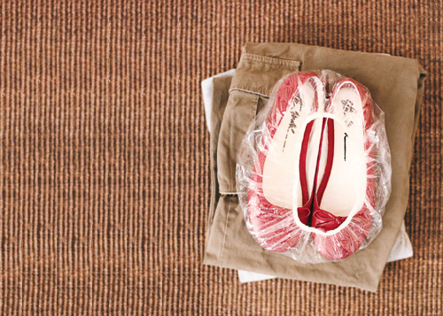

28. Use raw spaghetti strands to light hard-to-reach candle wicks.
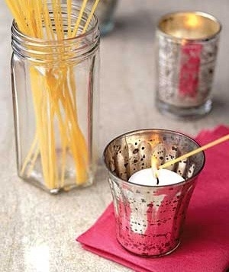

29. Use Earl Grey teabags to get rid of a sunburn.
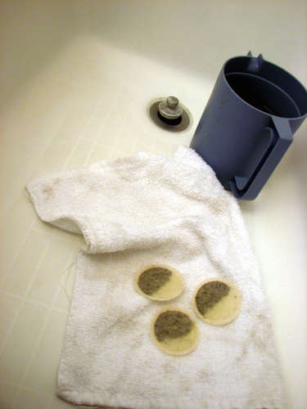

30. Use mustard to suck the pain out of a burn.
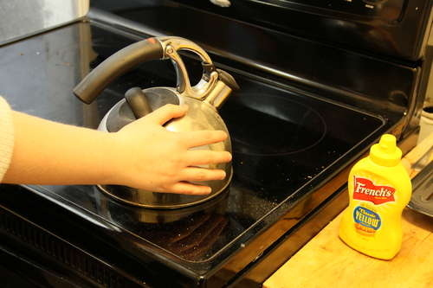

But also, don’t put your hand on a boiling kettle.

31. Rub the cut edge of cheese with some butter to keep it from getting moldy.
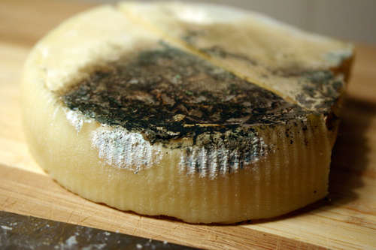

32. Use Scotch tape or nail polish to relieve an insect bite.
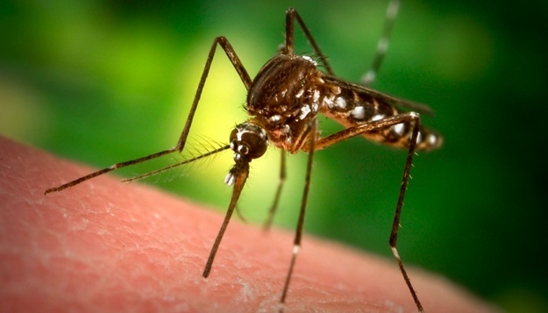

Blocking oxygen from getting into the bite will stop the itching.

33. Use a blow-dryer on a mirror to clear the steam after a hot shower.
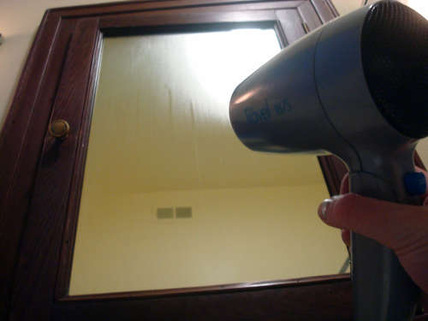

34. Throw baking soda on a burgeoning grease fire.
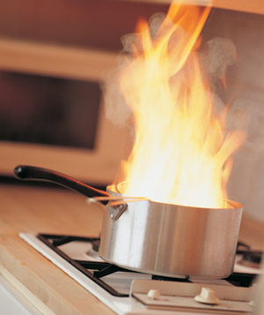

It works much like a powder fire extinguisher. But don’t use water, baking powder or flour, as it’s likely to make the fire even bigger.

35. Open a bottle of wine using your shoe.
youtube.com
Maybe the most useful thing anyone needs to know, ever.

