23 Essential Winter Camping Hacks
Reasons why camping in the winter is actually better: There are no bugs, the wildlife is in hibernation, and no one but you is crazy enough to be out there in the arctic temperature.

There are a lot of important basics that you need to know if you’re a newbie, so check out this guide from REI to make sure you know the bare bones to survive.

1. If your flashlight batteries stop working in the cold, warm them up before using them.
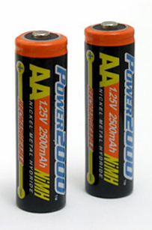
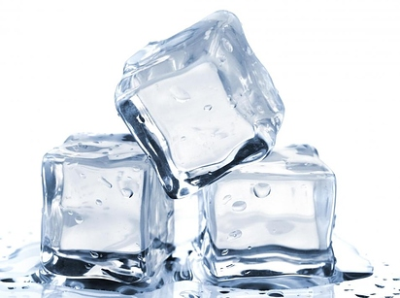
Batteries don’t discharge as well until warmed up, so hold them in your hand near a heat source or keep them in your sleeping bag.

2. Buy your winter camping essentials when they’re on sale during the summer.
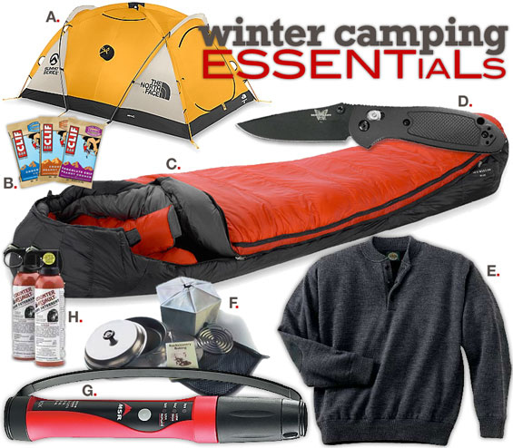

gearpatrol.com
Another cheap option: Rent your gear from REI.

3. If you’ve got room in your sleeping bag, keep your clothes for the next day in there with you.
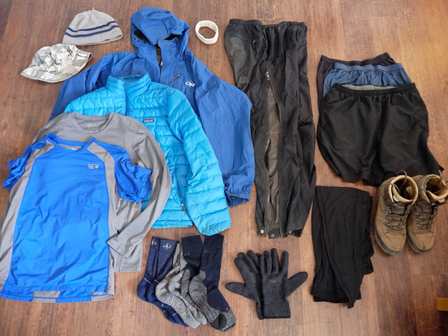

mountainphotographer.com
Avoid having big pockets of air between you and the sleeping bag — it’s just more space that you’ll have to expend body heat trying to warm up. Instead, stuff your next day’s outfit in there with you and as a bonus, you won’t have to put on cold clothes in the morning.

4. Use hand warmers to warm up your sleeping bag.
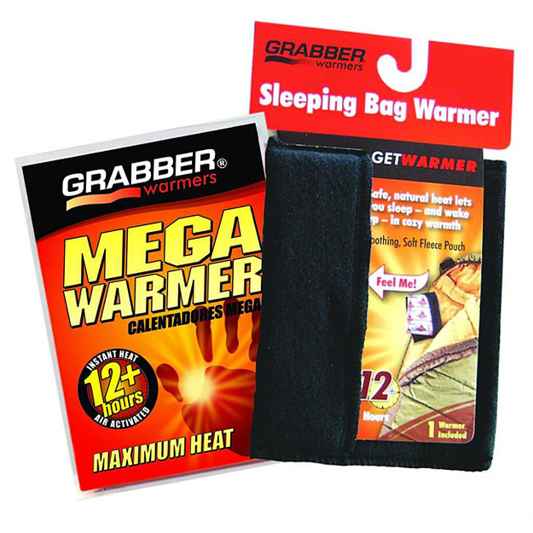

overstock.com
If you’re in super-low temperatures, your sleeping bag relies on your body as its only heat source. With a hand or sleeping bag warmer, you can warm up the sleeping bag much faster while trapping in the heat.
You can also use them to warm up your boots before you put them on.
They’re $11.89 from Overstock.

5. Yoga mats can double as foam sleeping pads to isolate you from the ground.
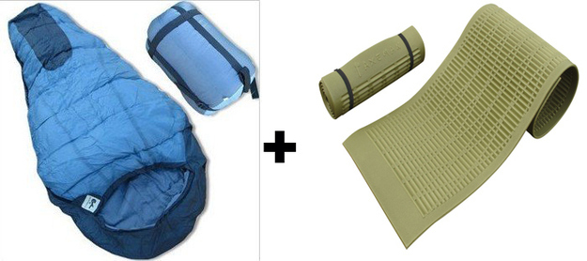

If you’re on a budget and already own a yoga mat or two, double up on them and layer them underneath you.

6. Keep your matches in a metal, not plastic, container.


Flickr: 64251830@N00 / Via allcampgrounds.com
Plastic can break if frozen. Always pack way more than you think you’ll need.

7. Don’t sleep with your face buried under the covers/sleeping bag.
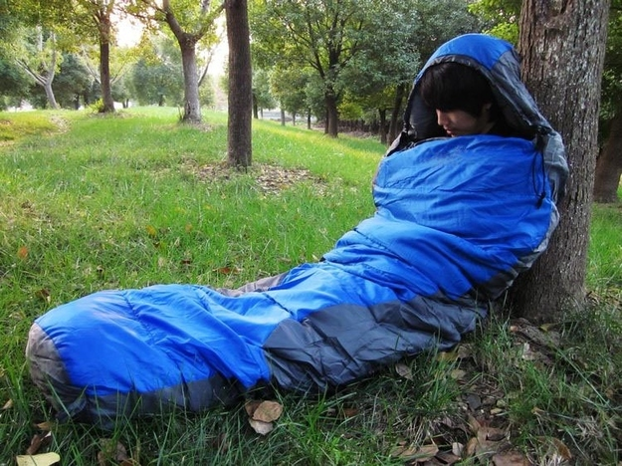

aliexpress.com
The moisture from your breath will cancel out the insulating properties of your sleeping gear.

8. If there are other people in your tent, sleep close together so that less cold air rises through the tent floor.


9. Make your own flannel sleeping bag liner.
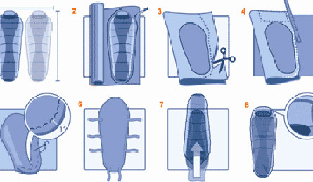

backpacker.com
A sleeping bag liner can add 8° to 15°F of extra warmth. A DIY flannel liner is a good option if you’re on a budget. Get directions here.

10. If you have to pee, don’t hold it. Use a pee bottle.


backpacker.com
Your body has to burn calories to keep urine warm, so it’s better in the long run to just deal when your bladder calls (or force yourself to pee before going to bed).
If you’re a guy, keep a pee bottle nearby. If you’re a girl, try a urination funnel for more convenient peeing.

11. Put boiling water in your water bottle and sleep with it at your feet.
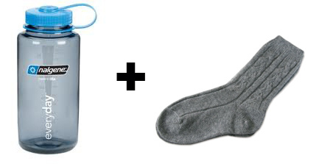

backcountrygear.com
Fill your water bottle with boiling water (make sure it’s able to withstand boiling temperatures, like a Nalgene) and put a sock around it. Keep it in your sleeping bag for extra warmth. In the morning, you’ll have non-frozen water to drink.
You can also try the air cooler from Granite Gear.

12. Open the vents in your tent even if it’s freezing.
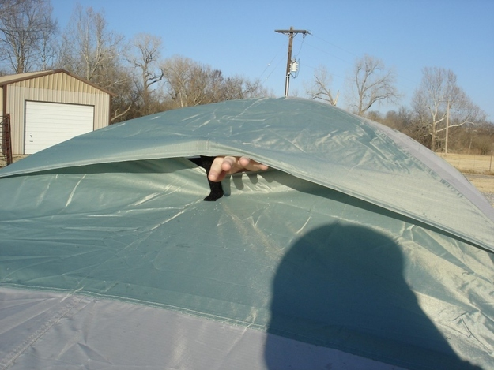

blog.nomadicscribe.net
Otherwise, your breath will condense, creating snow or water inside your tent.

13. Cowboy coffee is the easiest and best way to make coffee while camping.
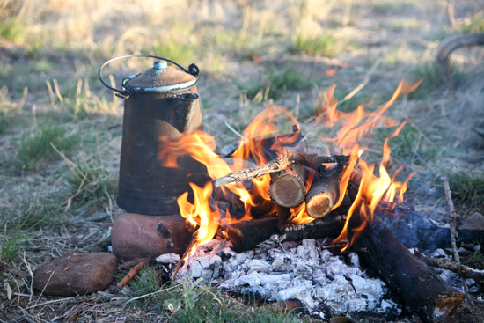

goldenstate.wordpress.com
Get the directions here.

14. Buy or make a stove stabilizer platform so your pot doesn’t fall over while cooking.
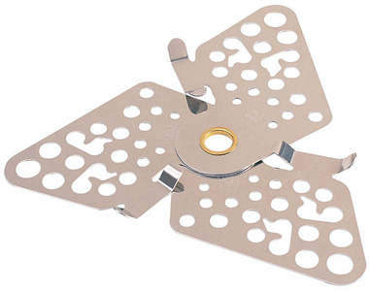

cascadedesigns.com
When you’re dealing with a heat-generating stove, it’s possible for any melting snow to topple the delicious food you’re making. You can buy a stabilizing platform, but you can also make one. There are a bunch of ideas here in the comments, including using a disposable pie pan.

15. Keep your water bottles upside down so they freeze at the bottom first.
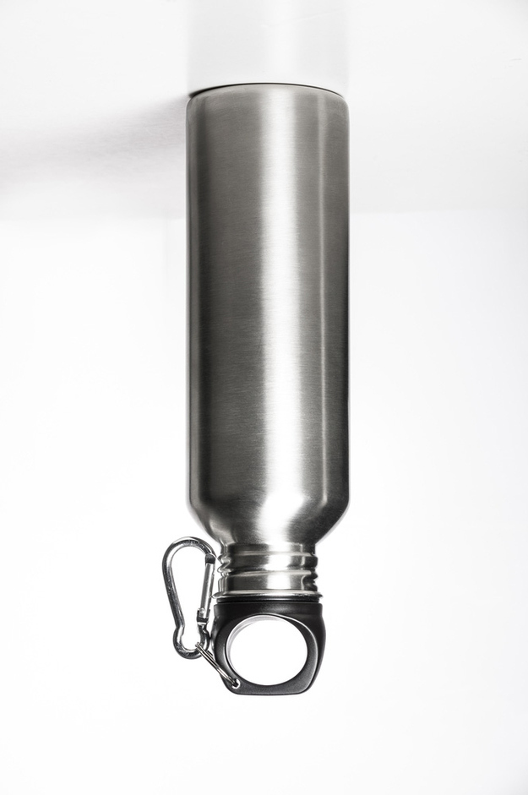

Shutterstock
Hopefully, this will keep the water at the top liquid and drinkable.

16. Tie a tarp between two trees to create a wind wall.
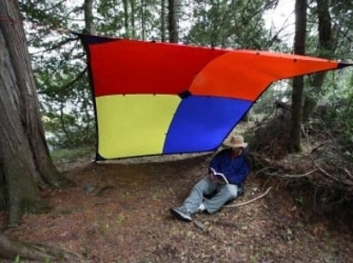
kk.org
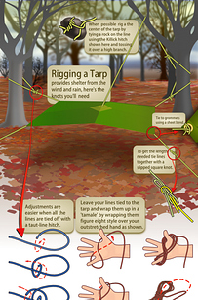
scoutmastercg.com
If you have heavy wind and/or snow coming from a particular direction, a wind wall will keep your tent warmer and help with fire building as well.
Click here for a handy graphic on tying tarp knots.

17. Double insulate your sleeping bag the DIY way with two car windscreen heat reflectors.
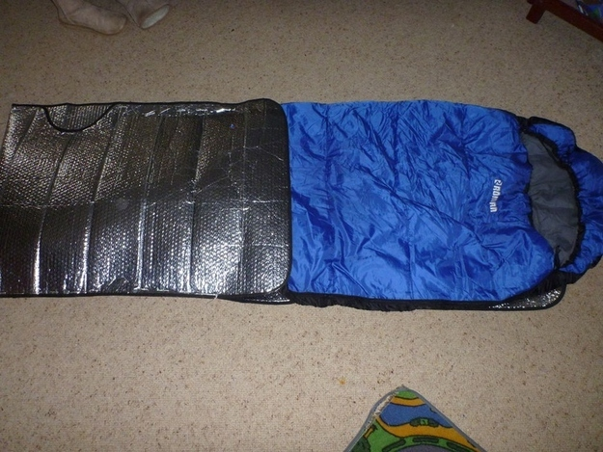

instructables.com
Sew two car windscreen heat reflectors together and place your sleeping bag inside. It reflects your body heat back onto you so you’ll stay much, much warmer. Just make sure you poke holes in them so you don’t wake up soaked in sweat.
Directions here.

18. Wrap your fuel bottles with duct tape.
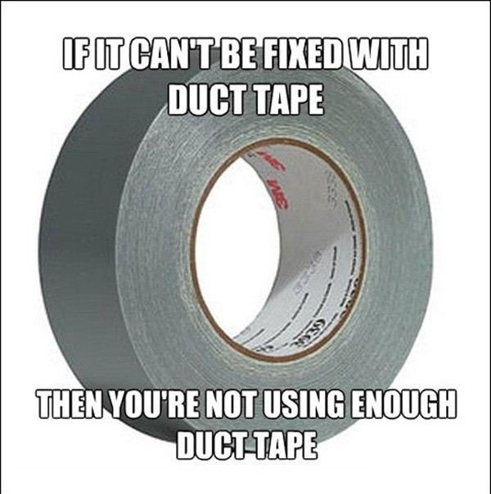

If your fuel bottle is made of aluminum, it can give you instant frostbite in cold weather. Duct tape will help insulate it and make it easier to handle.

19. Use wooden utensils, not metal ones.


littlebitfunky.com / Via campingroadtrip.com
Since metal can get super cold, metal utensils can cause the temperature of whatever you’re cooking to drop quickly. Opt for wooden or plastic instead.

20. Use your backpack as a foot cover.
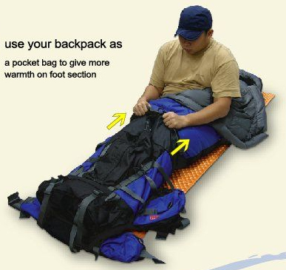

luxeoutdoor.com
Alternatively, you can stick your hiking boots and other things you don’t want to freeze into the bag and stuff it into the bottom of your sleeping bag.

21. Hook a binder or key ring to your zippers to make them easier to unzip.
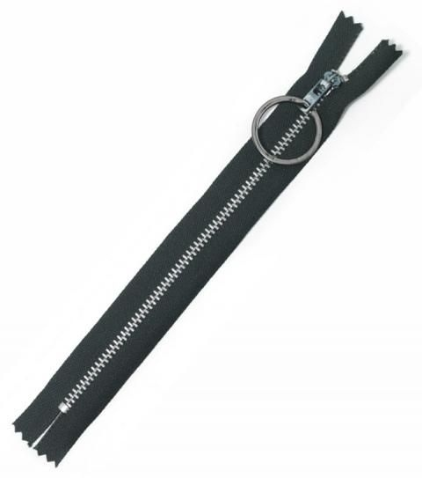

fieldandstream.com
“When it’s really cold outside and you have on a lot of layers, it can be hard to find your zipper—-especially with frigid hands or while you’re wearing very thick gloves. As a simple solution, just hook a 3⁄4-inch key ring on the handle.”

22. Know the quickest and best way to start a fire in adverse conditions.
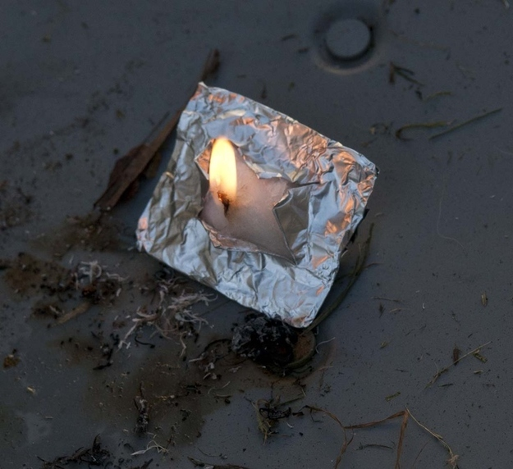

preparednessadvice.com
Take a small square of foil, a cotton ball coated with Vaseline, and fold the cotton/vaseline soaked ball into the foil in a small square. When it’s time to start the fire, cut an X in the packet and twist out a small amount of cotton into a wick and strike a spark to it. It will light dependably first time, every time. It will last up to 10–15 minutes depending on how much vaseline you put in the cotton.

23. A powerful pocket chainsaw helps you cut wood easily — especially when you’re having a hard time finding dry wood.
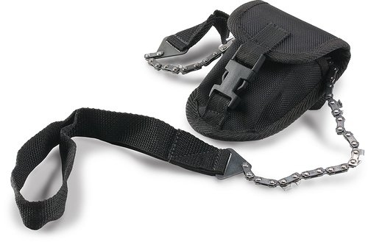

amazon.com
This is a great tool to have anyway, but it’ll come in very handy if you’re winter camping. If you’re having a hard time finding dry wood, sometimes the best option is to get it from the inside of a log. The chainmate is $13 from Amazon.

And now for some basic survival tips:

Wear synthetics, and say NO to cotton.
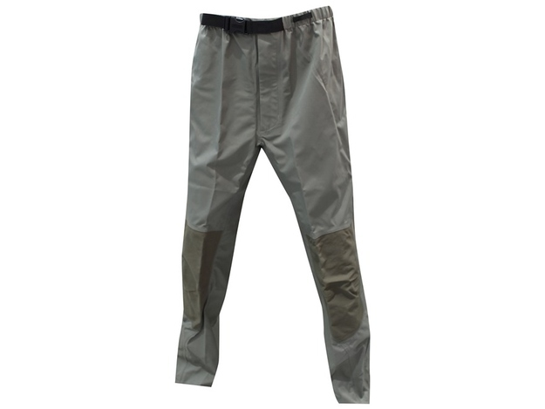

Synthetics are a cheaper alternative to wool and do a good job of wicking away moisture and sweat. Whatever you do, don’t wear jeans — they take forever to dry.

Start shedding layers the second you start perspiring.
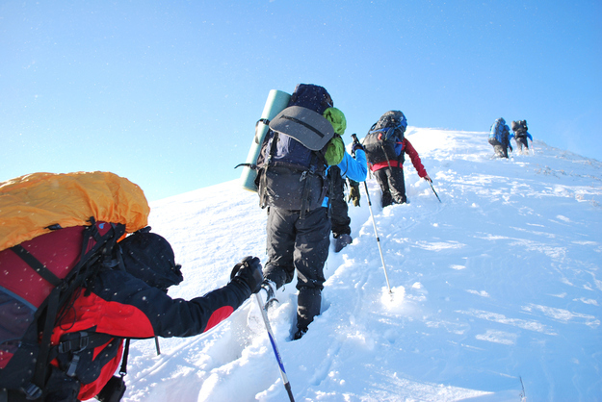

http://www.shutterstock.com
Strenuous activities like hiking will naturally induce sweating. The liquid will chill you to the bone once you stop moving, so start shedding layers once you get overheated.

Wear sunglasses to prevent snow blindness.
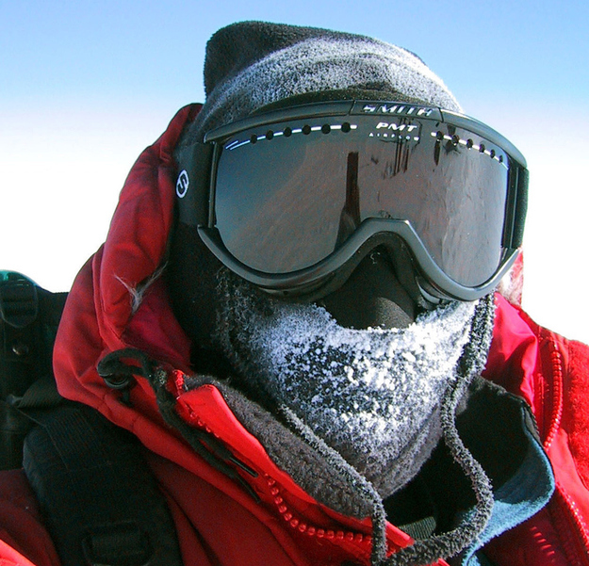

nsidc.org
Snowblindness is a type of temporary eye damage caused by snow reflecting UV light. Because snow is reflective, looking out into white snowy expanses can cause a sunburn to the eyes. So don’t forget your sunglasses, even if you know it’s not going to be sunny. And don’t forget your sunscreen either.

You can drink the snow.
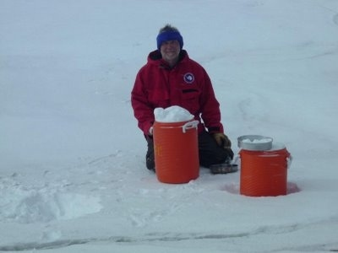

icelabyrinth.blogspot.com / Via backpacker.com
Leave your pump filter at home — it’ll freeze. The best options for drinking water is either a chemical or UV treatment. But you can also melt snow down for drinking. You can boil it to be on the safe side, but it’s not necessary since snow doesn’t harbor gut-busting bacteria.

Invest in a pair of fleece-lined waterproof socks and a balaclava.
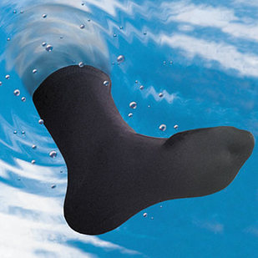
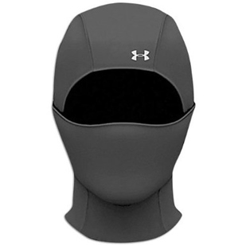
amazon.com
If you know you’re going to be in a wet climate, wool socks might not cut it. Used by the U.S. military, these socks keep extremities dry and warm down to temperatures as low as -30º F. They’re $54.95 from Hammacher Schlemmer.
A balaclava will keep cold air out much better than a hat and scarf will. Under Armour makes a good one.

Bring extra fuel for your stove.
Fuel will go much faster in cold climates, so be sure to bring more than enough.
A good rule: “plan on 1/4 quart per person per day if you need to melt snow for water. Plan on 1/8 quart per person per day if water will be available.”
The MSR Whisperlite is specially rated for cold weather and uses white gas, which works well in cold temperatures.

