22 ESSENTIAL DIAGRAMS FOR CAMPING
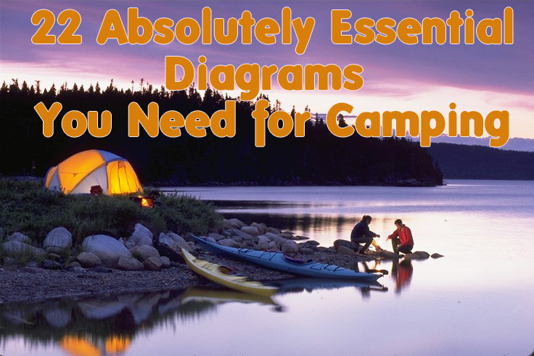
View this image ›
1. How to Build a Campfire
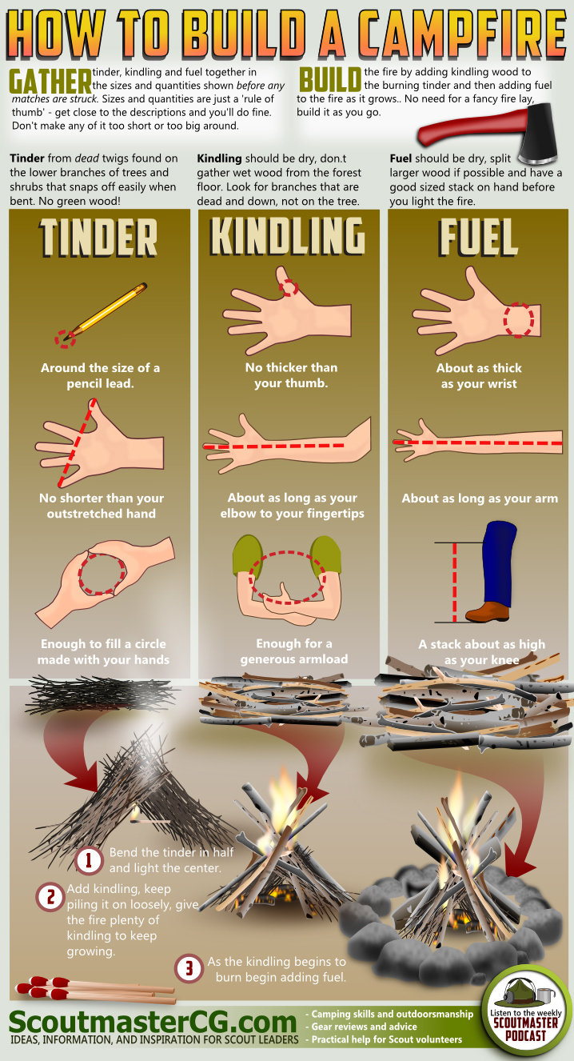
2. Tent Tips
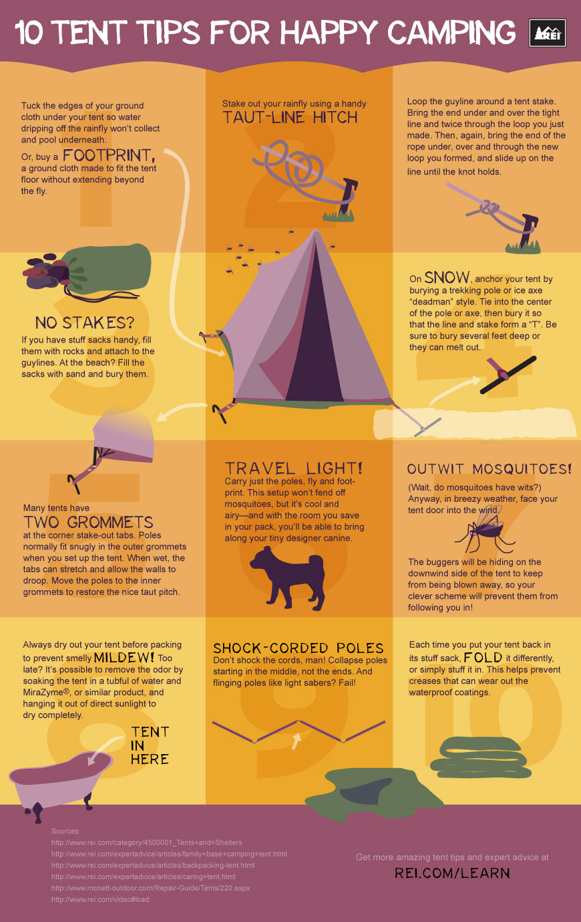
3. Everything You Need to Know About the Technicality of S’mores
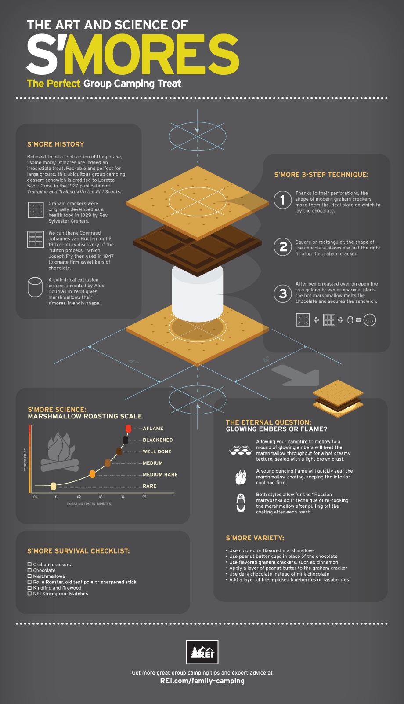
4. How to Estimate Remaining Daylight with Your Hand
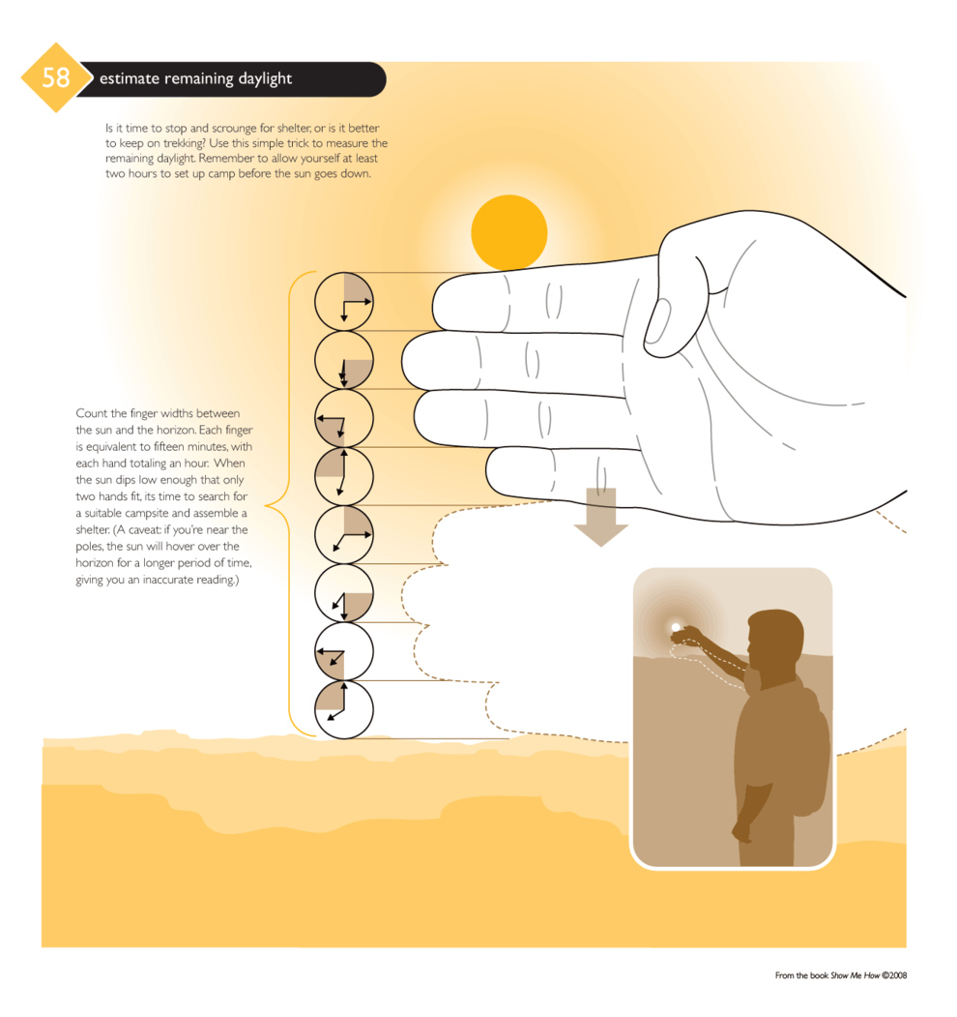
5. Snacks to Pack
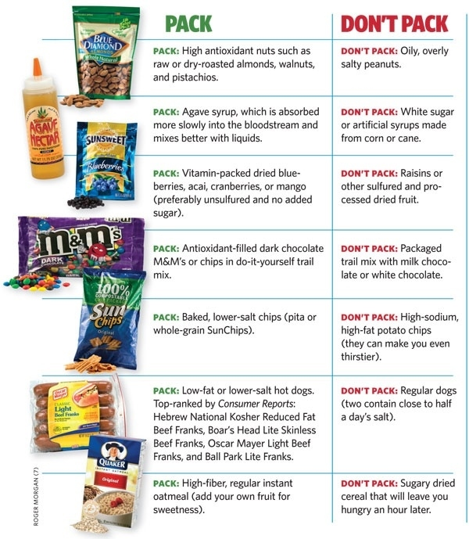
6. What You Can Do to Repel Mosquitoes
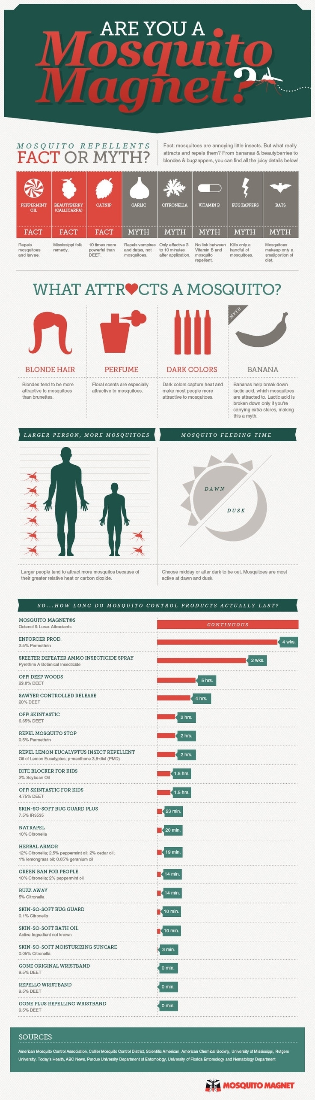
7. How to Sleep Warm
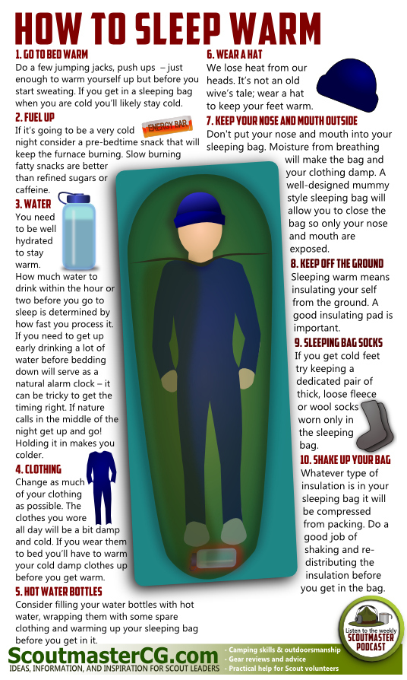
8. How to Survive Hypothermia
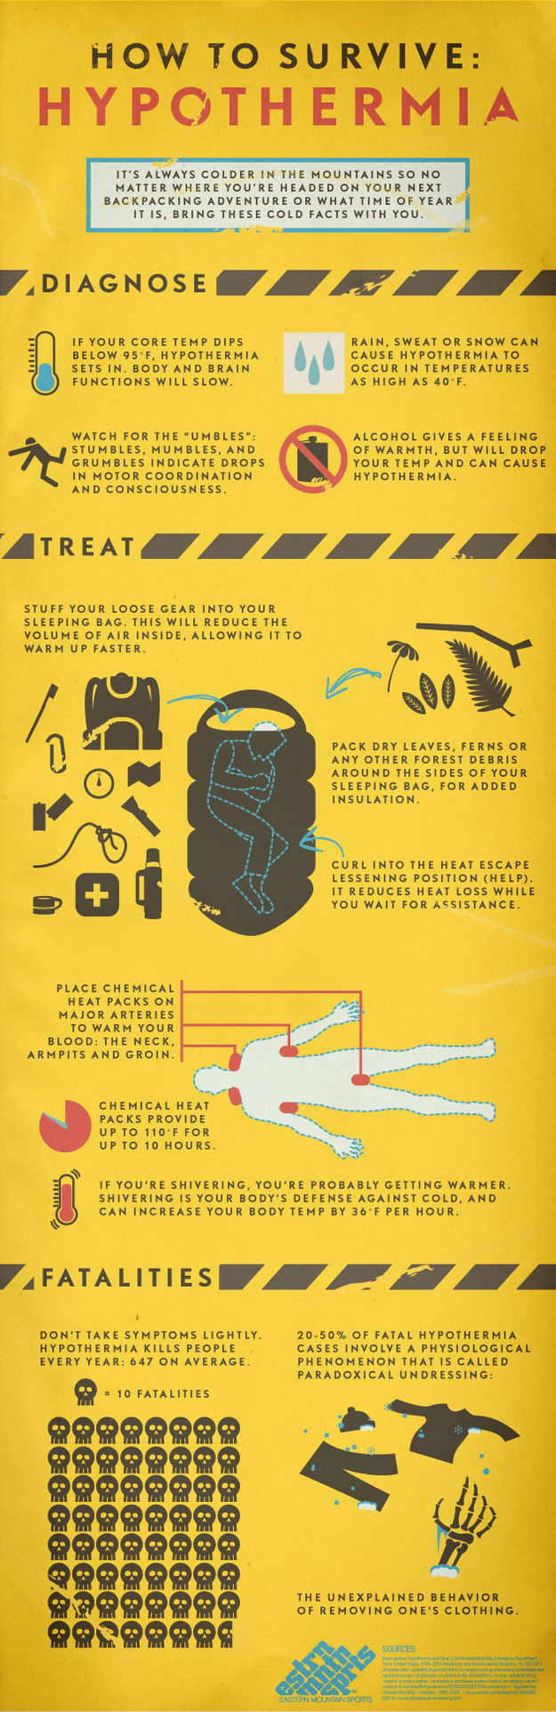
9. Backpacker’s Checklist
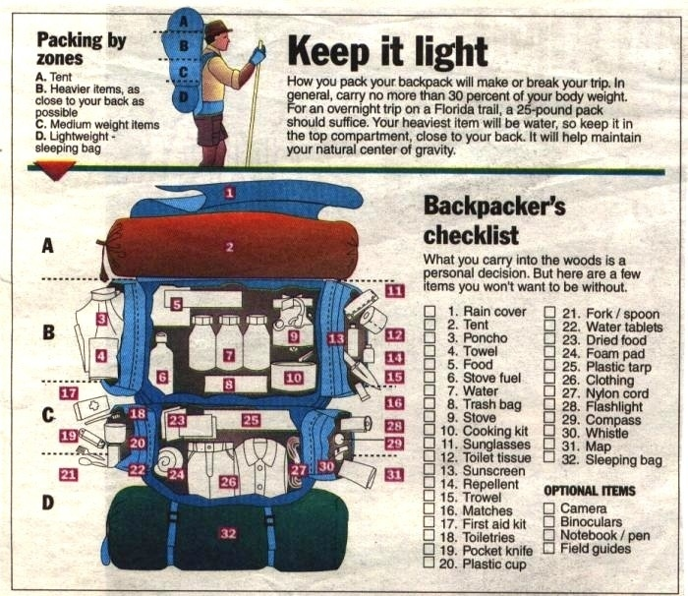
10. How to Rig a Tarp
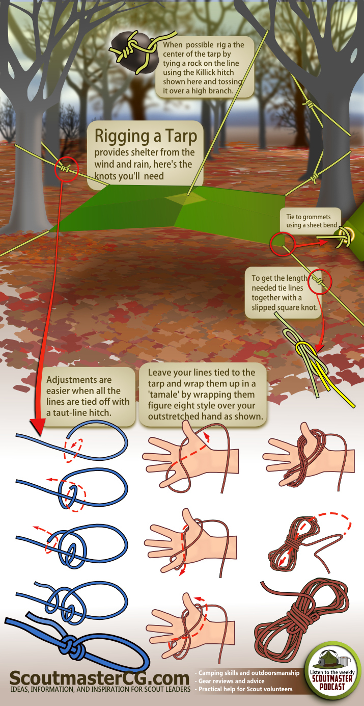
11. How to Get Your Dutch Oven to the Right Temperature
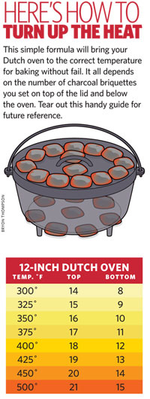
12. How to Identify Animal Tracks
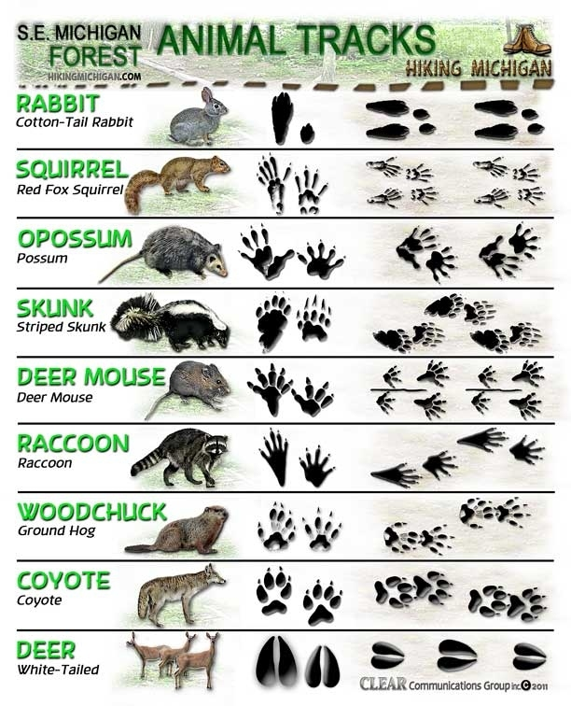
13. Know Your Stargazing Events This Summer
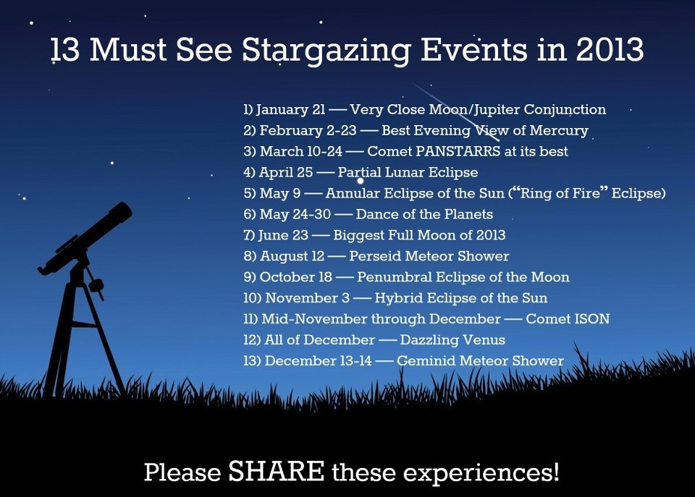
14. 10 Easy Fire Starters
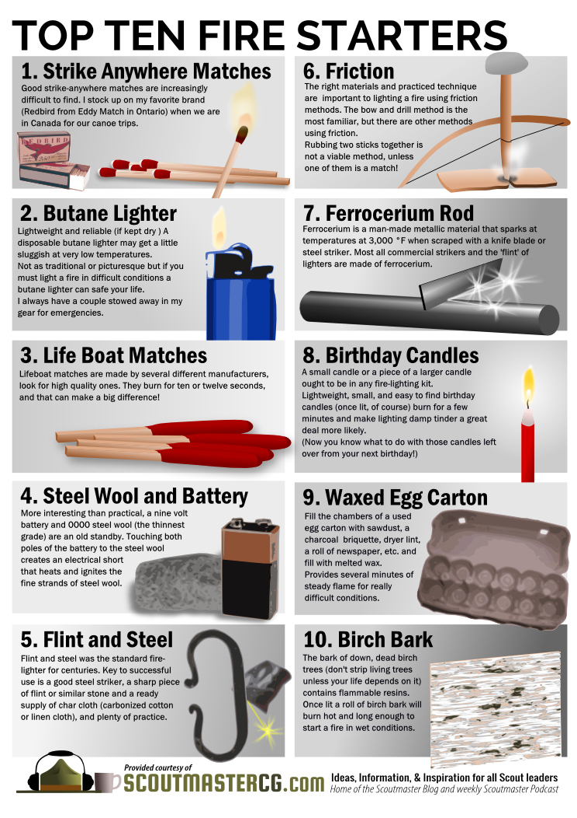
15. Kayak Camping Checklist

View this image ›
16. A Guide to Hammock Camping

View this image ›
17. Guide to Spider Bites

View this image ›
18. Checklist for Car Camping

View this image ›
19. How to Make Shelters in Survival Situations Using Nature

View this image ›
20. How to React to a Wildlife Encounter

View this image ›
21. Tarp Tips

View this image ›
22. Know Your Poisonous Plants

View this image ›

