12 Survival Lessons from Ukraine
by FerFAL
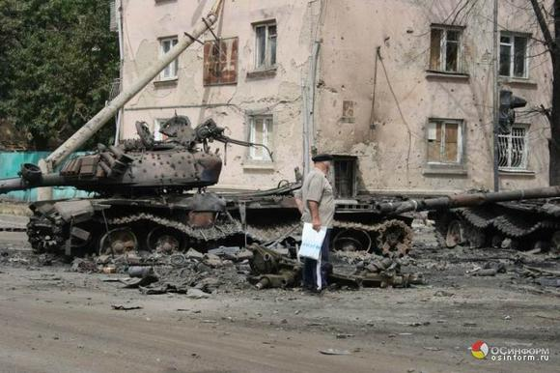
The war in Ukraine is a tragic event but it’s one that we can all learn from. Nothing provides as much valuable information as real world situations where ordinary people are forced to deal with extraordinary events. At the end of the day, the war in Ukraine gives us plenty of examples of what works and what doesn’t, and while personal experience is important, the wise person learns from other people’s mistakes so as to not repeat them himself.
There are several articles explaining what people are going through in eastern Ukraine right now. This article over at dailymail provides a good visual image of what people are going through. There’s also a thread in survivalist boards where a Dunbass resident that goes by the name of George1980 has been posting, sharing his experiences. I highly recommend reading it if you have the time.
Using this information, here are twelve important lessons based what has happened so far in Ukraine:
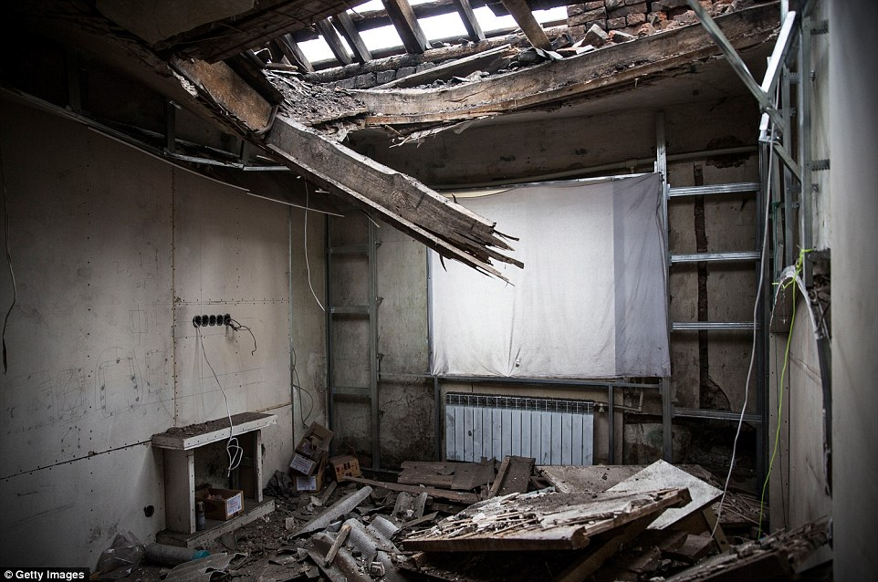
1)Artillery & infantry beats survivalist hero fantasies. Every. Single. Time.
Maybe the most obvious lesson to be learned is how miserably all these fantasies about forming survival groups, living in a retreat while fighting against impossible odds would ultimately fail. There’s simply no surviving against an occupation force when facing them as an individual or small group. Houses, towns and even entire cities can eventually get surrounded and overpowered. A single house or compound represents a laughable resistance to organized armed forces, let alone ones with artillery and air support at their disposal. Once shooting at your position is no longer fun, they’ll just blow you up. It’s as simple as that.
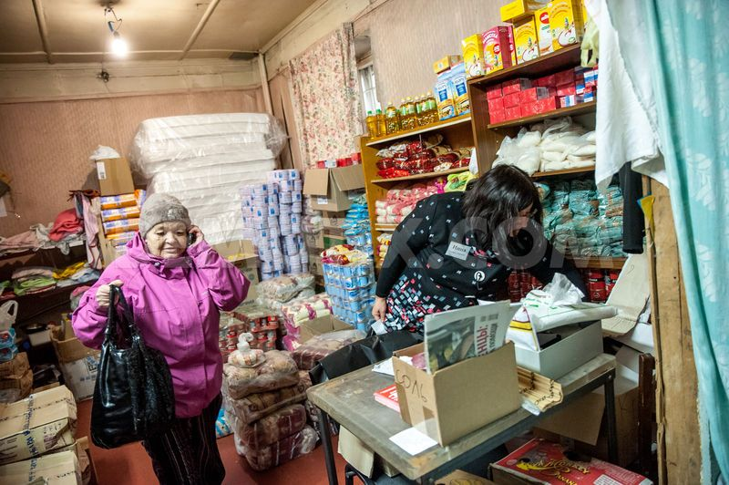
A refugee woman receive humanitarian aid at the “Station Kharkiv” volunteers help centre at Krasnotkatska str. Kharkiv, Ukraine.
2)Cover the basics. Food, water, shelter and medicines.
In various parts of eastern Ukraine, People are suffering the lack of water, electricity and food shortages. You need to store food, food that requires no refrigeration and little or no cooking. You need water, not just a water filter (which you should have as well) but actual jugs of water. For true emergencies and survival situations, just like you can’t have too much food you can’t have too much water. Have a well, have a river, if nothing else keep an eye out for large barrels on sale and keep some full of water. Even the jugs for carrying water become valuable. Have a good supply of medicines: ibuprofen, vomit and diarrhea medicine, liquid ibuprofen for children, bandages, diapers, formula and antibiotics. Antibiotics are the difference between life and death when you need them. Have lanterns, flashlights and lots of batteries. Get and emergency crank radio. Get a solar charger for your phone and batteries. Have alternative means of cooking and heating. A wood burning stove may do the trick, but make sure you always keep extra wood stored for emergencies. Maybe you’re lucky enough to still have power, if so an electric burner can be put to good use then, saving other fuels for when power goes out. Have extra fuel in storage for your vehicle, enough to make it to your potential bug out location in case you have to leave in a hurry. Have a tent and sleeping bags. These can be used not only for sleeping in tents, but also if you happen to find yourself in a refugee camp during winter or in an unfurnished flat after evacuation or if you’re staying with friends or family.
In a shelled city, underground is the only safe place to be, to some extent at least. An actual bunker would be ideal, but people try finding shelter anywhere underground. In buildings, windows and doors are covered with sandbags and people sleep in the interior room away from exterior walls and windows. Windows never survive shelling. The broken glass makes it impossible to stay warm in winter. Plastic sheeting can sometimes be used to close openings and still allow light in, but this is far from an ideal solution and the loss of heat is substantial.
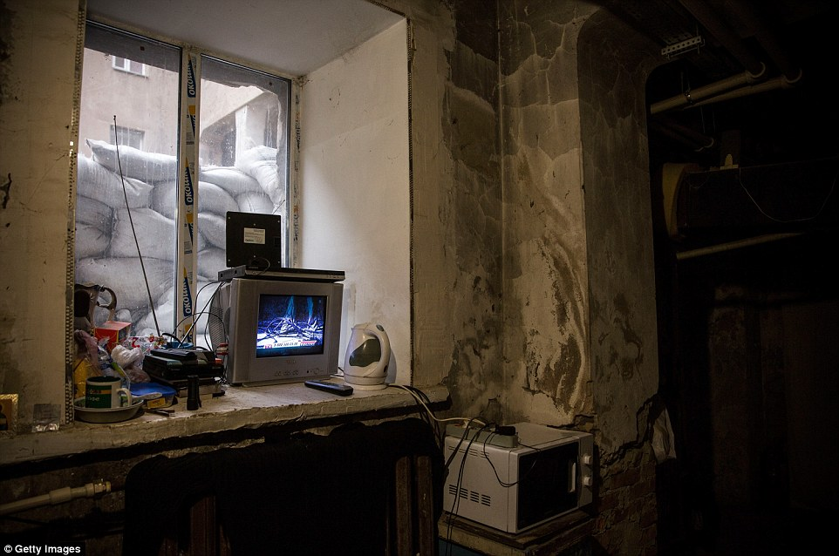
3)Don’t get involved.
From a survival perspective, the best way to go about conflicts that can develop into violent clashes is to not get involved in the first place. Avoid going to protests and marches. This is especially true in cases such as the one of Ukraine, where people are seen on one side or the other during protests and clashes, often filmed. Something as simple as a rival remembering your face from the rallies can land you in jail or worse. In this kind of situation, it’s even neighbors, former friends and coworkers that may remember your political affiliation. They may end up mentioning your name to the new authorities and they will come after you.
4)Attitude, clothes, and gear can get you killed or arrested.
Here is where the gray man approach comes into play. Be as neutral as possible not only regarding your actions and behavior, but also when it comes to insignias, clothes, and gear. Even beards or unusual or characteristic hair styles can get you in trouble. According to George1980 “There was very unpleasant situation on the Ukrainian check-point, when one soldier wanted to arrest me as separatist))
Fortunately, my wife and daughters were with me and this soldier did not stopped me. Problem was that I have a beard and, may be, my face was very “suspicious” ))) Soldier told me that)”.
Checkpoints in Ukraine are there for a reason: finding enemies. Having a weapon can get you into trouble, but also things such as maps, GPS, political propaganda, radios, this can all be consider espionage material. Adventurers traveling around the world have often mentioned how they get arrested in war zones because of their cameras and laptops. You’re not local, you have electronics capable of being used for communication, then you’re a suspect until proven otherwise. Lots of people have GPS, radios and maps in their Bug Out Bags. Just make sure to be smart about it and understand that in some cases, when dealing with factions fighting over power, it can get you in trouble and its better to get rid of some of it before reaching a checkpoint.
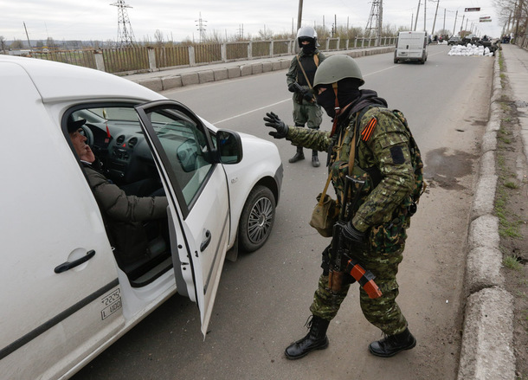
5) Learn to deal with checkpoints.
In checkpoints, women and children aren’t as carefully inspected as men. Private vehicles are checked much more thoroughly than public transportation. Maybe you’re better off taking a bus or train. Its important to travel light and be in good health and properly dressed to walk long distances if needed. Bribes may be needed so have cash. A hidden weapon may get you killed or arrested. Is it worth the risk to conceal a handgun among your belongings while evacuating? Probably not, but you’ll have to decide that yourself given your specific situation. Valuable items such as jewelry, cash and even electronics may be “confiscated” or downright stolen by the troops. Conceal them as well as you can. Cash and small gold coins can be hidden in shoe insoles, inside children toys or dirty diapers in the baby’s diaper bag. Coins can be sewed under jacket patches and insignias, under buttons. Women have managed to hide small rolls of cash inside them as if they were tampons, placed inside condoms. Refugees have swallowed small gold coins and jewelry so as to be recovered later. Desperate times call for desperate measures. When it comes to gold vs silver, gold is more compact and easier to hide. I wouldn’t like to swallow 1000 usd worth or silver coins!
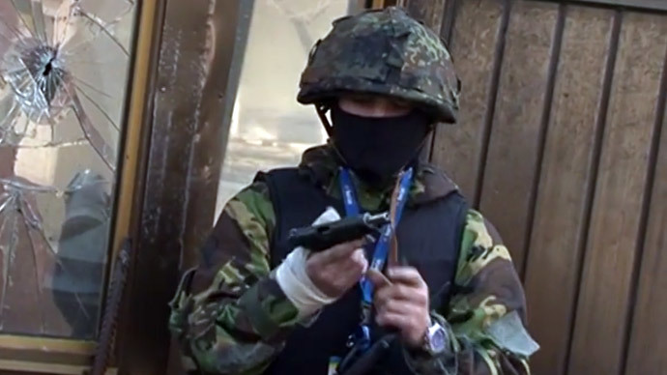
6)Guns can save you, but they can also get you killed.
According to George1980 “separatists very afraid Ukrainian saboteurs on their territory and try to catch every man with gun who are not from their “Army”.”
Are you fighting along with one of the factions involved? If not, then make sure you’re not confused with one. If you just want to be left alone, then don’t openly carry a gun. Openly carrying a weapon means you are a fighter on either side of the conflict. If you’re not with either one, BOTH will consider you an armed enemy. At the end of the day a gun can save your life, but in a world of no easy black and white answers a gun can also get you killed. Keep any weapons concealed, and be ready to ditch them, sell them or cache them depending on the situation you are involved in. Just going gun-ho is not the one and only answer to all problems.
I sure would like to be armed if I was still in Argentina today. If there’s trouble, 1000 bucks will most likely buy any cop’s silence. At the same time, in the 70’s during the military Junta and state terrorism, going around armed in Argentina wasn’t a good idea if you wanted to avoid trouble. If you were caught and found to be armed, the security forces would immediately assume you were a montonero, a leftist terrorist, and you would be tortured, executed or go “missing”. During these torture sessions, people that had no involvement would often mention the names of innocent people, just to stop the tortures. Just being in the wrong phone list of a coworker or fellow student was enough for the security forces to pay you a visit.
7)Get a Glock 9mm and a rifle with a folding stock.
As explained earlier, you want to be able to conceal your weapons. Eventually, you may have to leave behind you rifle and even your handgun. You sure won’t be boarding an evacuation plane with one. What about going through check points? Is it worth getting killed or arrested? Or are you better of selling you gun to someone that is staying behind, grab a few extra hundred bucks just as you board a bus or train leaving the conflict area? You want a gun that is ubiquitous, that fires a common round and has a well-known reputation. Basically you want a great weapon that works well for you, but you also want a weapon that is eventually easy to sell as well. Conflict or not, Glocks and AKs are great staples.
8)Passports and ID are crucial.
When traveling away from the conflict zones in Ukraine you better have your ID. Soldiers at checkpoints will want passports, driver licenses or other ID proofs. They may not ask for them all the time, but if they do, you better have them. They will want to know as much about you as possible. If you get the chance to leave the country, you better have your passport ready as well. Other countries are already refusing offer asylum to refugees. Here is where a second citizenship would be just priceless. While others are refused entry, having an EU passport would mean you could just board a plane and start over elsewhere while others are refused entry entirely or have to go wherever they offer asylum. Because of this, having updated documents is very important.
Many Americans fail miserably at this part and just don’t understand how important it is. My parents grew up in Argentina during the 70’s. Even years after the end of the dictatorship, I remember the look on their faces if they forgot their wallet when going out. They were terrified. Back in the day, getting stopped by the police and being caught without your “documentos” meant you weren’t making it back home that night. If you couldn’t prove your ID, you were considered an enemy/extremist/spy. The Triple A (Argentine Anticommunist Alliance) were constantly looking for left wing activists. People have been arrested and tortured just because they had long hair or dressed like hippies. You wanted to be as gray as possible, literally gray, so as to avoid being thrown inside one of the Triple A’s infamous olive green Ford Falcons, never to be seen again.
9)Cash is king
Food was still available in Donetsk, but people just didn’t have enough cash to afford it. With inflation being about 30% a month, food prices go up accordingly, so you’re better off with Dollars or Euros rather than local currency. They may not be accepted in some chain stores, but you can exchange them on banks or on the streets at the ongoing currency exchange rate, protecting your savings from inflation and only changing for local currency as needed.
At one point George1980 said “So my conclusion is so: cash is main tool of survivor!”
I couldn’t agree more.
10)Work on your EDC
The poorest refugees arrive by train and bus, while those with means come by car.
When bombs began falling close to an elderly woman’s home near Lugansk’s airport, “the granny grabbed her granddaughter, and they jumped on a train and came here with only the clothes on their back,” Shapoval said.
http://www.usatoday.com/story/news/world/2014/07/02/ukraine-war-refugees/11927955/
One day it may be all you have to work with. George1980 mentioned how important a good multitool was, how at times it was the only tool he had after leaving Dumbass and moving into an empty flat. This is a actually a great point. I always think of my everyday carry kit in such terms. If the flashlight I have in my pocket right now is the only one I’ll ever have or the one I’ll have to use to get by for years. Which one would I rather have? If my folding knife is the one I’ll have for defending myself, for prying open a window or a door after artillery hits my home or for preparing food, what kind of knife would I like to have? How about having to sell that knife for much needed cash or use it to bribe a Ukraine or Russian soldier in a checkpoint, which knife and multitool would I like to have to bargain with? What if I have to leave with nothing but the clothes on my back, I evacuate on foot with my family, everyone soaking wet, can I start a fire? As a matter of fact, do I even have enough cash to buy bus or train tickets for everyone?

11)Open an off shore account
Greece, Ukraine, Iceland, Argentina, doesn’t matter where it is, when things get ugly, the currency starts devaluating and banks close their doors you’ll want an off shore account. Maybe you keep some of your savings there. Maybe you make a transfer just in case when you hear some bad rumors floating around. Transfer fees aren’t very high and its cheap insurance. One thing is for sure: Just like you can’t buy a gun when bad guys are kicking down your front door, you cant open an account in a foreign country just when the local economy is about to go to hell. You need to do these things ahead of time. An offshore bank account means you can keep some of your savings abroad, move money around, move elsewhere and keep you money safe even if your country if falling apart. People in Ukraine sure understand the value of such an asset.
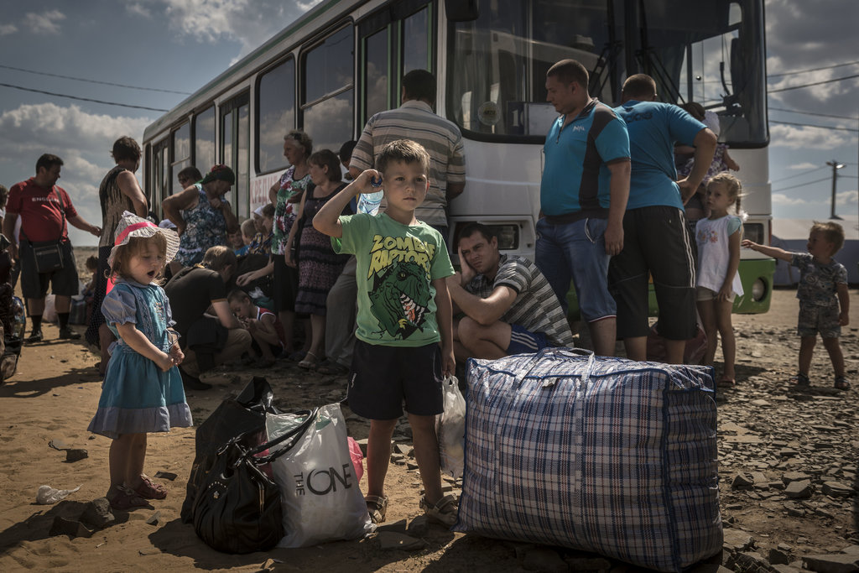
12)Be ready to bug out and know when to do so
If there is one thing we can learn from the war in Ukraine, as well as war and conflict in other parts of the world, is that not being there is the best thing you can do to ensure your survival and well-being of your family. Always have a bug out abroad plan, no matter who you are or where you live. Just think about it. If you had to leave your country today, (don’t think of all the reasons you wouldn’t, just for a second, think about it as if you didn’t have an option). Where would you go? Do you know someone there that can help you?
Finally, know when it’s time to leave. This is something I address and emphasize in my book “Bugging Out & Relocating”. It’s about having a plan but also crucial, it’s about executing it at the right time. Those that hesitate, those that choose denial when the signs are all over the place, they may live to regret that. A day too late, an hour too late may make all the difference in the world.

