Whole Grains Guide

Recipes, Cooking Tips and Nutrition Information for Healthy, Whole-Grain Foods
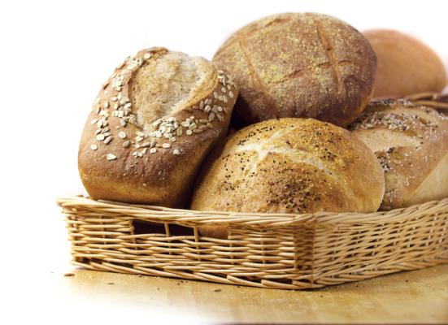
Whole grains factor into every global cuisine, yet most of us could benefit from getting more of these nutritious gems into our daily diet. Unlike the refined white flour in most processed food, whole grains contain plenty of fiber, vitamins and minerals, while being low in calories. Besides being great for your health, whole grains come in a diverse array of rich, nutty flavors and satisfying textures.
Whole grains are also versatile, with a wide range of flavors and textures to complement many dishes, both sweet and savory — and even gluten-free. They work as marvelously in hot breakfast cereals and cold breakfast muffins as they do in popped snacks, side dishes, breads and casseroles. Plus, they’re inexpensive and filling. You can make whole grains the star of the meal or hide them in your favorite recipes.
Since its inception in 1970, MOTHER EARTH NEWS has been a leading source of information on natural, whole grains. Perhaps you want to learn to grow or harvest your own grain, grind it with your own home flour mill or find out which grain mills are best. MOTHER is your source. If you’re interested in learning how to cook whole grains to their best advantage or simply want to discover some delicious whole-grain recipes, we’ve got you covered. We’ll also introduce you to some of the best whole grain suppliers around the country, plus a number of cookbooks and other resources to help you get started cooking everything from amaranth, barley and bulgur to farro, quinoa and wild rice.
- What Are Whole Grains?
- Dietary Guidelines and Whole Grains
- Whole Grains and Nutrition Labels
- List of Whole Grains
- Featured Whole-Grain Recipes
- How to Cook Whole Grains: A Variety of Methods
- Featured Articles From the MOTHER EARTH NEWS Archive
- Great Whole Grain Sources
- The Bread Baker’s Library

What Are Whole Grains?
A whole-grain kernel is comprised of three parts: the germ, the bran and the endosperm. In conventional grain refining, most of the bran and germ are removed, resulting in the loss of dietary fiber, vitamins, minerals, lignans, phytoestrogens, phenolic compounds and phytic acid. In addition to helping maintain healthy body weight, these key nutrients can reduce the risk of several chronic diseases, including type 2 diabetes, hypertension, cardiovascular disease, stroke, gall bladder disease, respiratory dysfunction, gout, osteoarthritis, certain types of cancers and premature death.

Dietary Guidelines and Whole Grains
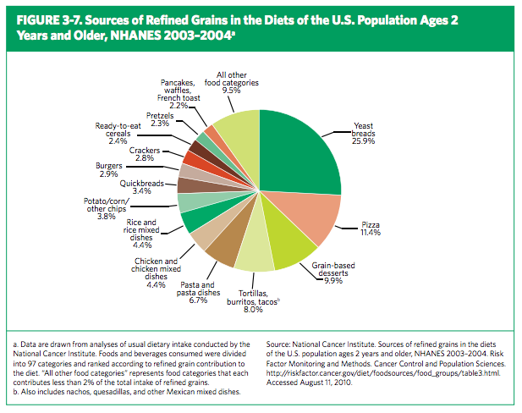
Every five years, the U.S. Department of Agriculture (USDA) and the Department of Health and Human Services (HHS) release dietary suggestions for Americans. Over the years, the “basic food groups” have remained largely unchanged, but in 2005, whole grains finally got their due. In order to combat the onslaught of advertising for and the widespread availability of junk foods, the organizations hoped to arm Americans with the knowledge necessary to take control of their collective health. The newest dietary guidelines emphasize that most Americans are overweight. They also maintain that obesity is worst among America’s children and adolescents, and that all this excess body fat is linked with a long list of life-threatening illnesses.
In order to forestall this epidemic, the guidelines encourage not only getting more exercise, eating more fruits and vegetables and eating far fewer trans fats, but also consuming many more whole grains. Prior to 2005, the guidelines maintained six to 11 servings of grain, including pasta and rice, as an appropriate daily intake. Meanwhile, they had nothing to say about how these foods were made. Now, the USDA and HHS think Americans should eat less refined grain in favor of more whole grain. The 2010 dietary guidelines report states:
- Limit the consumption of foods that contain refined grains, especially refined grain foods that contain solid fats, added sugars, and sodium. Whenever possible, replace refined grains with whole grains.
- Consume at least half of all grains as whole grains. Increase whole grain intake by replacing refined grains with whole grains. (For most Americans,
- Choose foods that provide more potassium, dietary fiber, calcium, and vitamin D, which are nutrients of concern in American diets. These foods include vegetables, fruits, whole grains, and milk and milk products.
- Americans should aim to replace many reined grain foods with whole-grain foods that are in their nutrient-dense forms to keep total calorie intake within limits. When reined grains are eaten, they should be enriched.
How to Increase Whole Grain Intake, according to the USDA and HHS:
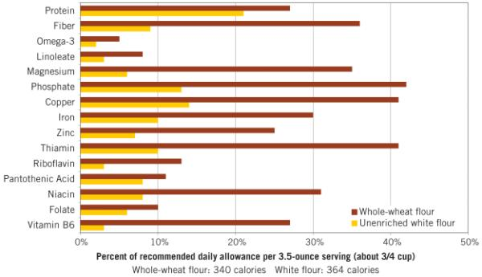
- Substitute whole-grain choices for refined grains in breakfast cereals, breads, crackers, rice, and pasta. For example, choose 100 percent whole-grain breads; whole-grain cereals such as oatmeal; whole-grain crackers and pasta; and brown rice.

- Check the ingredients list on product labels for the words “whole” or “whole grain” before the grain ingredient’s name. Note that foods labeled with the words “multi-grain,” “stone-ground,” “100% wheat,” “cracked wheat,” “seven-grain,” or “bran” are usually not 100 percent whole-grain products, and may not contain any whole grains.
- Use the Nutrition Facts label and the ingredients list to choose whole grains that are a good or excellent source of dietary fiber. Good sources of fiber contain 10 to 19 percent of the Daily Value per serving, and excellent sources of dietary fiber contain 20 percent or more.
How to Decrease Refined Grain Intake, according to the USDA and HHS:
- Eat fewer refined grain products, especially those that are high in calories from solid fats and/or added sugars, such as cakes, cookies, other desserts, and pizza.
- Replace white bread, rolls, bagels, muffins, pasta, and rice with whole-grain versions.
- When choosing a refined grain, check the ingredients list to make sure it is made with enriched flour

Whole Grains and Nutrition Labels
Whole grains cannot be identified by color. Refined bread products may be dyed dark brown in order to make them appear healthier. The U.S. Food and Drug Administration (FDA) requires that if a grain kernel has been cracked, crushed or flaked, then the resulting seed must contain nearly the proportion of the original kernel to be called “whole grain.” In order to label “whole-grain” food products as such, at least 51 percent of their ingredients must be whole grains and must be low in fat. In addition, it is helpful to learn the names of various grains, and look for them in ingredients lists.

Whole Grains List
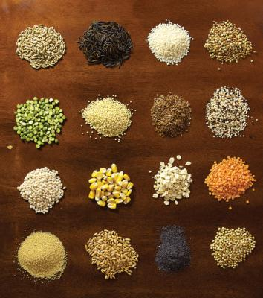
- Amaranth
- Barley
- Buckwheat
- Bulgur (cracked wheat)
- Corn
- Cornmeal
- Couscous
- Farro
- Millet
- Oats, groats
- Oats, steel-cut
- Oats, flaked
- Oats, rolled
- Popcorn
- Quinoa
- Rice, brown
- Rice, wild
- Rye
- Teff
- Triticale (rye-wheat cross)

Featured Whole-Grain Recipes
- 7 Hearty Oatmeal Recipes by Tabitha Alterman
- Bulgur Recipes for Dinner or Anytime by Betty Warner
- Quinoa-Zucchini Cakes With Summer Herbs by Tabitha Alterman
- Hearty Hardtack Recipes by Gail E. Johnson
- Pancake Recipes: 10 Variations on a Breakfast Favorite by Carol Taylor
- Whole-Grain Recipes by the MOTHER EARTH NEWS editors
- Homemade Whole-Grain Tortillas by Tabitha Alterman
- African Millet Salad With Corn and Peppers by Robin Asbell
- Pecan and Wild Rice-Stuffed Squash by Robin Asbell
- Filet Mignon and Barley Stew With Spinach by Robin Asbell
- Buttermilk Wheat Germ Pancakes With Yogurt and Berry Sauce by Robin Asbell
- Chocolate Chunk Buckwheat Cookies by Robin Asbell
- Turkey and Barley Meatloaf by Robin Asbell
- How to Cook Bulgur: Five Recipes by Julie Needham
- Cooking With Whole Wheat: Mama Karhu’s Recipes by the MOTHER EARTH NEWS editors
- Discover Millet by Robin Asbell

How to Cook Whole Grains: A Variety of Methods
Did someone say versatile? Not only do grains offer a wide range of textures, but you can coax out many different flavors by trying different cooking methods.
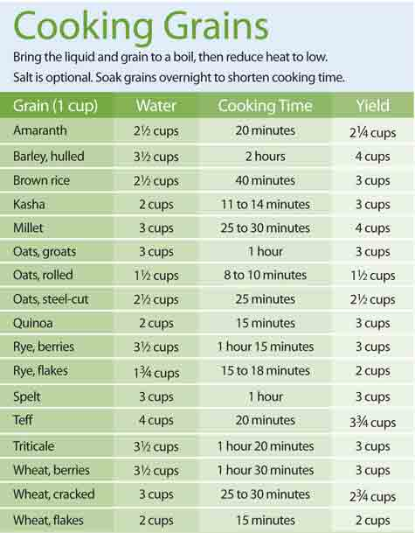
Simmer. Most of the time, you’ll be cooking grains via the absorption method—the way you cook rice. Put liquid and grains in a pot over high heat until liquid boils, then reduce heat to low, cover and cook until soft but chewy. Large whole grains such as rye berries and oat groats will cook up fluffy and somewhat firm (think rice pilaf). For a creamy consistency (such as porridge and polenta), add more liquid or allow grains to set before serving. For a list of cooking times for different grains, check out this handy chart of whole grain cooking times.
Boil. Many whole grains can be cooked just like pasta. Drop them into boiling water until soft, drain and serve. This is useful if you’re not familiar with cooking a particular grain, because you can test for doneness and not worry that you didn’t include enough liquid. (But it also means tossing some potentially nutritious stock down the drain.) Some whole grains, most popularly barley, can also be boiled in soups and stews.
Bake. Whole-grain flours, available at most natural foods stores, are wonderful for making cookies, cakes, pies, muffins and more sneakily nutritious treats. If you’re a novice whole grain baker, be sure to follow recipes. The amount of rise you’ll get depends on several factors, including the amount of gluten in the grain.
Steam. Soaked grains that require a short cooking time are good candidates for steaming, whether in a bamboo steamer, steamer pan or rice cooker. And even when cooked via the absorption method, most grains benefit from a final steam of 5 to 10 minutes — just remove the pan from heat and cover.
Pressurize. Pressure cookers save you a bundle of time and are perfect for cooking whole grains, but the equipment demands some familiarity. Check out this article from Mother Earth Living to learn more about pressure cooking, see Get to Know the Wonder-Working, Time-Saving Pressure Cooker.
Pop. Some grains — amaranth, quinoa and teff, for example — can be popped in a hot, dry pan for a quick, healthy snack. Top popped grains with salt, pepper or your favorite herbs, or stir them into honey or syrup for a more decadent treat.
Soak. Soaked grains are softer and cook up in less time. If you want large, chewy grains to lighten up a bit, you can soak them from 30 minutes to overnight before cooking. For smaller grains, soaking will encourage a porridge-like consistency. If you presoak your grains, reduce cooking time by about 10 minutes and cooking liquid by about 1/4 cup per cup of grain.
Toast. To help smaller grains like buckwheat, millet and quinoa retain their individual nature, you can toast them to harden up the outer layer, then use a little less liquid during cooking by any of the other methods listed here. Be sure to add toasted grains to already-hot liquids to prevent them from becoming mushy.

Featured Articles From the MOTHER EARTH NEWS Archive
Whole Grains
Grain Glossary by the MOTHER EARTH NEWS editors
Whole grains are among nature’s most complete health foods. While most of us are comfortable with wheat, corn and oats, we may be less sure about strange grains such as quinoa. Here is a list of some grains that, if not already familiar, you’ll want to get to know.
The First Crop by Anne Vassal
From bulgur to kasha, learn the secrets of cooking with grain.
Whole-Grain Corn
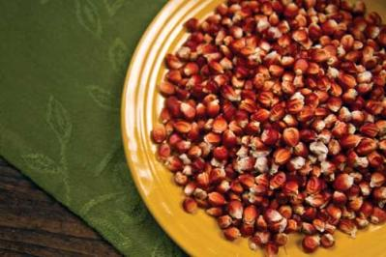
Holy Whole-Grain Corn Nutrition by the MOTHER EARTH NEWS editors
Cornmeal of whole-grain varieties, such as ‘Floriani Red Flint,’ is much more nutritious than de-germed yellow cornmeal (the type typically sold in supermarkets because of its long shelf life).
Floriani Red Flint Grain Corn: The Perfect Staple Crop for Every Homestead by William Rubel
Grow this productive heirloom grain corn for out-of-this-world flavor and exceptional nutrition. Plus, try our great cornmeal recipes!
Uncommon Corn by Barbara Pleasant
Grow these colorful whole-grain corns for improved nutrition and great taste.
How to Dry Corn and Grind It Into Cornmeal by Carol Suhr
Carol Suhr’s guide on preserving a crop of homestead corn, including how to dry corn, grinding corn meal, and recipes for cornmeal pancakes, dried corn pudding and corn tamale pie.
Cooking With Rice by Anne Vassal
Delicious whole-grain rice recipes that are rich in fiber and low in fat, including recipes for jambalaya, porcini mushroom risotto, tomato pesto risotto, broccoli and cheese pie, and southwestern salad.
Whole-Grain Breads and Baking
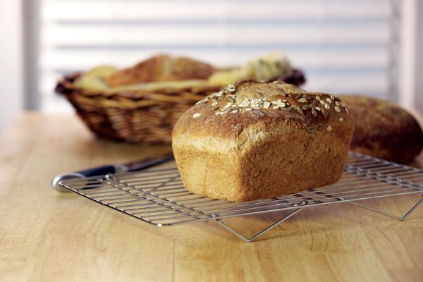
Homemade Whole-Grain Bread: You Have to Try This Amazing Recipe by Tabitha Alterman
Learn techniques to save time and money while boosting flavor and nutrition in homemade whole-grain bread. All it takes is adding whole-grain flours and sprouted grains.
Amp Up Your Bread With Sprouted Grains and Multigrains by Tabitha Alterman
Make homemade bread even more nutritious and tasty by adding a variety of whole and sprouted grains, including nutrient-dense sprouted wheat.
The Master Recipe: Whole-Grain Artisan Loaf by Jeff Hertzberg and Zoë François
With just five minutes a day of effort, you can make superhealthy breads with nutritious whole grains, fruits, vegetables, nuts and seeds. Plus, you’ll save big bucks on groceries.
Perfect Pie Crust With Whole-Wheat Flour by Tabitha Alterman
Making a tender, flaky pie crust from scratch is easy when you use the right secret ingredient.
The Lost Art of the Pie by Anne Vassal
How to cook and prepare desserts and roll pie crust, including recipes for whole-wheat pie crust.
Why Whole Wheat Is Way Better by Marleeta F. Basey
In this piece, we look into the nutritional benefits of grinding fresh, whole grains at home and review the different types of grain mills.
The Taste of Maine in Grain by Scott Vlaun
Get inspired by Maine’s artisan bread revolution.
Wholesome Holiday Bread Recipes by Erica Rowe
Intent on celebrating Thanksgiving and Christmas holidays while still eating healthy, the author devised a few natural and wholesome holiday bread recipes.
Delicious, Homemade Whole-Grain Hamburger Buns by William D. Adams
Once you discover the rich goodness of homemade hamburger buns, you’ll never be satisfied with wimpy, store-bought buns again.
Staff of Life by John McLure
The simple art of baking bread.
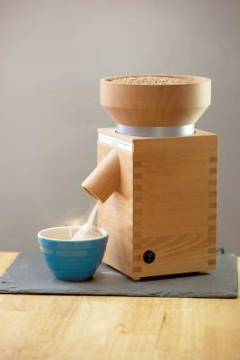
How to Make Sprouted Grain Bread by the MOTHER EARTH NEWS editors
The Essene Whole-Grain Bread Recipe
Slicing Homemade Bread by John Shell
DIY bread slicer
Sourdough Recipes: Create Delicious Breads, Muffins and Hotcakes by the MOTHER EARTH NEWS editors
Learn how to create a sourdough starter to bake sourdough breads, muffins, and hotcakes using these easy-to-follow recipes.
We Make Bread From Wheat We Grow Ourselves by Barbara Houghton
One Wisconsin family satisfies nostalgic desires by baking bread from wheat they grow themselves.
Wheat and Bread: Growing, Harvesting and Baking With Wheat by John and Sally Seymour
How to grow wheat, including wheat varieties, soil, winter or spring wheat, sowing, harvesting, mowing, drying, threshing, winnowing, milling, wheat and bread baking, and using yeast.
Simple Bread by Jerry Nelson
This simple bread recipe using whole-wheat flour, soy flour and brewer’s yeast is nutritious, tasty, inexpensive and easy to prepare.
Whole-Wheat Flour vs. Unenriched White Flour by the MOTHER EARTH NEWS editors
Find out just how beneficial whole-wheat flour really is.
Grinding Whole-Grain Flour
Grind Your Own Flour With a Bike-Powered Grain Mill by the MOTHER EARTH NEWS editors
A bike-powered grain mill is a more efficient and incredibly fun way to grind your own flours and meals. Check out our video of the MOTHER EARTH NEWS staff using a GrainMaker mill to grind ‘Floriani’ grain corn into a nutritious cornmeal.
Choosing the Right Countertop Grain Mill by Marleeta F. Basey
Learn how to choose a quality and versatile grain mill to grind flour at your own home. Also, see reviews on specific grain mills and the many health benefits that fresh-ground grains have to offer.

Recommended Sources for Whole Grains
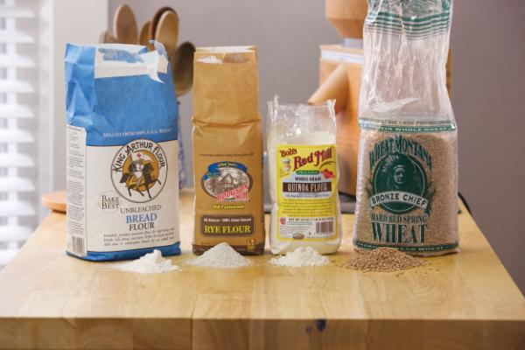
- Bob’s Red Mill
- Daisy Organic Flours
- Heartland Mill
- Hodgson Mill
- King Arthur Flour
- Pleasant Hill Grain
- The Urban Homemaker
- Wheat Montana Farms

The Bread Baker’s Library
- Whole Grain Breads by Peter Reinhart
- King Arthur Flour Whole Grain Baking: Delicious Recipes Using Nutritious Whole Grains by PJ Hamel, Susan Reid and Susan Miller
- Bread: A Baker’s Book of Techniques and Recipes by Jeffrey Hamelman
- Bread Science by Emily Buehler
- My Bread by Jim Lahey
- The Bread Bible by Rose Levy Beranbaum
- Bread Making: Crafting the Perfect Loaf from Crust to Crumb by Lauren Chattman
- Beard on Bread by James Beard
- Amy’s Bread by Amy Scherber and Toy Kim Dupree
- Tartine Bread Book by Chad Robertson

