Where will you get sugar?
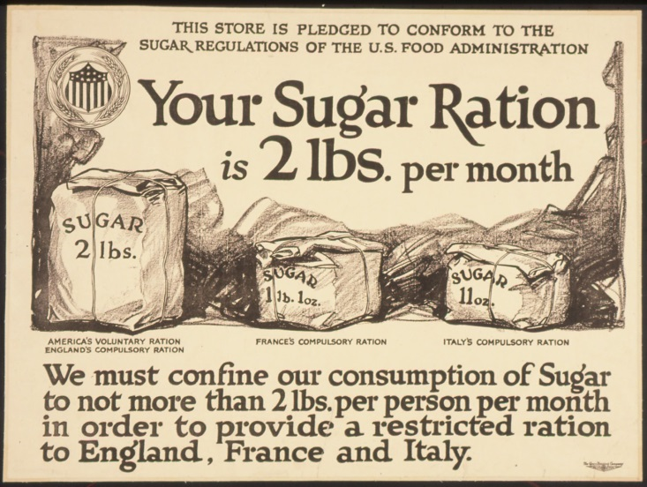
One thing I do know is sugar stock can and will run out if a tragic event happens. To have alternatives to one of the most useful and traded preps will be a a benefit. You not only need sugar for comfort foods but for canning and even making moonshine (which can be used as fuel) and as moonshine. What I do know is sugar is one of life's musts.....
So I am just going to do a quick post on things that can substitute sugar.
Sugar can come from so many different places. If you live in a warmer climate you can grow sugar cane. But a lot of us do not live in areas that it can be grown. These are some other options.
- Honey would be the first place most of us would go to. Click here for PDF
- Next up would have to be Maize. You boil down the GREEN Maize stalks and BAM sugar...or as we know it corn syrup. It is a thin syrup.
- I then would look at getting a Sugar Beet garden up and going. Click Here
- A close second to this is sugar beets is Pumpkin sugar which is made the same way as the sugar beet sugar.
- Then we have all kinds of tree saps to tap into. Some are very sweet like maple and birch.
- Milkweed makes a decent brown sugar can be made by boiling down the flowers heads. Click here to learn more about the milkweed plant.
- Dates, raisins dried fruit can add a sweet kick to many things to. They can be dried and powdered to make a sugar replacement. They can also be made into jams and syrups as well.
- Look at watermelon an easy crop to grow...and it's juice can be boiled down to a sugar. You can do this with other fruits to.
- Last but not least we have barley malt syrup which is made from germinated barley grains. Brown rice also produces malt syrup. More or less you boil down the water that the barley or rice have been cooking in for several hours. FACT: There is .7 grams of sugar in one cup of rice. Barley is much sweeter and tastier than rice.

