Using Nature’s Tin Foil
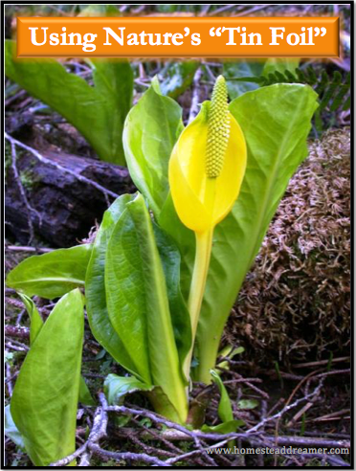
Before the invention of aluminum foil, people used leaves and other things to cook food in the coals or on hot rocks around the fire pit. Some are also used to steam food or wrap before boiling to keep the ingredients together. Learning which natural ‘tin foil’ is available in your area can not only give you some new flavors and cooking methods to play with, it is also a wonderful preparedness/survivalism skill to have!
Why do leaves work as a food wrap or natural ‘tin foil?” Because of their water content! Most people who use leaves as a food wrap buy them dried in packages at the store and then soak them to bring back the strength of the fibers that hold everything together. If you tried to use them when dry, they would crack, flake off, or simply break. Using leaves as a food wrap can impart their flavor into your food so choosing which one can be a chore. Then again, if you are in a survival situation, it is unlikely that you would be able to buy any. Learning what is available in your specific area in the wild will put you ahead of the game. Imagine you have to get out of dodge quickly. You grab some food and whatnot (assuming you don’t already have a bug out bag) but forgot to include anything to cool that food in. What would you do? Let’s look at the different types of leaves people across the globe use to cook with and in.
The Leaves
- Skunk Cabbage – These are found in the wetland areas of the world, particularly in the Pacific Northwest. The leaves are very large and the wildflower gives off a scent that many would consider unpleasant but thankfully, the leaves do not make the food taste anything like the smell. Native Americans used these for wrapping fish and spices into and then cooking the food in the coals of a fire. The leaves are thick and filled with water which help them keep from burning up.
- Bamboo – Bamboo leaves are used to steam food in by many Asian cultures. They need to be soaked in water before use to avoid cracking (unless you are lucky enough to have access to fresh ones).
- Banana/Plantain – Plantain leaves have been used for centuries as a way to wrap food for cooking and storage. They are also used as a way to carry pouches of food and can be used as a plate, too.
- Corn Husks – Fibrous and strong, corn husks are used by many Hispanic cultures for various dishes. Like plantain leaves, they can be used not only for cooking, they also make great wraps for food you want to store or bring with you. Depending on what you used it for, they can be reused, too. They also leave a nice flavor on the food.
- Lemon, lime, or fig – While these leaves are not large enough to wrap large amounts of food in, they are used as beds for other food and can be wrapped around smaller bits before grilling.
- Lotus – Another Asian specialty, lotus leaves get very large and according to the Cook’s Thesaurus, leave a nice, earthy aroma. They need to be soaked (usually bought dried at the store) before using.
- Cattail – Cattail leaves have been used to cook fish and other foods in for years as well. While the leaves aren’t as large as others, you can weave them into a mat large enough to wrap food into. Plus, if you find cattails, dig those babies up! The roots are a tasty, starchy treat!
You can use pretty much any leaf, but I urge caution. You want to avoid poisonous leaves like oak or ivy, of course. Use common sense when considering the use of leaves to cook food in. If in doubt, don’t use it until you are certain it is safe!

