Using Plastic Buckets and Mylar
New to prepping? Wondering how others use those large buckets and Mylar bags for food storage? Wonder no more. The mystery that is Mylar will be revealed in three easy phases.
Phase 1) Plastic buckets are generally used for bulk storage because they’re fairly rodent proof. They tend towards water impermeability, but they’re not always great at that. What they really do is keep the mice and rats out of your food. Important thing, right?
Phase 2) The second layer of the food storage is a plastic Mylar bag. Mylar evolved out of the NASA space program and is a really cool material which is used everywhere. It’s an interior layer of polyester and an exterior layer of evaporated aluminum that has the ability to keep all moisture out of the things you store inside it. It is not, however, strong enough to be used on its own – you need an exterior layer.
Phase 3) The third thing that goes into many Mylar bags is something to kill bugs. I use oxygen absorbers. You can purchase these purpose made, or you can simply buy off the shelf hand warmers at the end of the winter season. Either way, the iron filings/powder will reduce the amount of oxygen left in the bag after it is sealed, thus reducing the ability of vermin to live in your stored food. Alternately, you can look at a food grade diamatacious earth to add to the bag. This product gets into the shells of insects and sucks the moisture out of them, causing them to be incompatible with life; read as, not eating YOUR food. These should be used only in food stuffs that are biologically reactive; this means that if moisture gets into it, will it get wet & hard (like salt & sugar) or will it mildew? If it mildews, toss one of these puppies in there.
Instructions
Step 1- Get plastic buckets. I get mine free from my local grocery store bakery. These are food grade. However, when you are using Mylar, you have the choice to use other materials that are not, such as dry-wall buckets. Food grade plastic will not leach any chemicals into your stored food. Other buckets might. Use these at your own risk and with your own best judgement.
Step 2 – Purchase Mylar bags and insert into the bucket. Fill with what ever food product you are storing.
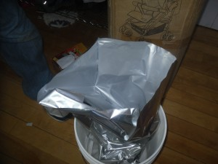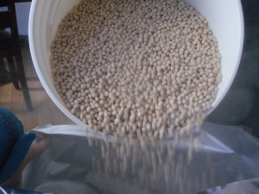
Step 3- Open O2 absorber and toss into bucket.
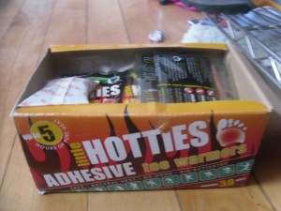
Step 4- Press all the air you can out of the top of the bag.
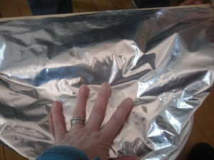
Step 5 - Have, on hand, a hot iron and a board. Flatten out bag at its seams and use iron to seal the bag. Mylar adheres to itself with heat, so just iron it shut and double-check that no air is able to get in and out – I do this by flattening the whole thing down as I fold the extra material into the bucket. If there is a little bubble of air pressing back at me, it’s a good seal. Alternately, you could pull the extra material up and see if it sucks air back down into the bag.
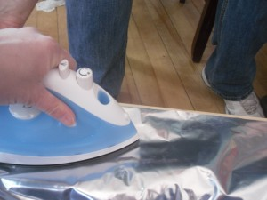
Step 6 – Put lid on bucket
Step 7 – Label and date so that you can rotate the stock.

Other handy tips: A bucket wrench is your friend when it comes to opening these puppies back up. Mine lives in my tool drawer. It cost about $5 at the hardware store. It looks like this:
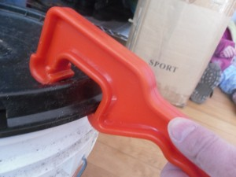
If you choose not to use Mylar, sometimes you get moisture in a bucket. It will mildew and cause rot. It looks like this on rice. Use of Mylar will prevent this problem in most cases.
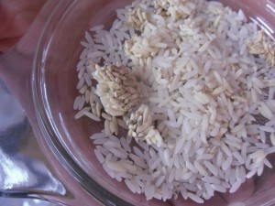
Happy food storage-ing!

