Taco Soup - Are You Afraid of Using Food Storage? Start With This Recipe…
·by Prepared Housewives·

This is a great food storage recipe that you can go ahead and stock-up on. It’s literally a matter of just dumping cans into a pot and you’re done. And if you’re brave enough to can your own meat the process is even faster. Just make sure you get gluten/dairy free taco seasoning or make your own if that is a concern! Of course you can soak and cook your own beans, can your tomatoes, and grow your own corn for a healthier dish, but sometimes when you’re trying to survive (yes, that includes Texas heat), having something super-fast and easy to make is a must!
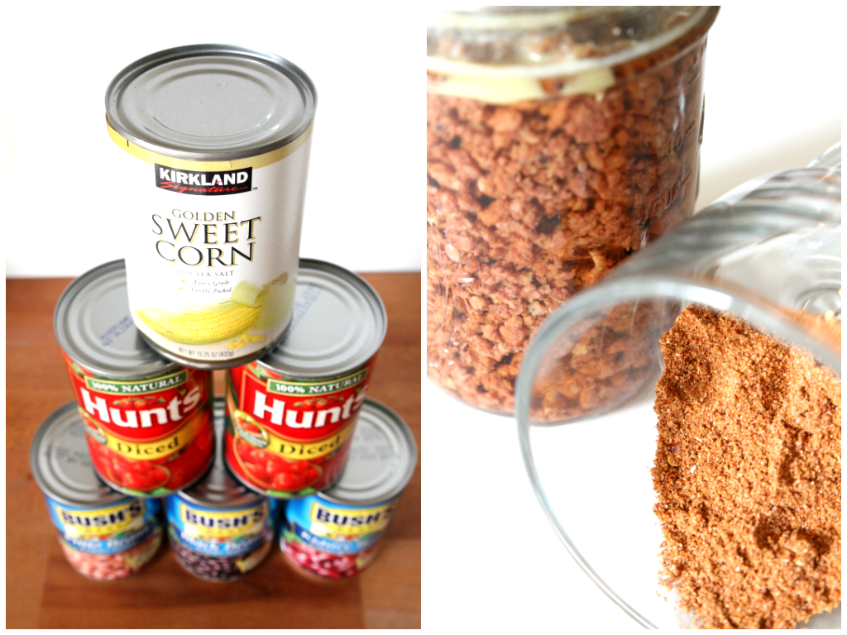
Get your tower of cans and open them up. Start with pouring all the beans into a pot and giving them a good rinse! You can use any combination of beans you want. So if you have more or less of something, go ahead and make this recipe your own.
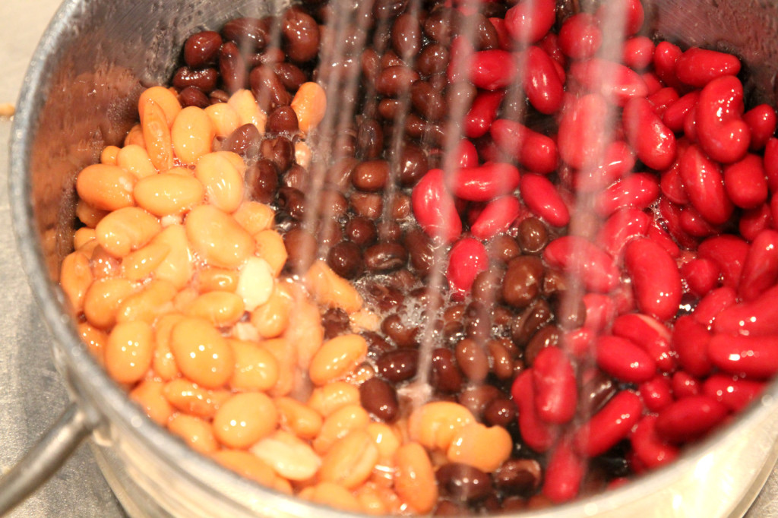
When you brown your meat, try using some of your dehydrated or freeze-dried onions. If you’ve been a little hesitant about using all that food storage you got succored into buying, try pulling out those onions first! Those cans of food can be intimidating to open since they cost you a fortune and you’re saving them for when the world ends, but muster up some courage and pull out the onions from your stash! You might just never cut an onion ever again, I rarely do. No more crying every time you make dinner, because they’re already cut up for you too!
You can re-hydrate them in some water, but I’m even lazier than that, I throw them right into whatever I’m cooking. If I feel I need to add a little extra water I do, but it’s seriously that easy. Have I convinced you to try them out yet? Anyways, let me know how it goes!
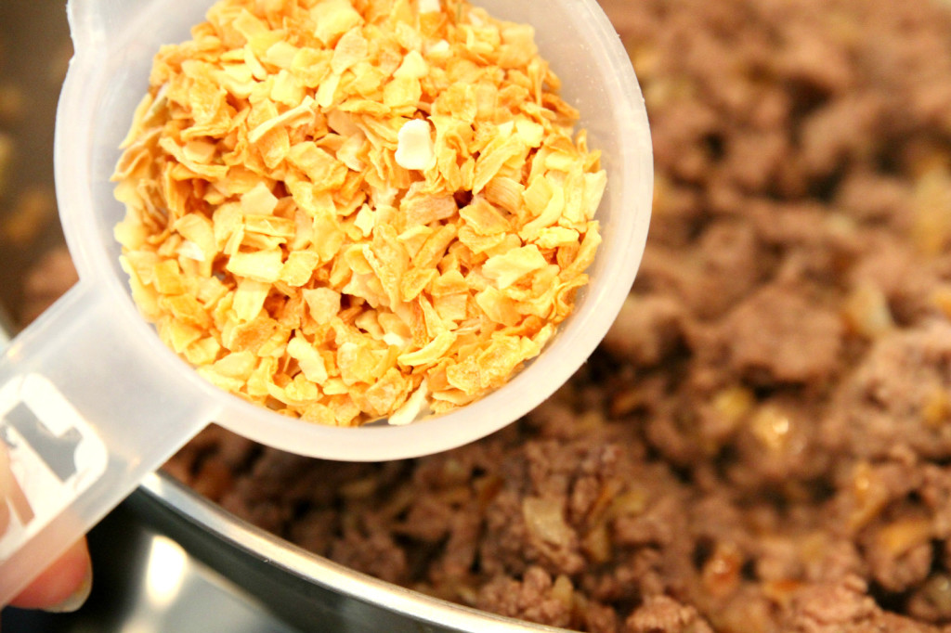
The last place you want to be during the Hot Summer is in a Hot Kitchen! This Taco Soup Recipe will have you in and out of the kitchen so fast you might feel a little guilty (or not ;) I love this recipe for many reasons, for one it won’t send my allergic nephew to the hospital because it’s gluten, dairy, nut, banana and free of everything else that makes your tummy happy. I was actually surprised there’s still yummy food even when you leave all the goodness out!

Once all the ingredients are in the pot and have simmered for about 30 minutes it’s time to dig-in.
All-right, time for you to try and make some! Feel free to sprinkle with chips and cheese if allergies aren’t an issue!

TACO SOUP RECIPE

Ingredients:
- 1 lb beef (or 1 jar of canned beef)
- 1 med onion (or use 1/3 c dehydrated onion)
- 1 pkg taco seasoning (or make your own)
- 16 oz corn
- 16 oz kidney beans
- 16 oz pinto beans
- 16 oz black beans
- 28 oz diced tomatoes
- 8 oz tomato sauce
- Toppings – cheese, chips, sour cream…

Directions:
Brown the beef and onion (remember to try out your freeze-dried or dehydrated stuff)! Add taco seasoning to meat. Rinse your beans and add everything to a pot. Simmer for 30 minutes or put into a crock-pot on high for 3-4 hours. Sprinkle on any desired toppings! This also makes for a great freezer-meal if you want to save some for later!

